Threading in Solidworks
Draw sketch of main part and smart dimension it.
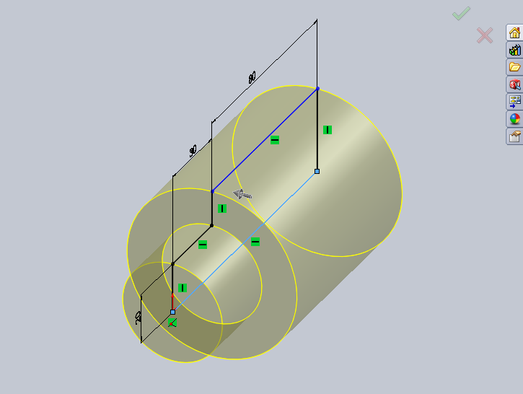
Use the feature Revolve base/boss ensure you click on central axis to create cylinder effect
Click on the end of the cylinder you wish to place thread and go normal to

Draw a circle on the end of the cylinder where you wish to place thread whilst you are still in the sketch do the following insert curve helix this will place a helix around the circle you have just drawn see below.
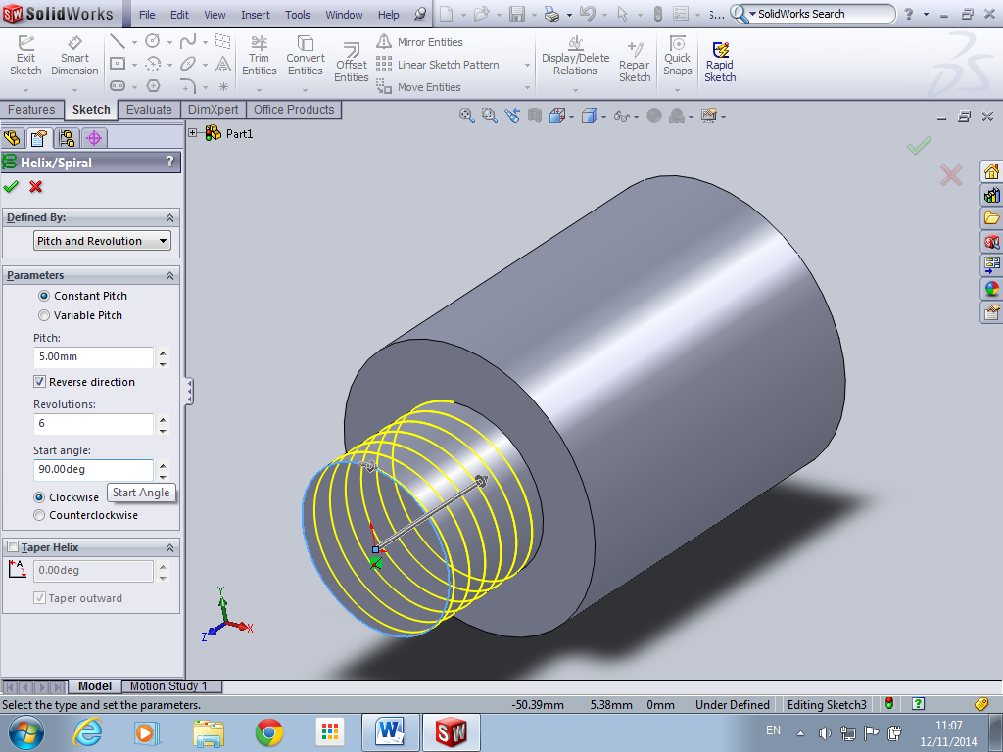
Its seriously important to take note of the Pitch and Revolutions at this point because they have to match the other threaded component otherwise they will not assemble properly. Note also start angle should be 90 Degrees.

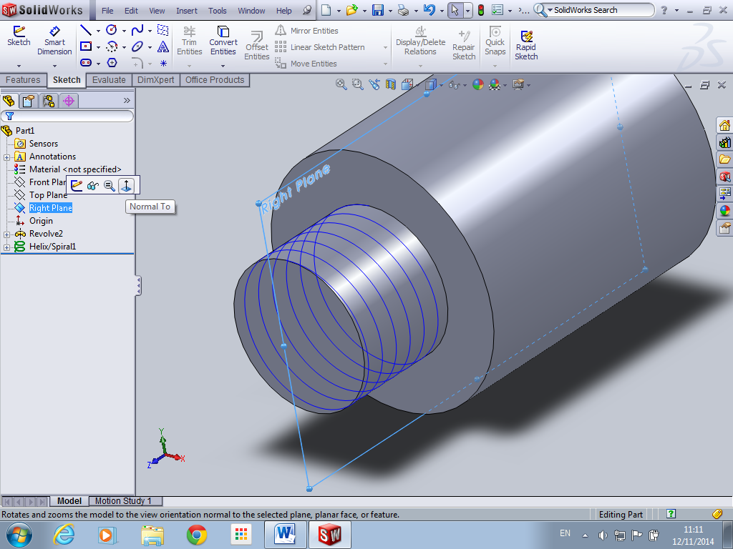
Next choose a plane that is 90 to the arrow of your helix point out here and go normal to this plane.
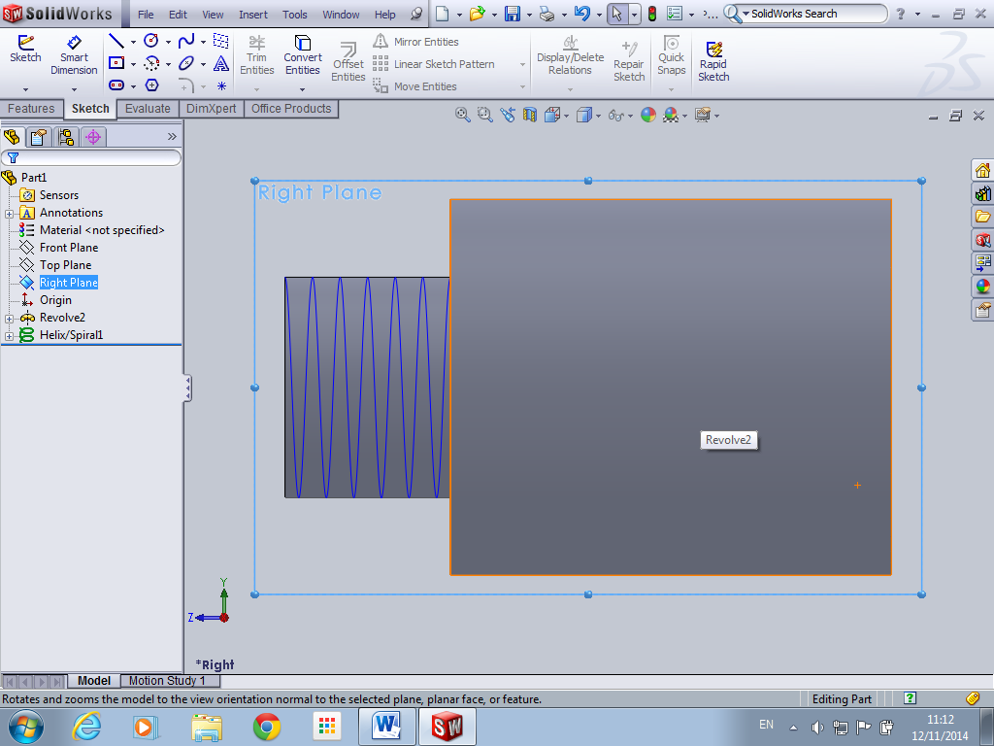
Scroll into the top corner where the helix touch the top corner of the cylinder and draw a triangle as shown below
Start the triangle in the middle and draw triangle then delete two (base) lines and replace with one base line
Its important to add a relationship between the centre point of base and tip of triangle in this case vertical……
Make sure you right click on the base of the triangle select midpoint and create coincident relationship with the helix
Exit sketch and got to feature and swept boss/base
Choose base of triangle as your profile and pick the helix as your path
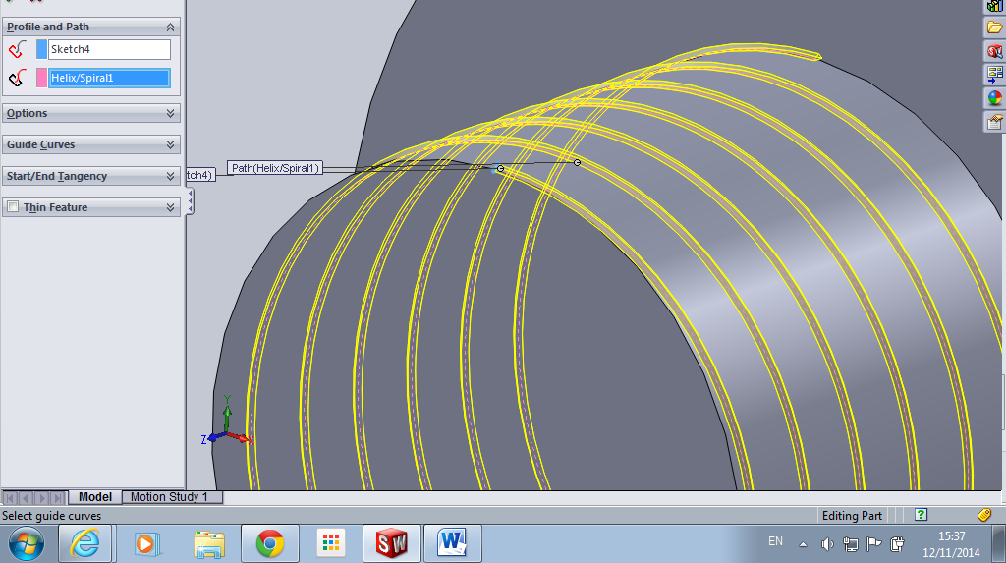
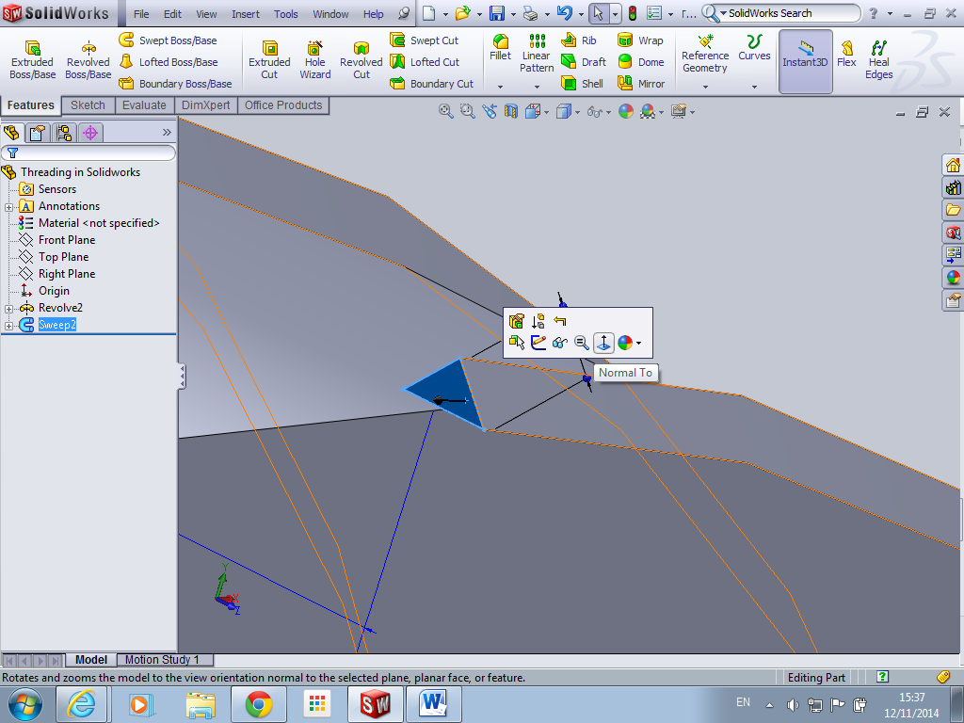
Click on the end of the thread and go normal to
Zoom into area and create a sketch of the triangle on the end of the thread as shown above

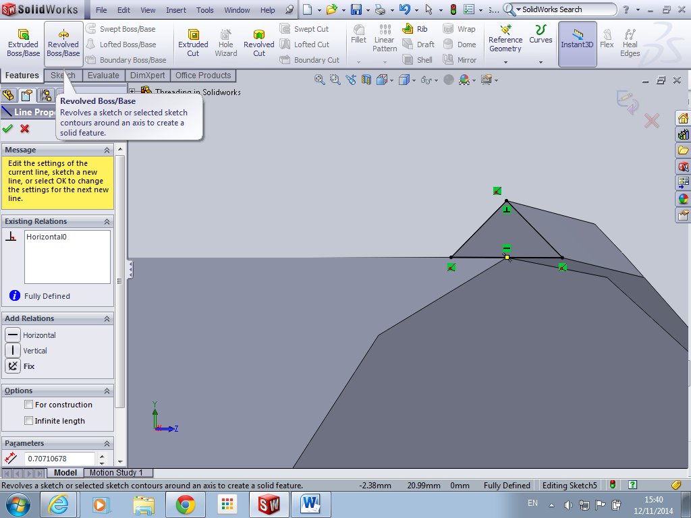
Features revolve base boss and use base of triangle as axis
Its important to rotate it back in enough so 92 degrees will close the thread
Repeat same for other end of thread

