Introduction to Linear Pattern - Lego Block

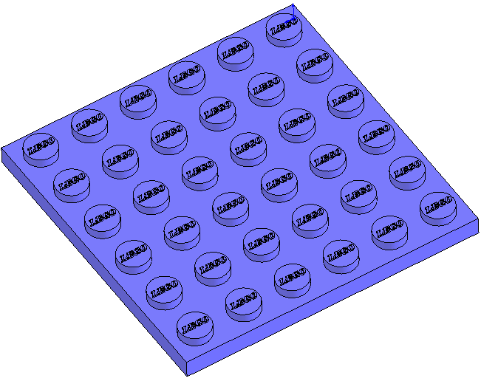

Prerequisite Knowledge Previous knowledge of the sketching commands Rectangle, Circle, Dimensioning and Text is required to complete this lesson. Previous examples of Extruded Boss/Base and Shell and editing appearance should also have been completed.

Focus of the Lesson On completion of this lesson you will have used:

- The Rectangle, Circle, Centerline, Text, Add Relation, Smart Dimension and Offset Entities commands form the Sketch Toolbar.
- The Extruded Boss/Base, Shell and Linear Pattern commands from the Features Toolbar.
- The Extrude Bass/Boss command to extrude text.
- The Linear Pattern Property Manager to pattern a feature.
Linear Pattern is used when creating multiple instances of one or more features on a face of a model. Select the Linear Pattern command 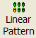 and the Property Manager appears. The Property Manager controls the layout of the pattern. The initial feature to be patterned is called the Seed Feature. When you create a pattern using a Seed Feature, all pattern instances must be on the same face. A pattern can be created in one or two directions. Generally, the order for creating the pattern is to select the Seed Feature, then specify the direction, the linear spacing and the number of instances. The pattern can be modified to allow certain instances of the patterned feature to be skipped.
Commands Used This lesson includes Sketching (Centerline, line, Smart Dimension, Text,), Extruded Boss/Base, Shell, Linear Pattern and Edit Materials.

Where to start? It is important to analyse the design of Lego blocks prior to attempting to model them. The basic single block with one stud on top measures 8mm x 8mm and has a height 9mm. All other blocks work on multiples of this. The particular block to be modelled here has a 6x6 array of studs on top. Hence it will measure 48mm x 48mm. Three of these blocks stack to the equivalent of one single block, giving it a height of 3mm. A 2:1 scale is used in modelling the block. The final measurements are 96mm x 96mm x 6mm.
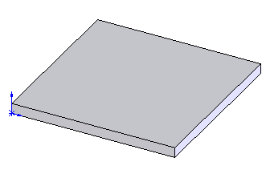
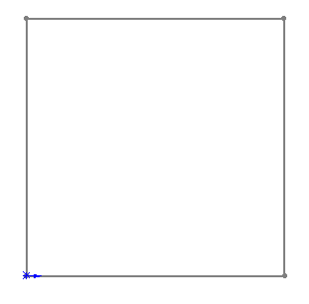

Sketch to generate feature Extruded feature

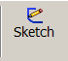
Getting started
Choosing a plane Select Sketch on the sketch toolbar. Choose the top (horizontal) plane and view Normal

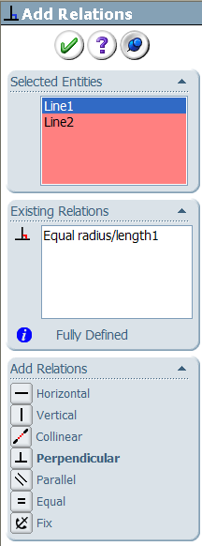
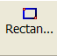
Creating a sketch Using the Rectangle command, create a sketch approximately 96mm x 96mm. Ensure that all lines are either horizontal or vertical indicated by the relations.
It is good practice when creating a part to follow the sequence sketch, relation and dimension.

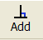
Select the Add Relation command from
the sketch toolbar. Select two lines and choose
Equal in the add relation property manager.

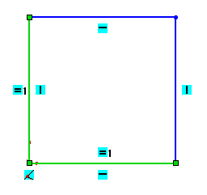

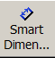
Dimensioning the Select Smart Dimension from the sketch toolbar and dimension the
Sketch sketch as shown.
Note the relation is maintained and a square is created.
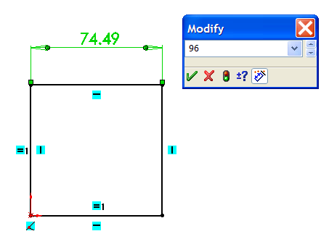

Note – The sketch will change from blue to black
when it is fully defined. To exit the sketch, select
the sketch tool on the confirmation corner, the
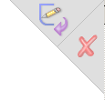
sketch will be saved.

Selecting X will discard changes made.

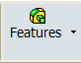
Creating the feature Select Features from the Command Manager. The Features toolbar has now replaced the Sketch toolbar along the top of the screen.

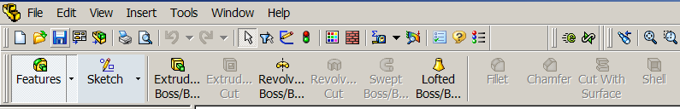

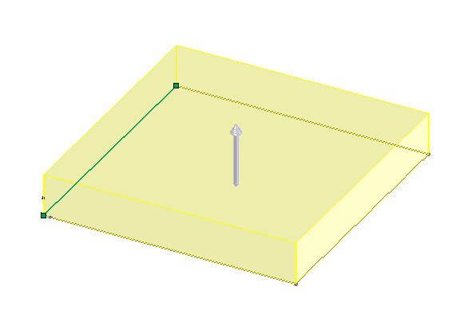
Choose Extruded Boss/Base, the sketch rotates to a trimetric view with a preview of the proposed extrude. Go to the extruded boss/base feature property
manager.

Extrude Feature Settings

End Condition = Blind

Depth = 6mm


Click OK button to create the feature.
Alternatively select the from the
confirmation corner.

Completed feature: This is the first completed feature of the
part. The sketch has been absorbed into
the EXTRUDE 1 feature in the Feature
Manager.
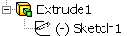



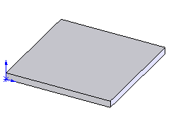
Renaming a feature: Select the feature in the Feature
Manager Tree and Press the F2 key and type the
new name Base to replace “Extrude1”

Creating the first To model the stud on the top surface of the base a sketch will first have
extruded stud to be created. This can then be made into the required feature.

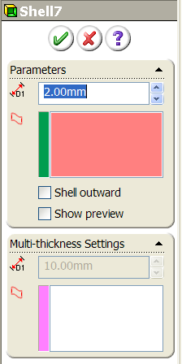
Creating the sketch Select the Sketch toolbar from the Command Manager.

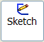
Enter the sketch mode by selecting at the start of the Sketch toolbar.

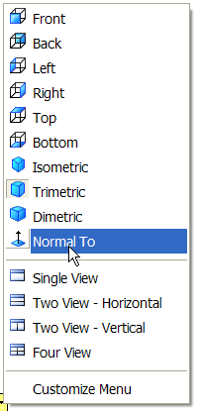
When prompted select the top face and select Normal To from the View Command. The base will rotate to a view looking perpendicular to the chosen surface.
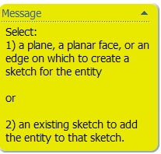

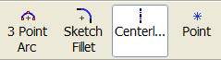

Select the Centerline Sketch command.

Draw a diagonal line on the chosen surface from the Origin. Select the
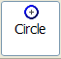
Circle sketch command and draw a circle centred on the centerline.

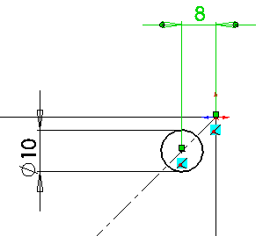
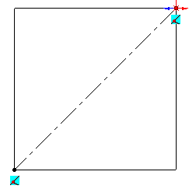
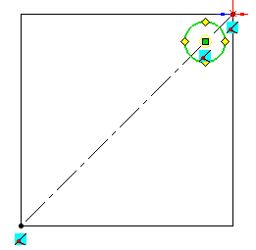

Using Smart Dimension apply the above dimensions to the circle. Exit the sketch.

Creating the feature Select Features from the Command Manager. The Features toolbar has now replaced the Sketch toolbar along the top of the screen.

Choose Extruded Boss/Base.
Select Isometric View form the Command View.
The feature previews in isometric.
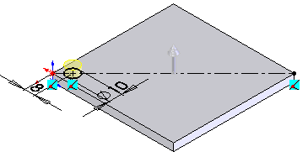

Use the Extrude Feature Manager on the left of the screen to set up the feature.

Extrude Feature Settings
End Condition = Blind Depth = 3mm
Click OK button to create the feature.
Alternatively select the from the confirmation corner.

Pattern the Feature The extruded Stud can now be patterned on the top surface of the base.
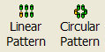
Choose the Linear Pattern Command from the features toolbar.
In the Linear Pattern Feature Manager

For Direction1 Select Edge 1, distance 16mm and instances 6

For Direction2 Select Edge 2, distance 16mm and instances 6

Expand the Feature Manager Tree of the Lego Block (left click on the + sign) on the graphics area and select Stud as the Seed Feature to pattern. Alternatively click the Features to Pattern box and select them on the actual model.
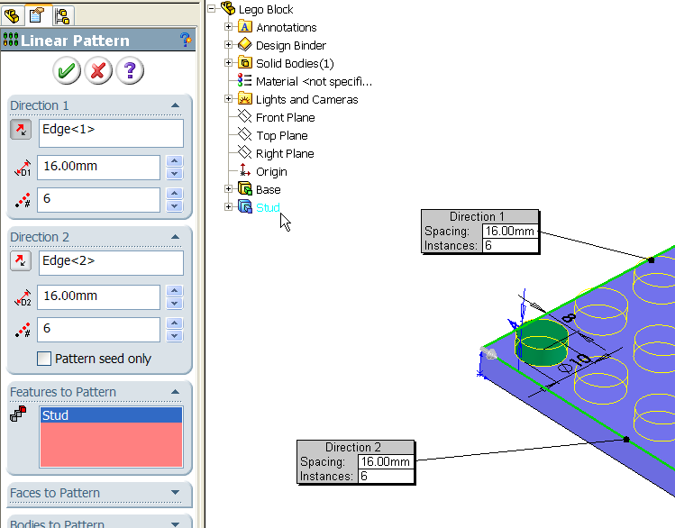


Click OK to create the pattern.
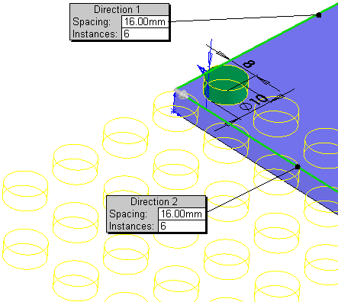

Changing Pattern
Direction
If the array previews in the wrong direction, change the direction using the change direction button.

Rename Feature Rename the feature Stud Pattern

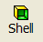
Shell Command The underside of the block needs to shelled out at this stage. Select the Shell command on the Features toolbar.

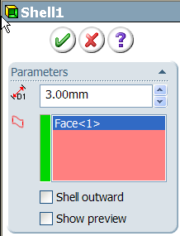
In the Shell Feature Manager

Distance = 3mm
Select the bottom face of the base.
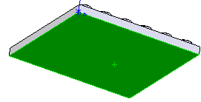

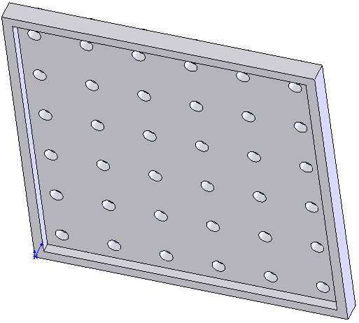
Click OK  button to create the pattern.

This is how the completed shell feature should
look when complete.

Creating Lego Text On the top surface of each connector is a small extruded legend of LEGO. This is a small extrusion that is created on the Stud extrusion and patterned as before.
Why was this not created and patterned with the original Stud extrusion?
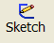
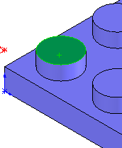
Creating the sketch Select the Sketch toolbar. Select Sketch on the Sketch toolbar.

Select the top surface of the original Stud to sketch on. Select Normal To from the View Command.

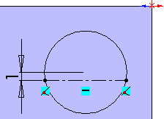
Using the Centerline command draw a horizontal line below the centre of the circle. Select the line and the circle and Smart Dimension it 1 mm from the centre of the circle. This line will be the baseline for the text.
The text height will be 2mm and will be centred on the horizontal diameter.

In the Tools Menu, select Sketch Entities and Text

Select the centerline we drew to position the text on. Uncheck and select the Font button. Enter the text as shown and format as below.
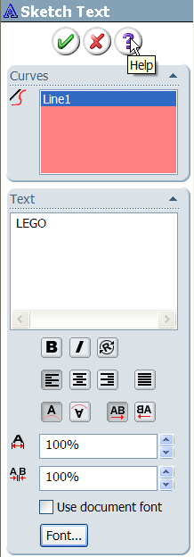
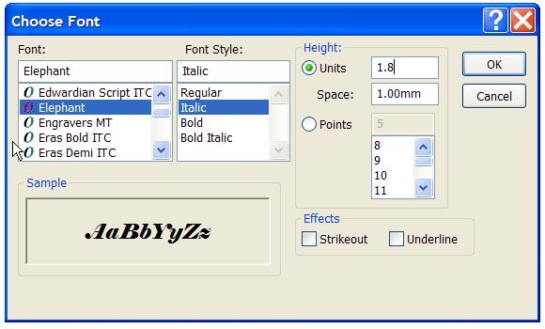

The text will preview in the Graphics Area. Centrally align the text on the centerline using the alignment button.

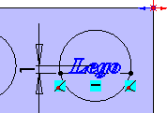


Click OK to complete the sketch.
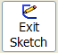
Creating the Feature Finish the sketch by clicking on the Exit Sketch icon or Exit Sketch in the Confirmation Corner.

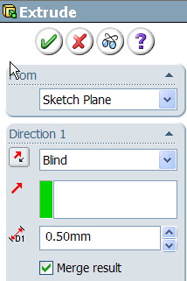
Select the Features Toolbar in the Command Manager. Select Extrude Boss/Base.

Change the view to Isometric in the View Command.

In the Extrude Feature Manager set the depth to 0.5mm.

Click OK to complete the feature.

Select this feature in the Feature Tree Manager, press the F2 key and rename the feature Lego Legend.

Pattern the Feature The LEGO Legend feature can now be arrayed with the exact same settings as the previous Linear Pattern. 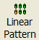This will position the LEGO feature on top of all the studs.
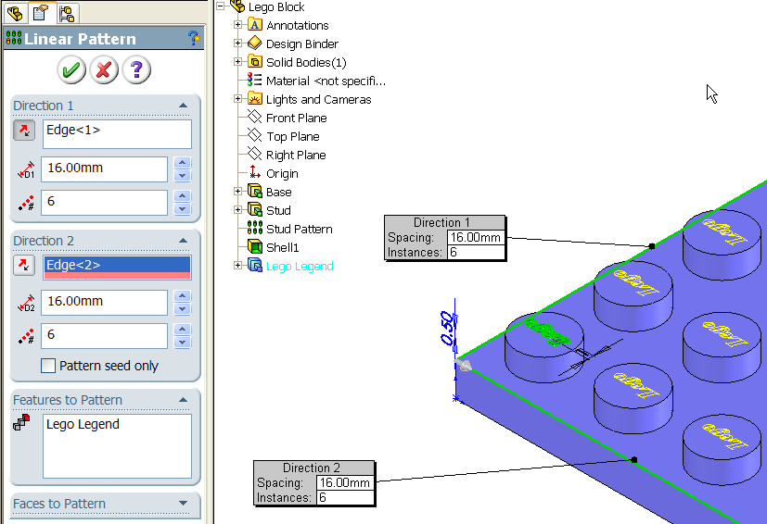

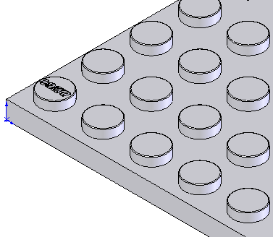

The Lego Block should now look like this.

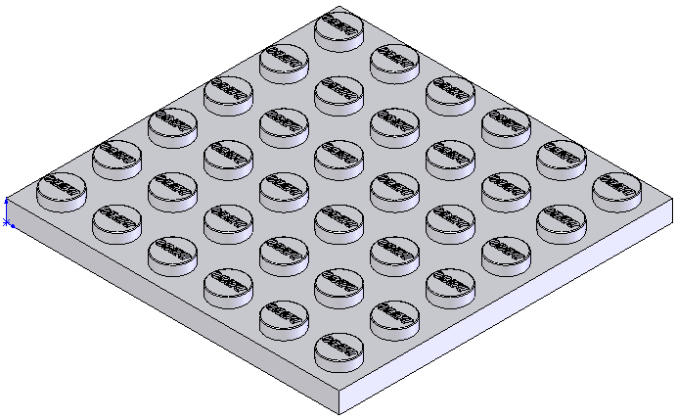

The underside The underside extrusions allow Lego blocks to be built. The studs on the top surface fit tangentially between these underside extrusions. These are hollow. First a sketch will be created and then the actual feature.

Creating the sketch Select the Sketch toolbar. Select Sketch on the Sketch toolbar.

When prompted, select the underside surface as the plane to sketch on. This will require the model to be rotated.
Select the Rotate View icon in the View Toolbar. Alternatively by pressing and holding down the wheel on the mouse the rotate view mode is activated. Also the arrows keys on the keyboard can be used.
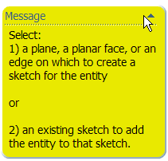
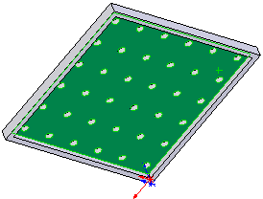

Change the view to Normal To in the View Command.
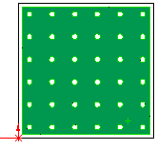
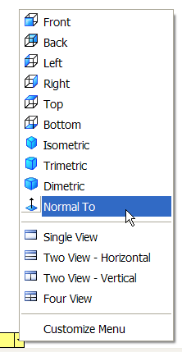

Select Hidden Lines Visible on the View Toolbar.

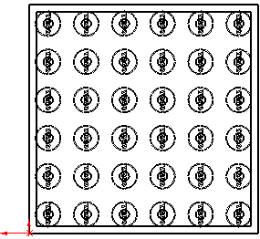

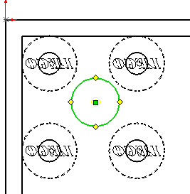
Select the Circle Command 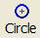 and sketch a circle as shown.

Select Add Relations 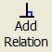 . Select the circle and Edge 1 and select as the relation to add.
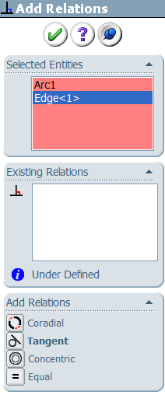
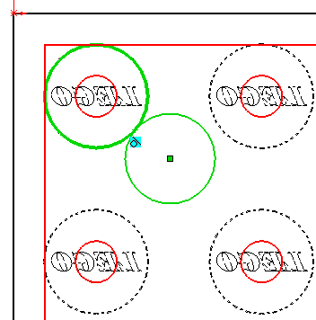

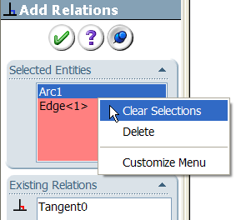
Click OK  to add the relation.

Select Add Relations again. Right click in the Selected Entities panel and select Clear Selections. Then select the circle and Edge 2 and add a tangent relation. The circle will now be tangential to all four hidden circles.

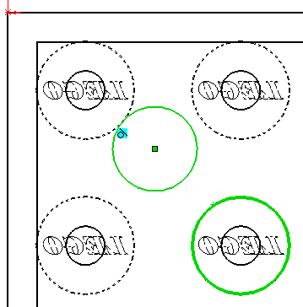
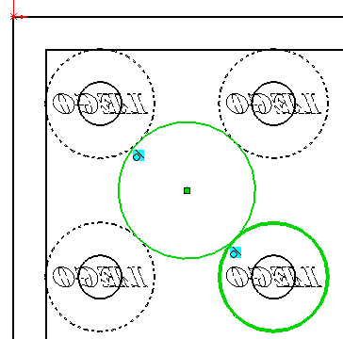

Click OK to add the relation.

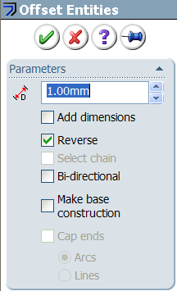
Select Offset Entities 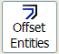. In the Offset Entities Property Manager set the distance to 1mm and check the reverse box.

Click OK to complete.

Creating the Feature Select Exit Sketch, select Features on the Command Manager and select Extruded Boss/Base.
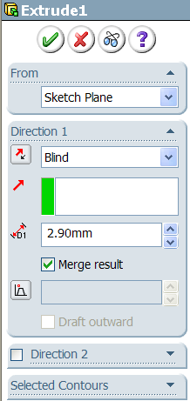
In the Feature Manager set the distance to 2.90mm.

Click OK to complete the feature.
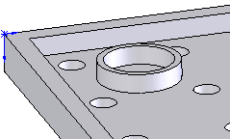

Rename the feature Underside Extrusion in the Feature Manager Tree.

Pattern the Feature Select Linear Pattern command and in the Feature Manager set the parameters as follows:
Direction 1 Select Edge 1, distance 16mm, No. of instances 5

Direction 2 Select Edge 2, distance 16mm, No. of instances 5
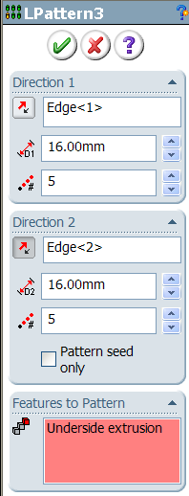
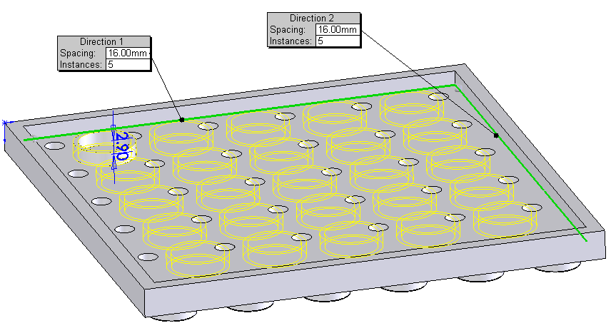

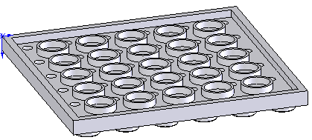

Click OK to complete the feature.

Rename the Feature Select the underside pattern in the Feature Manager Tree, press F2 and rename the feature Underside Pattern.

Adding color An important aspect of the design of Lego blocks is their colour. To add colour to the model:

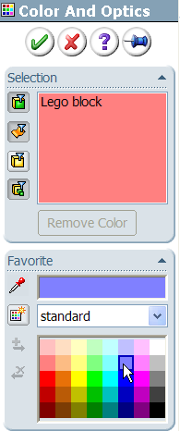
Right click on the Lego block feature in the Feature Manager Tree. In the menu select Appearance and Color.

In the Color and Optics Property Manager select a colour for the Lego Block.

Click OK to complete.

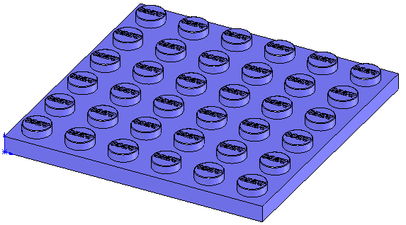

Save the completed model.

Further Exercises



