KNURLING IN SOLIDWORKS
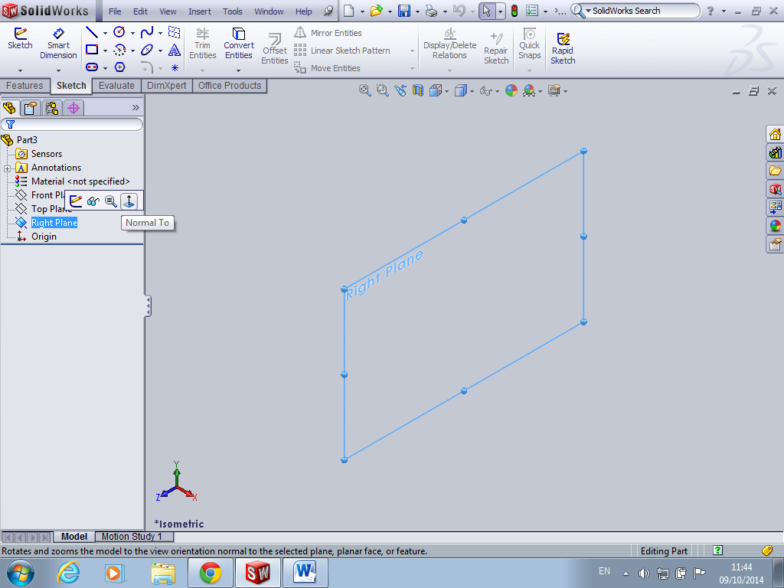
Click on plane you want
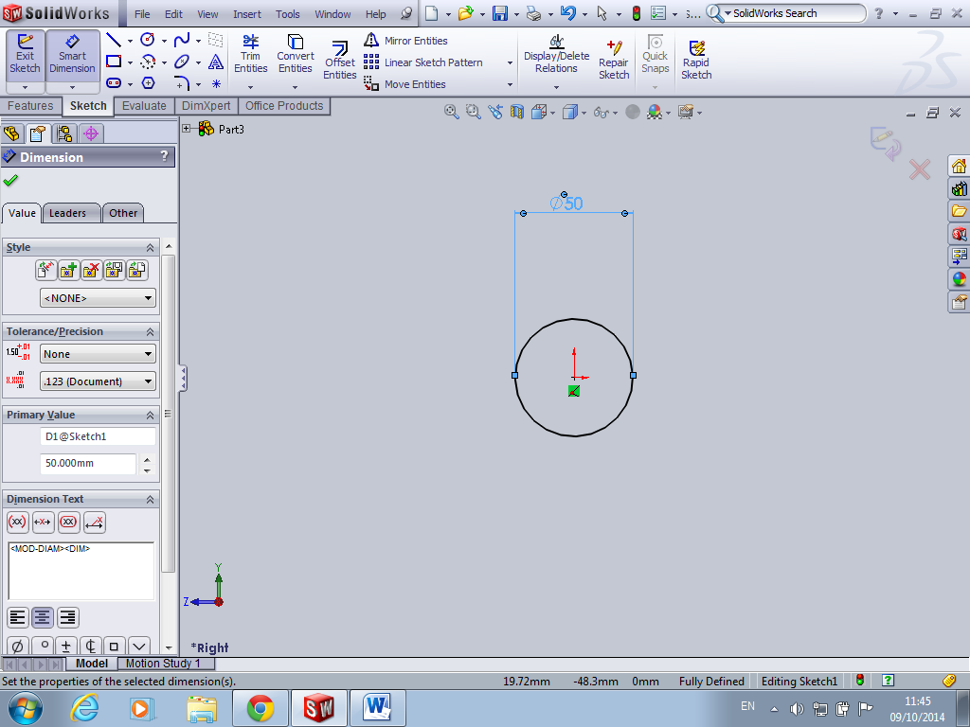
Sketch circle
Smart dimension and extrude
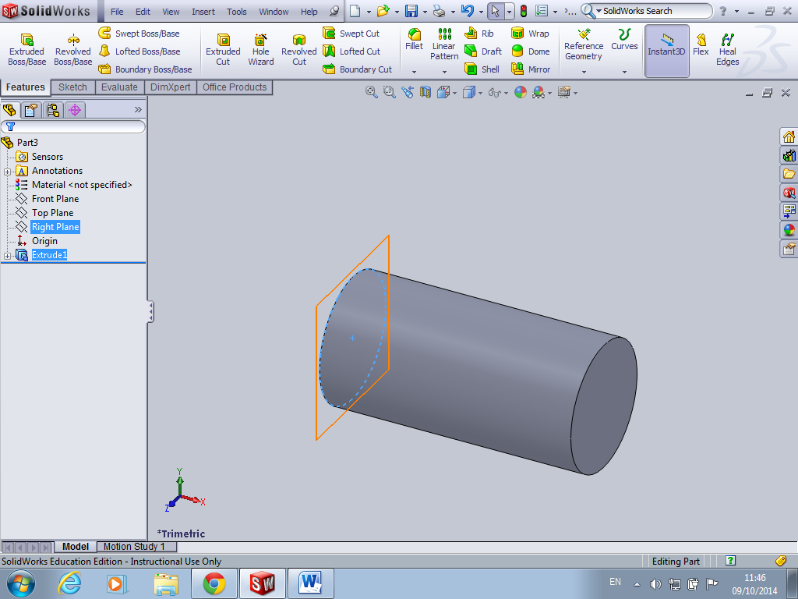
Click on plane you started with and sketch a circle same diameter as knurling in this case same as cylinder diameter
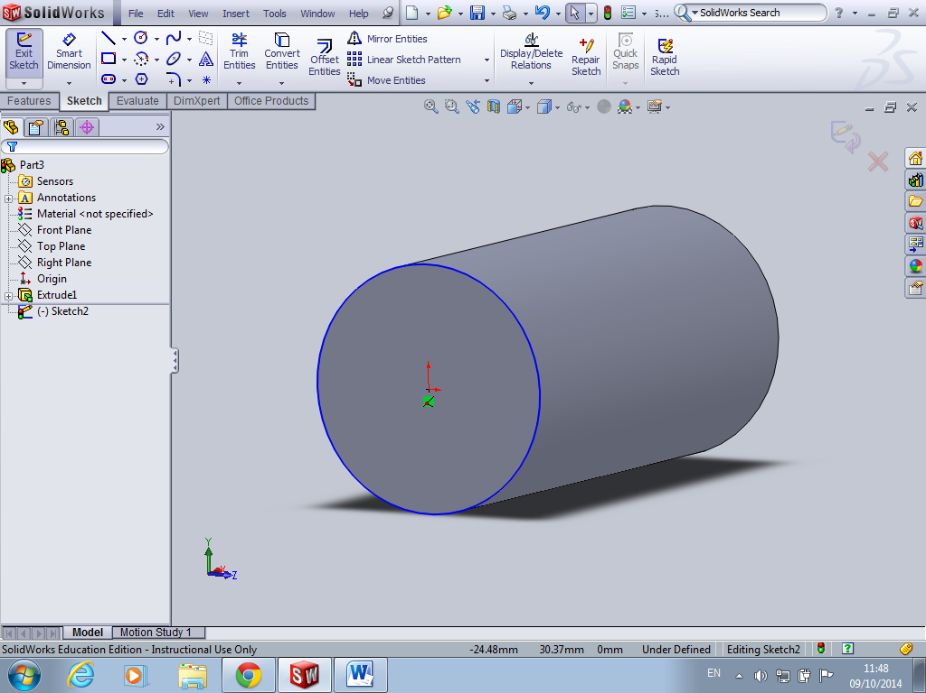
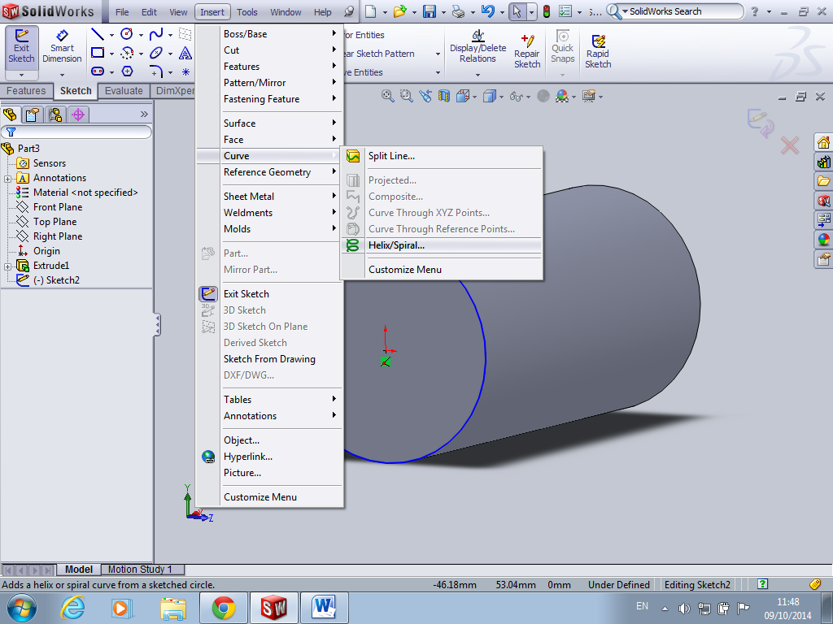
While the sketch is still open insert curve helix spiral
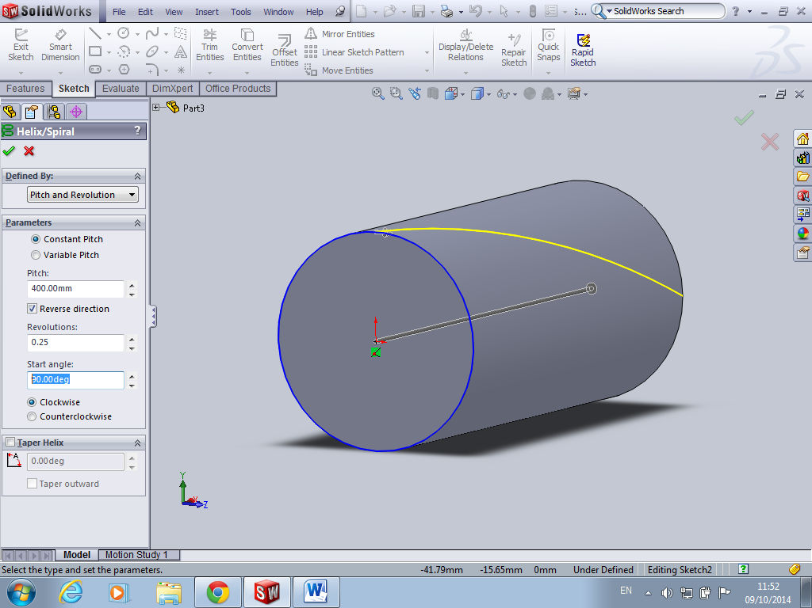
For knurling you only need a quarter of a revolution so therefore the length will be 4 times the length of cylinder. Also important to note start angle is good to have it at 90 degrees

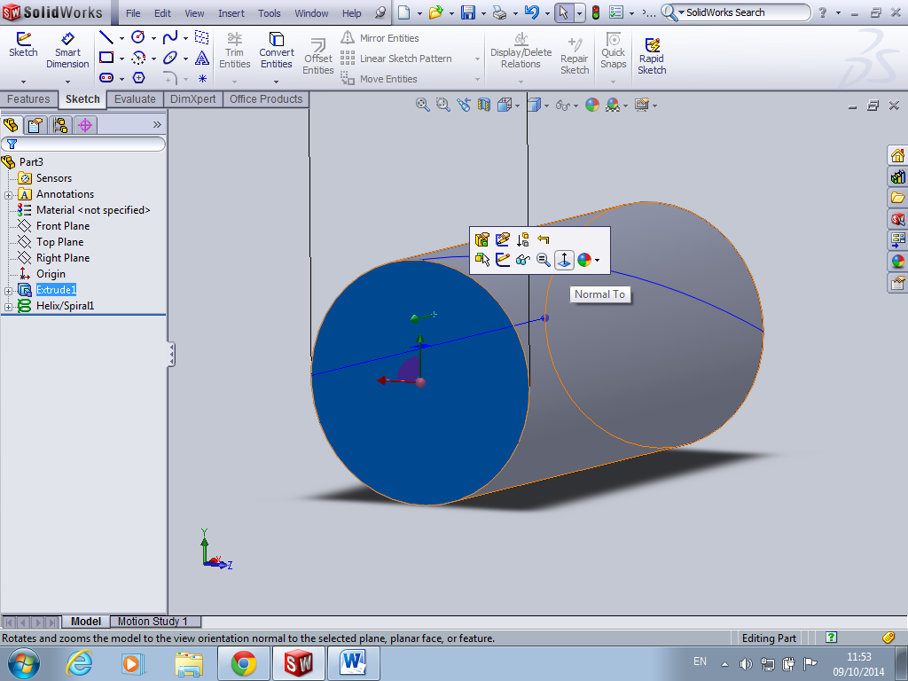
Click on the base of the cylinder and normal to
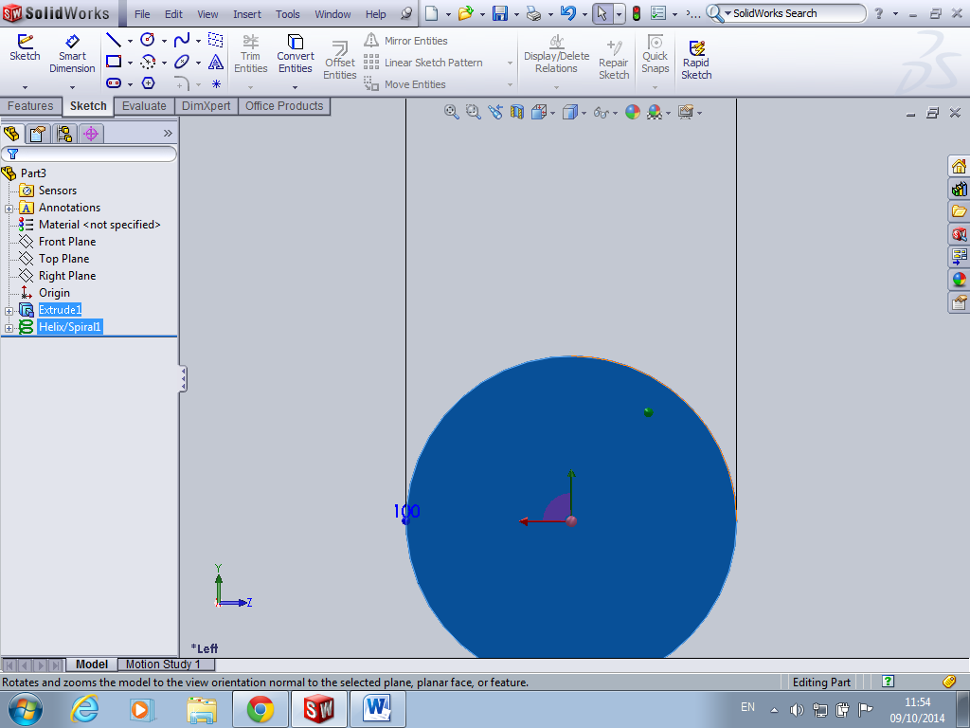
Locate end of helix as this is where you need to begin drawing your triangle (located here in orange)
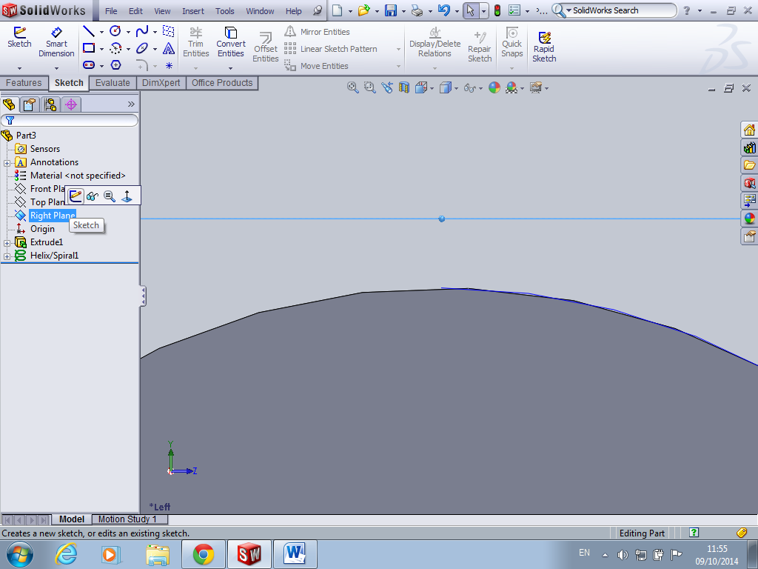
Highlight right plane and sketch, this will ensure you draw triangle in correct place and at the end of your helix
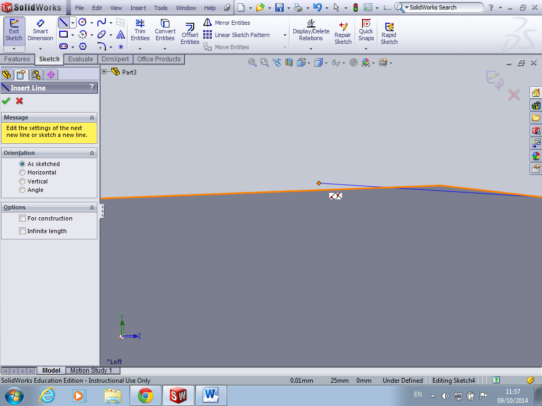
It is vital that you begin sketch at the end of the helix to prevent any missing relationships later.
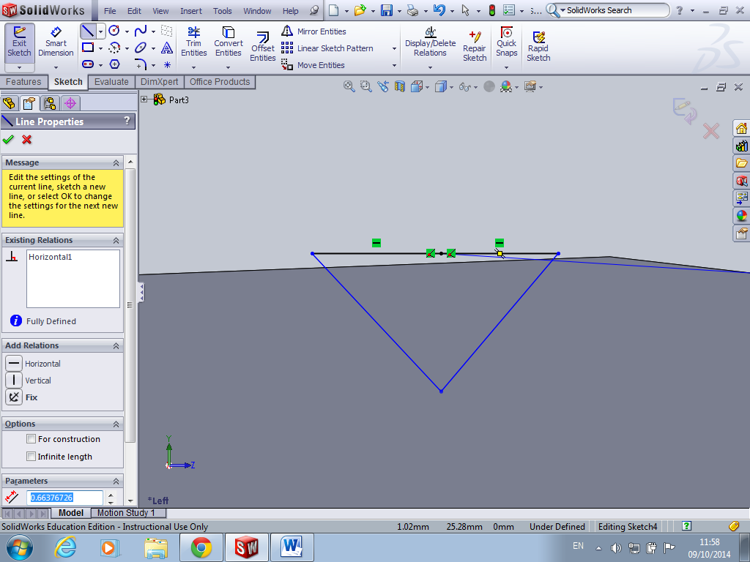
Draw a rough sketch of a triangle you will note at this point I need to draw two lines to draw the base just delete them and replace them with a single line (hard to draw a single line and ensure it is on the helix
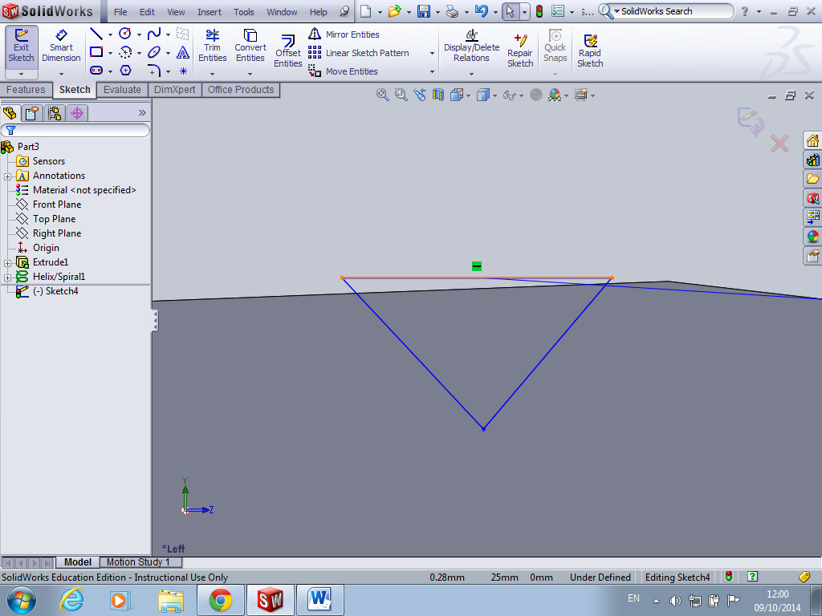
One single line now
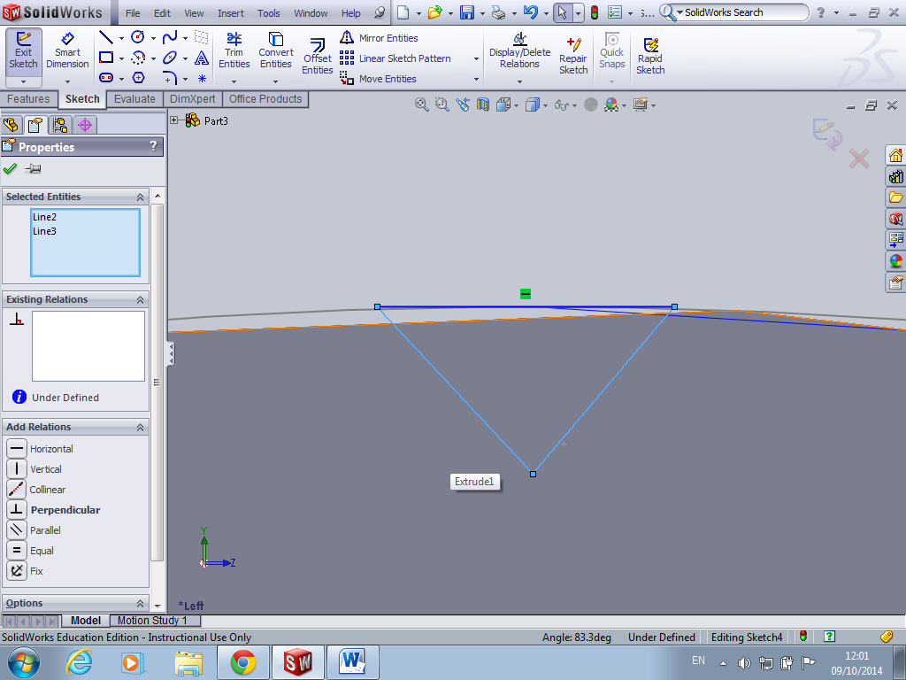
Highlight these two lines (ensure you hold down ctrl button) and ensure a perpendicular relationship
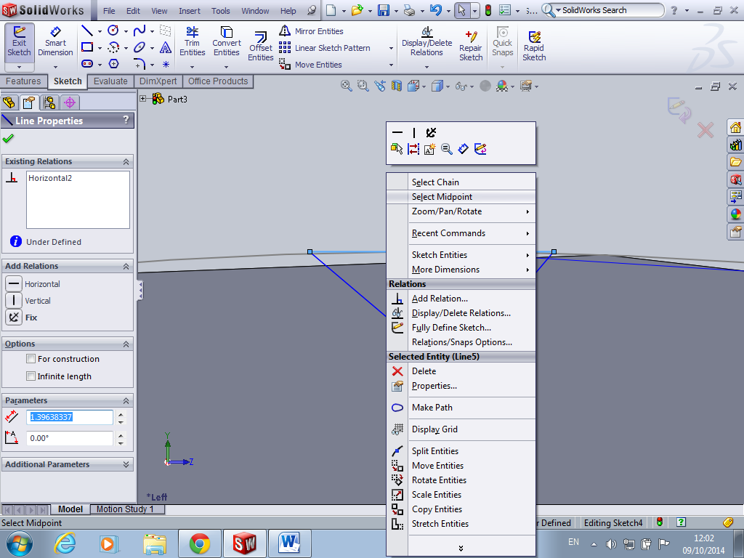
Right click on base of triangle and select midpoint and make a vertical relationship with the tip of triangle
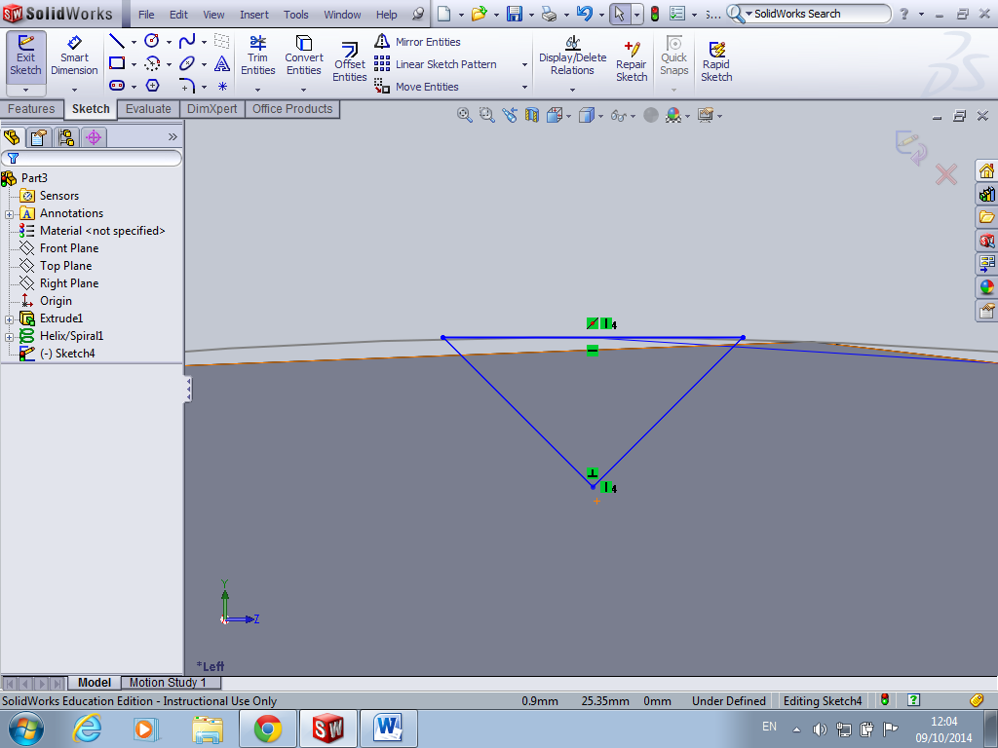
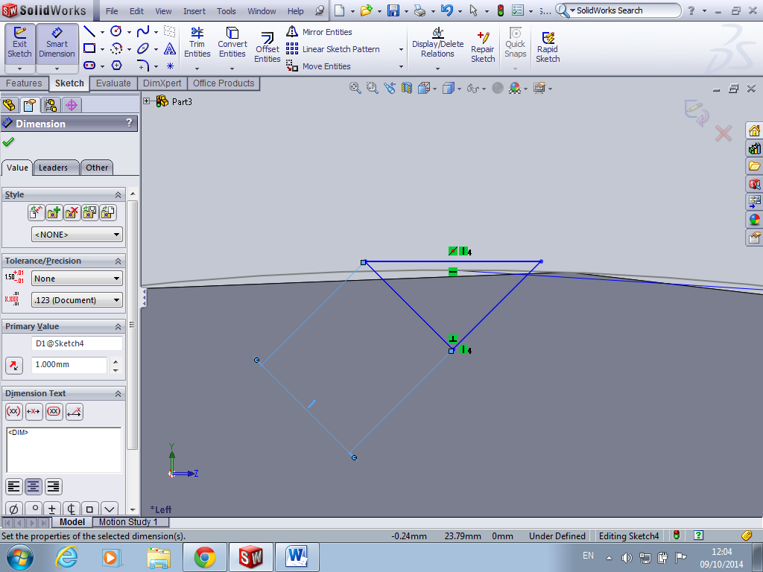
Smart dimension your triangle this will vary as everybody will use different measurements depending on what they are modelling
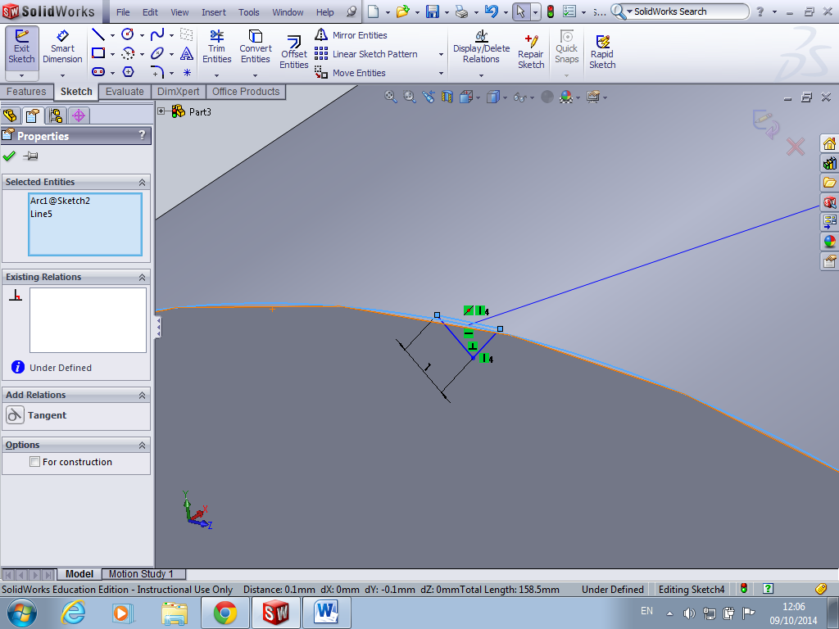
Highlight base of triangle and sketch of circle on end of cylinder and create a tangential relationship
Close the sketch
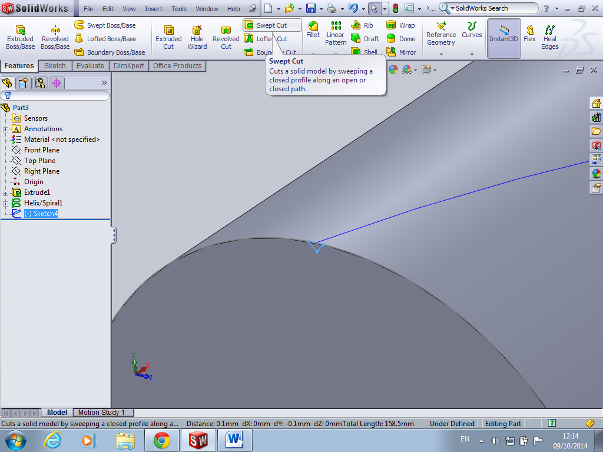
Next is features and swept cut
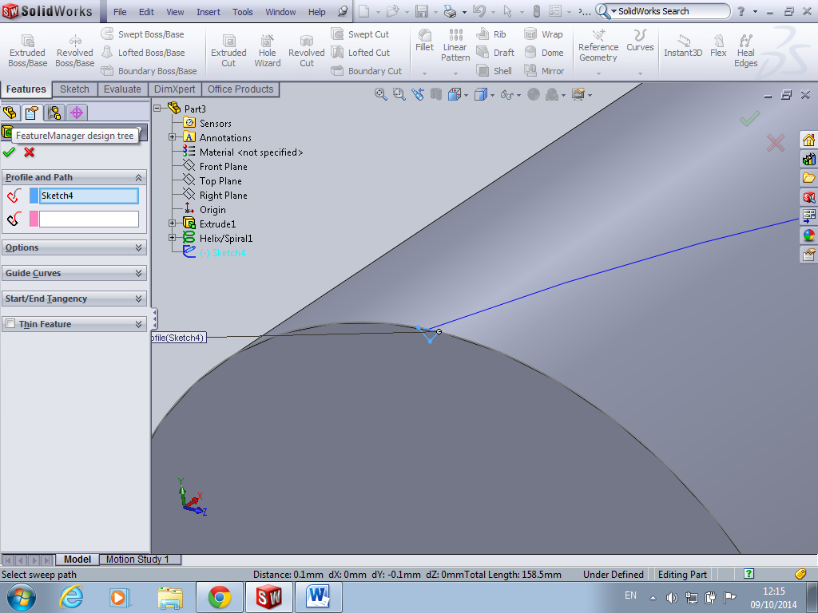
Click here to bring out design library (easier to locate items you are looking for)
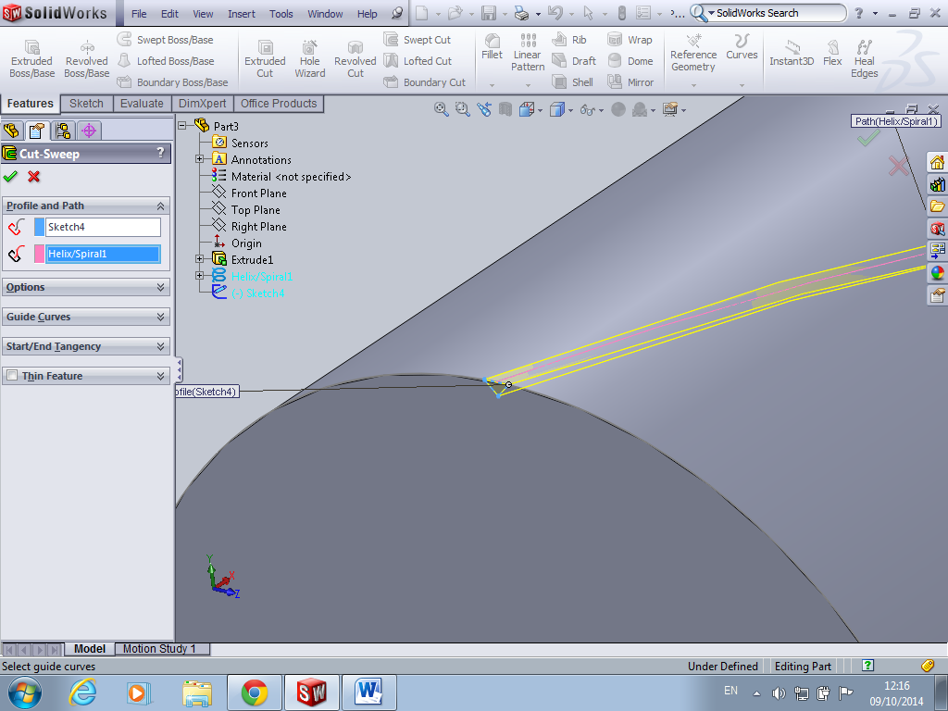
Pick the triangle as your profile and the helix as your path then green arrow
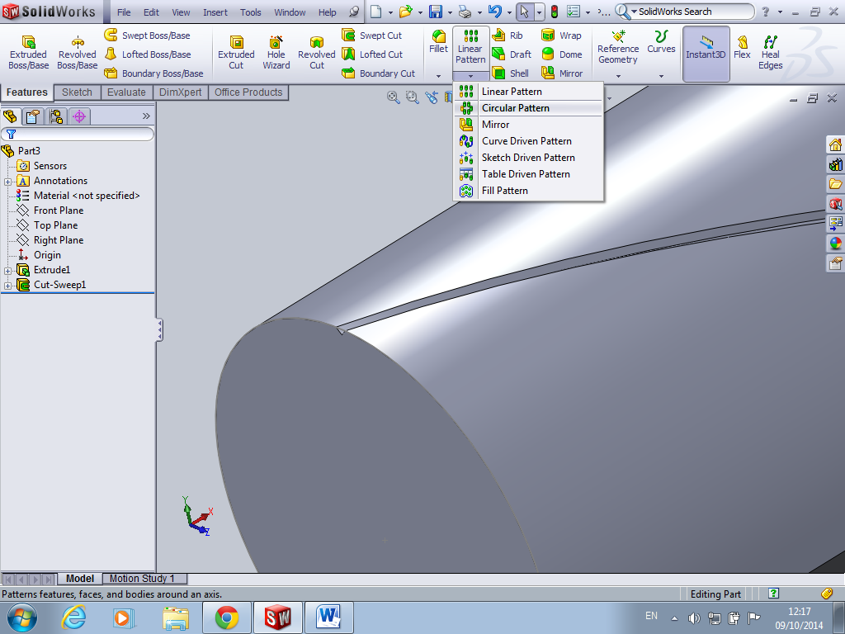
Next you need to circle pattern the knurl all around the cylinder go to features and circular pattern
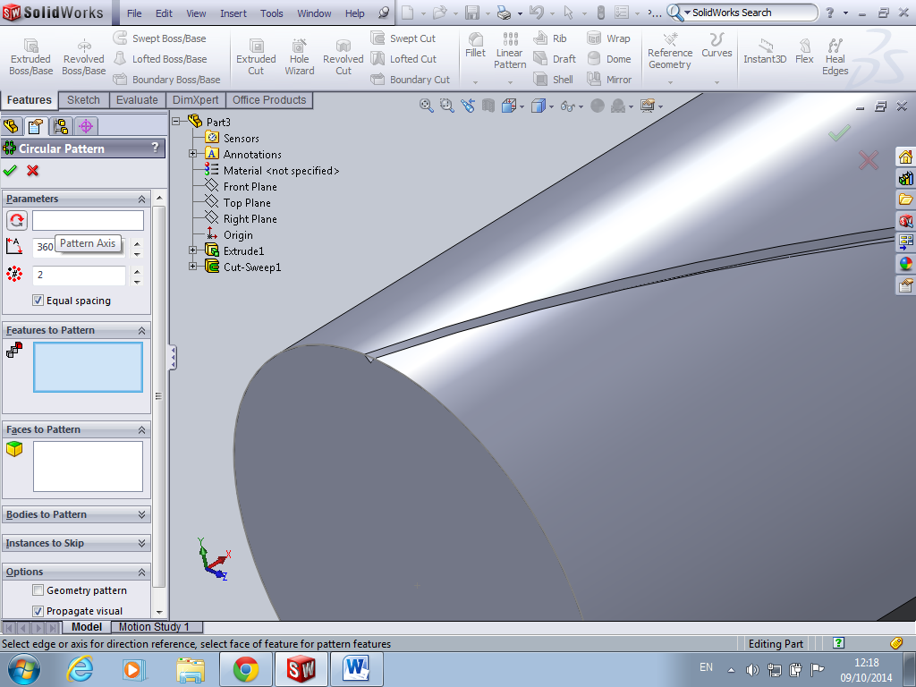
Ensure you choose circle sketch drawn earlier on the end of cylinder as your axis. Ensure equal spacing is ticked and choose a no. your happy with until knurl is what you desire.
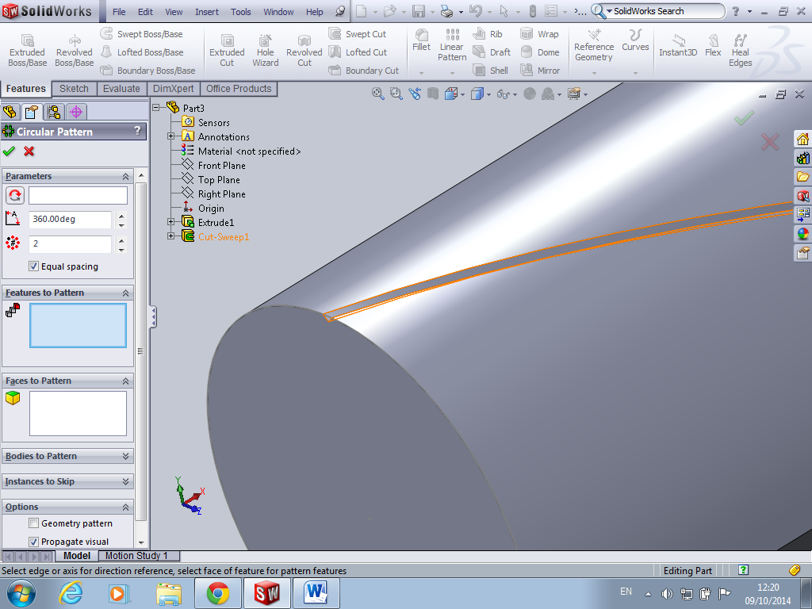
Click on the features to pattern box and select the cut swept on the design tree
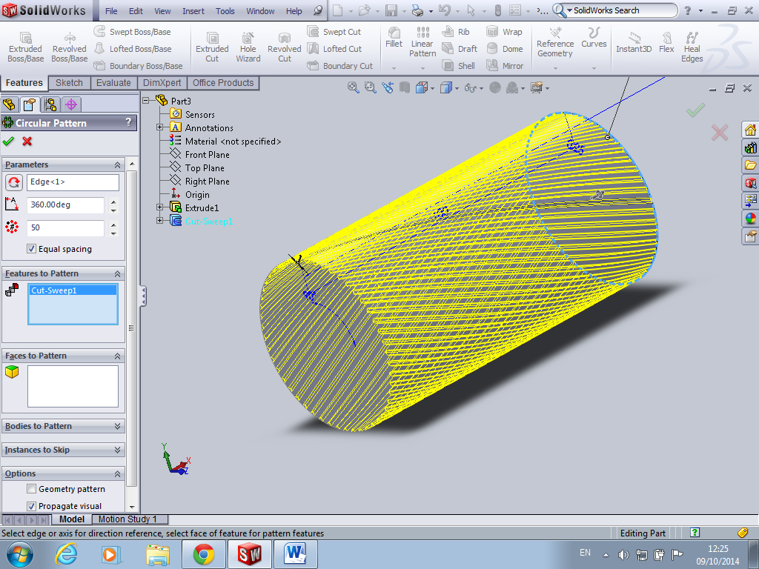
Ensure you have checked all feature before you click on green arrow. You could easily confuse both ends of the cylinder and the circle sketch.
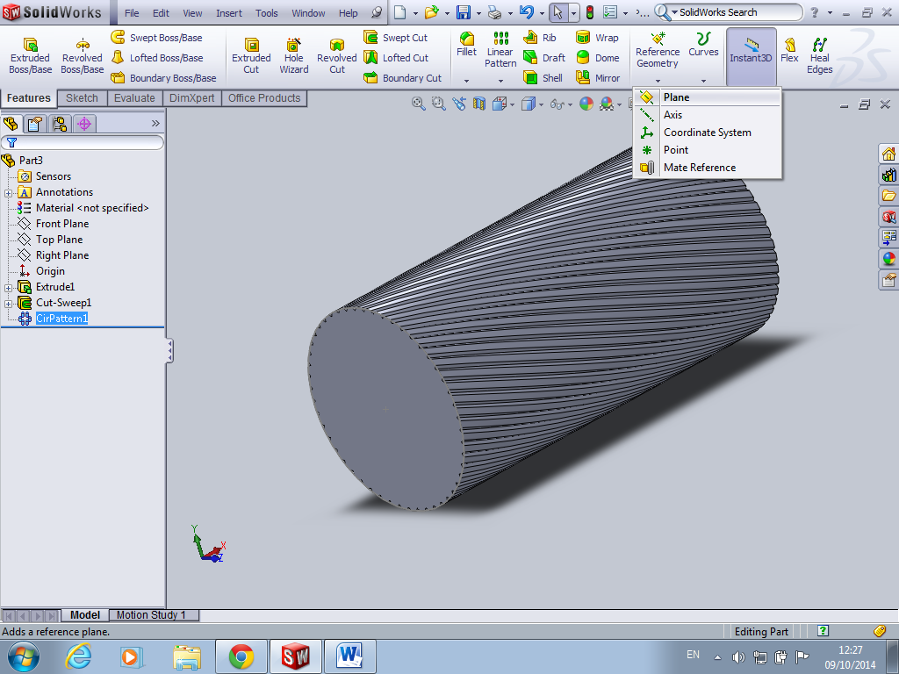
Next insert plane halfway up the cylinder ensure it’s the same plane as you started sketch on
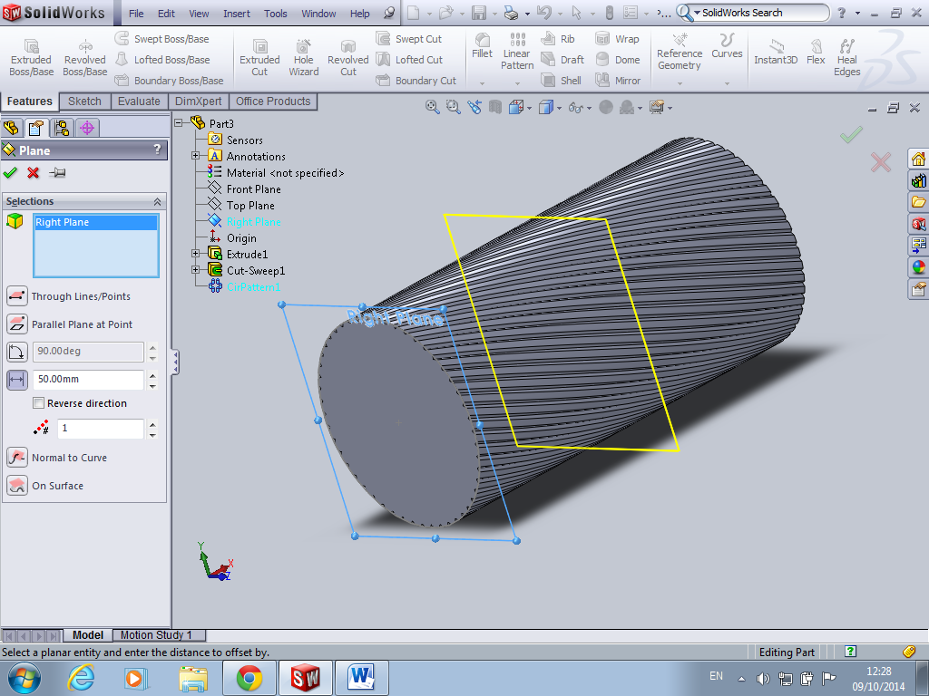
Again your dimension have to be spot on here in order to ensure plane is half way otherwise it will not mirror correctly
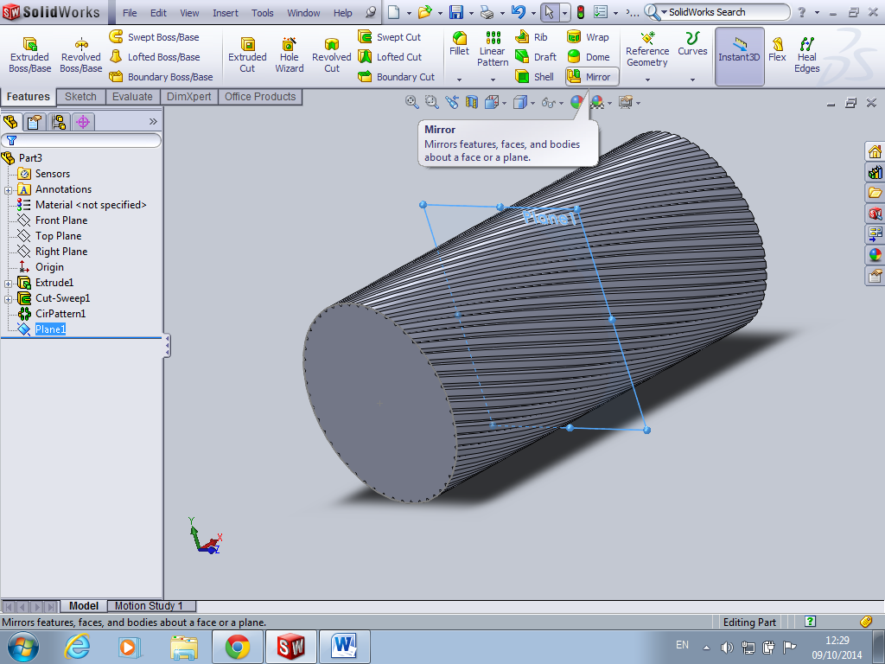
Next choose mirror command
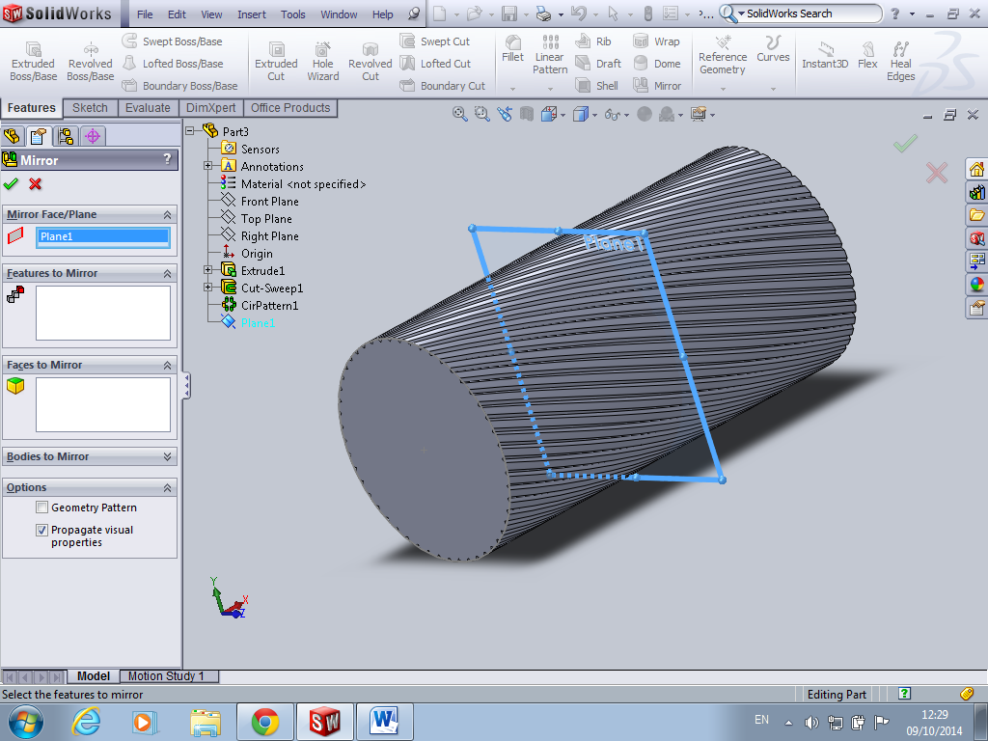
Highlight the plane you just inserted
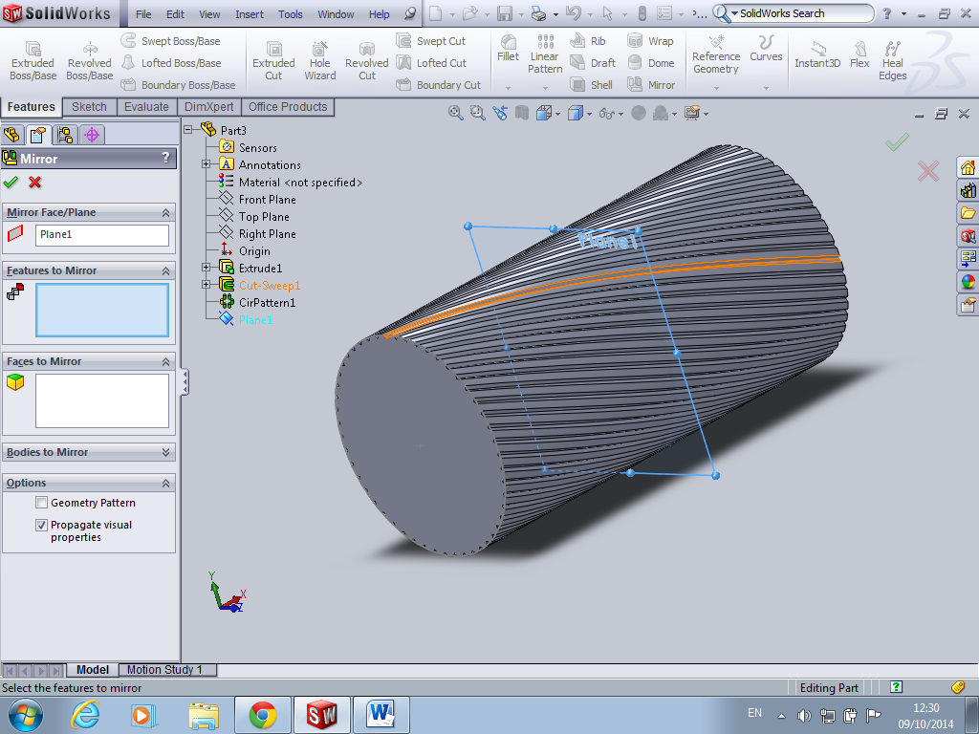
Click on features to mirror box and select circle pattern from design tree
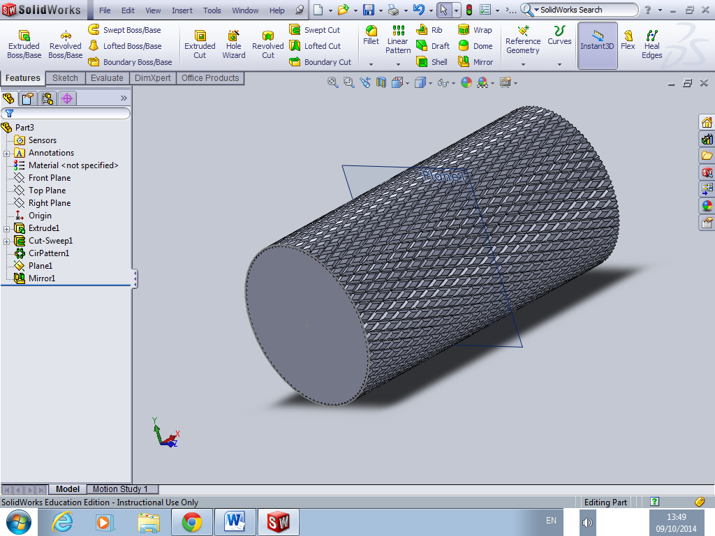
Complete!!!!!

