Introduction to Sweep - Shell Structure part (B)

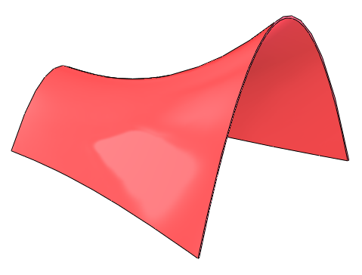



Prerequisite Knowledge Previous knowledge of the following commands is required to complete this lesson, sketching (line construction, dimensioning, parabola), Swept Boss / Base, Surface cut, Shell, apply appearance.

Focus of the Lesson Sweep creates a base, cut, or surface by moving a profile (section) along a path.

On completion of this lesson you will have the used the following aspects:
- Swept a sketch profile along a path to create swept boss / base.
- Examined the keep normal constant option within the sweep feature.
- Surface cut to cut away unwanted elements of the model.
- Shell the structure to required shape.
- Applied a colour.

Commands Used This lesson includes Sketching (line, Smart Dimension, parabola), Swept Boss / Base, Surface Cut, Shell and Appearance.

Where to start? Initially you must consider the following:

What sketch is required for the Profile of the
shell structure?
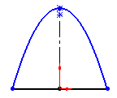
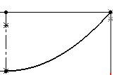
What sketch is required for the Path of the
shell structure?

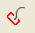
Profile - Parabola

Path - Parabola

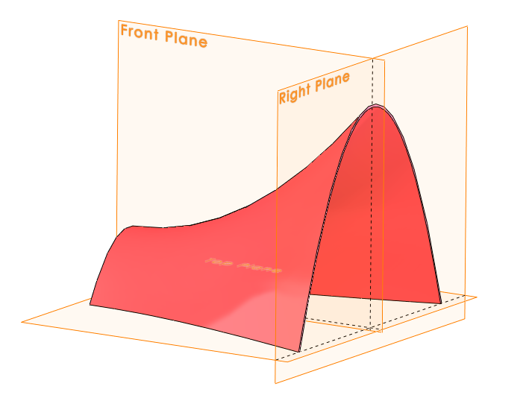
Plane selection On which planes should the sketches for
the Profile and Path be created?

The Profile will be created on the
right plane and the Path on the front
plane as shown.


Note: By using the default planes like this
it simplifies sketching the model.

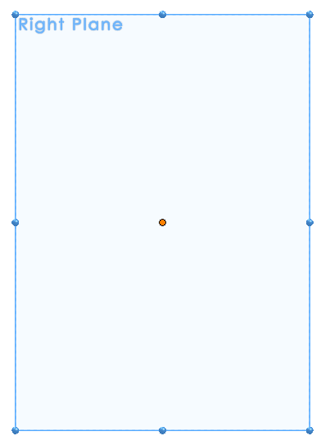

Getting Started Starting with the sketch for the profile of
the sweep.
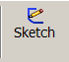
Select Sketch on the features
command toolbar.

Select the Right Plane, the right plane
will move into normal view, as shown.

Save part Save part as Shell Structure.
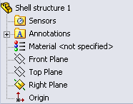

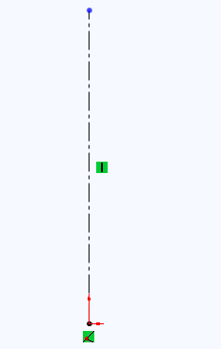
Sketch the Profile Create a sketch of the axis using
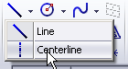
the centerline command.

Note: The centerline is drawn from
the origin.

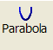
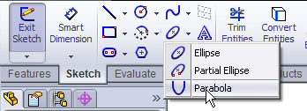
Parabola Command Select Parabola on the sketch toolbar.

OR

Select tools, sketch Entities and
Parabola.
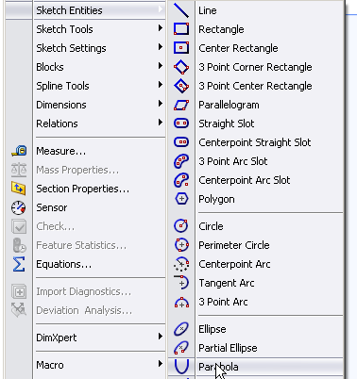

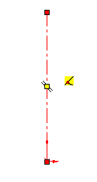
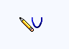
Draw Parabola When selected the pointer changes to

Click to place the focus of the parabola along
the axis.

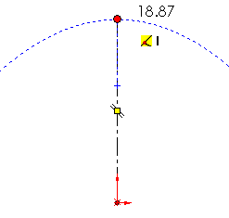
Extend from the focus and select
the vertex of the parabola as
shown.
Vertex

Focus

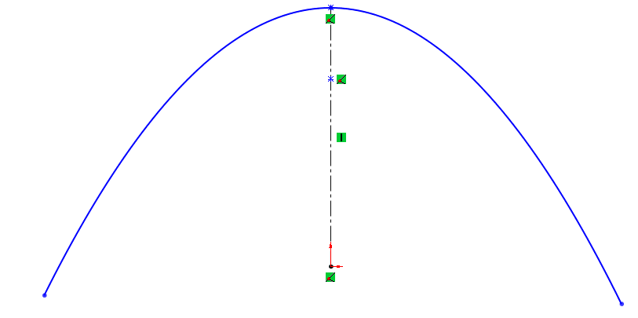
Place the parabola Select the outline of the
parabola as shown.

He ends of the parabola cannot be placed easily at this stage, therefore the ends are drawn in any position and repositioned afterwards.


Click OK button to create the parabola.

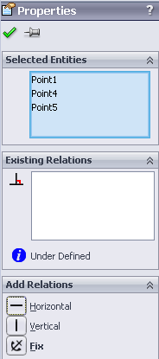

Add Relations Select one endpoint of parabola.
Hold down the control key, choose
the origin and the other endpoint
of the parabola.

On the left hand side choose Horizontal
from the Add Relations dialog box shown over.
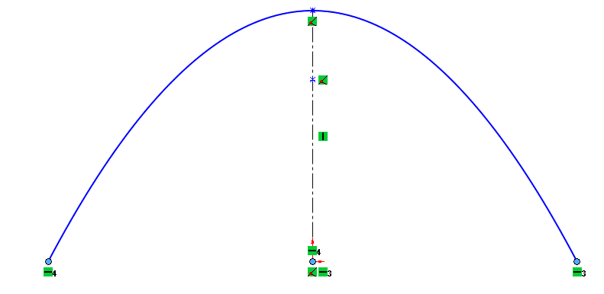

Construct Base Construct base line as shown.
line
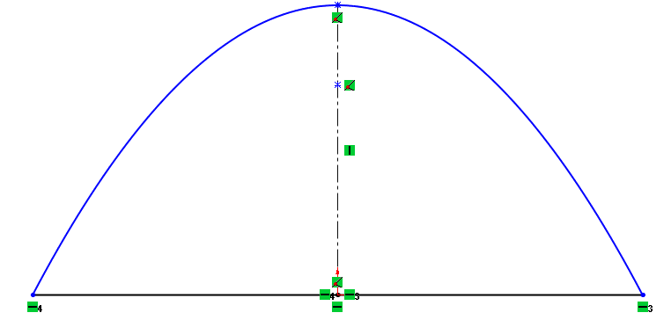

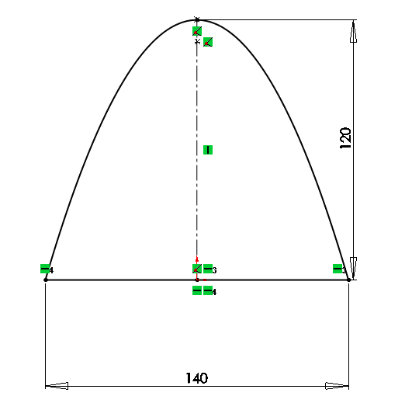

Dimension sketch Dimension sketch as shown.

Note: The sketch is now fully
defined as it is now black.

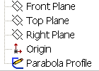
Exit sketch and On completion of the sketch, confirm the sketch.
Rename
Rename the sketch as ‘Parabola Profile’

Sketch the Path Create a sketch, on the front plane for the
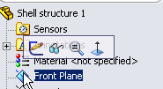
Path.

Select normal-to to get the
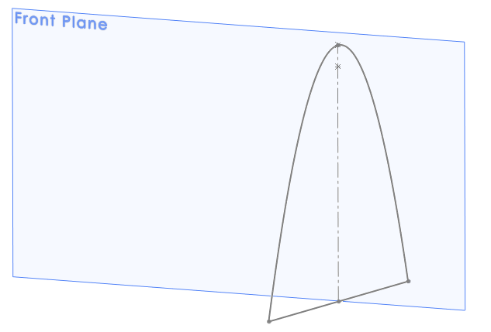
below view of the model.

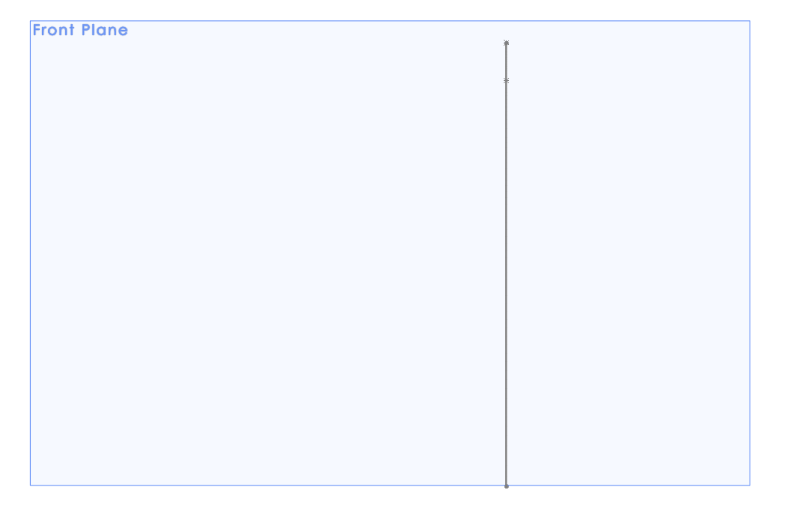

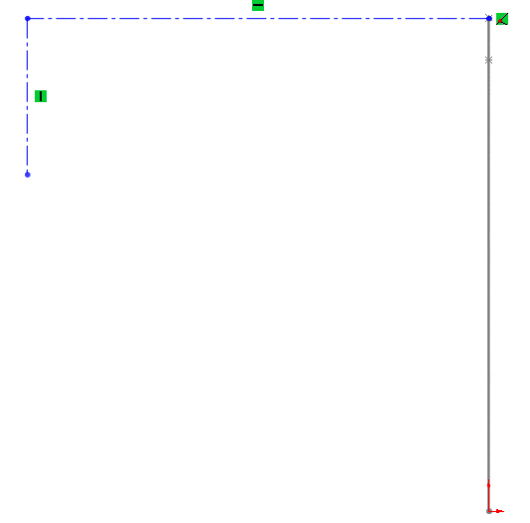

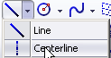
Create sketch Select centerline and
create the sketch show.

Note: the centerline is drawn
from the top of the parabola.

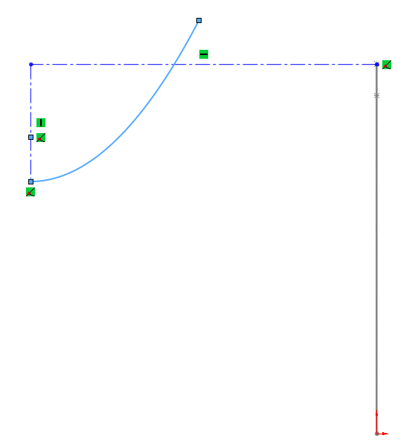

Draw parabola Select parabola and sketch the
axis and ordinate of the second parabola
as shown.

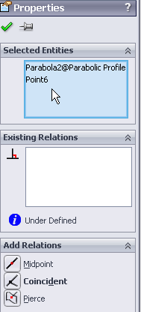
Fix end point of Select the ‘Profile Parabola’ and the endpoint
the parabola of the parabola (path) as shown.

The properties window offers a number of
choices. Choose pierce

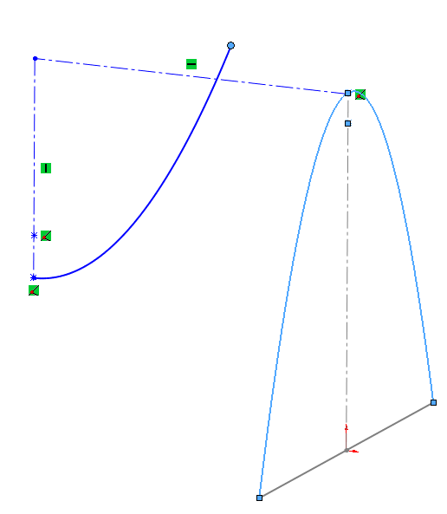

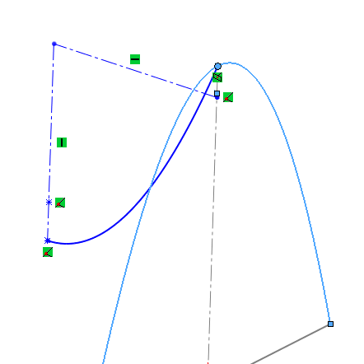

Note: The ordinate of the parabola has been
repositioned as shown.

Add relation Select endpoint of axis line
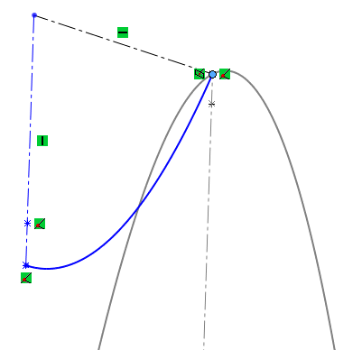
and the vertex of the ‘Profile Parabola’.

Select merge in the
properties window.

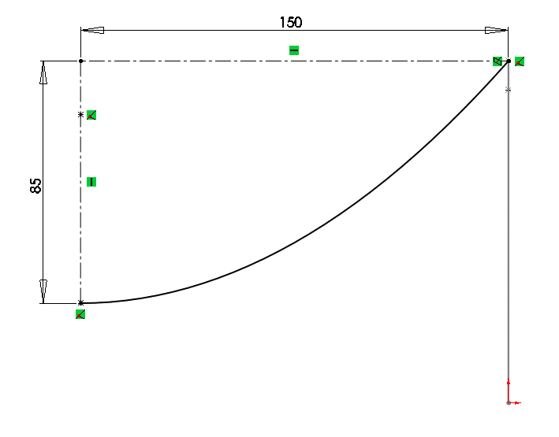

Dimension parabola Smart dimension the parabola
as shown.

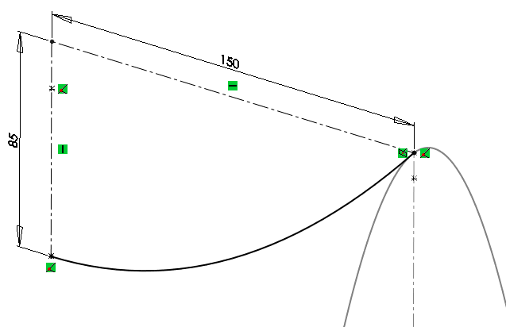

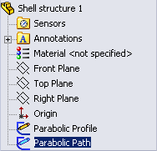
Rename sketch

Swept Boss/Base Select the parabola as the profile and semi-parabola as the path.
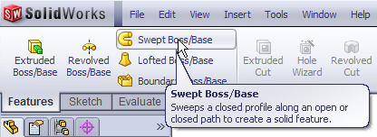
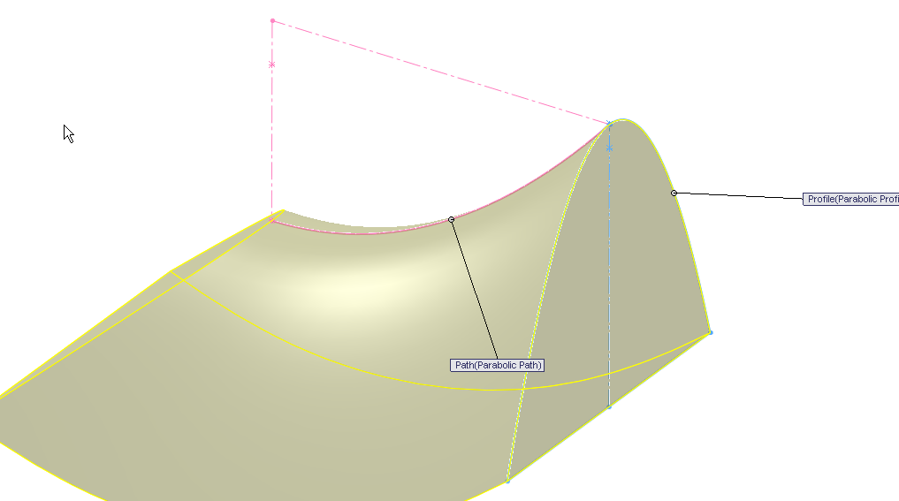

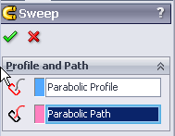

Note: The angle between the profile and the path is maintained as the profile is swept along the path. This is the default condition. Therefore the profile (Parabola Profile) is not maintained in a vertical position, as required in this case. This can be seen in the preview.

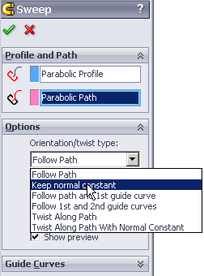

Edit orientation In the FeatureManager of sweep. Select
options. Open the menu under
orientation/twist type:

Select keep normal constant. The preview
will now change as shown below.

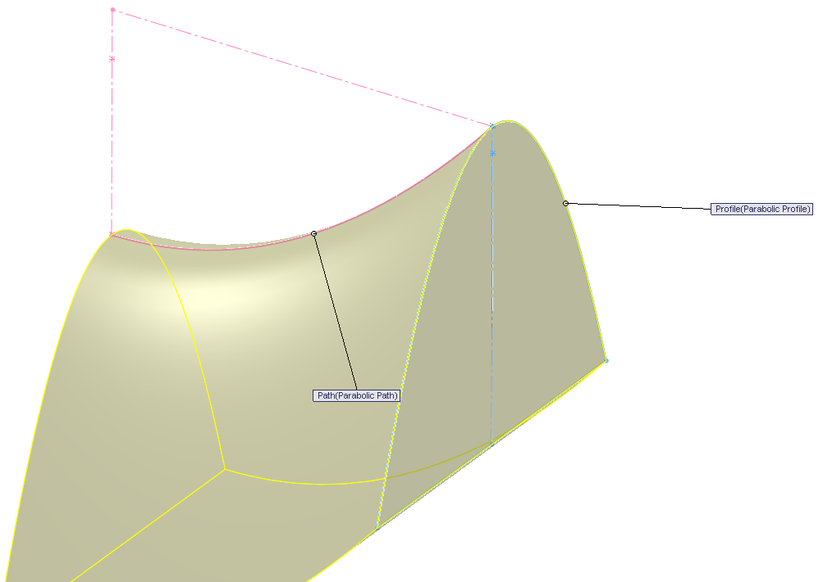

Note: By using the keep normal constant option, the sweep section
remains parallel to the beginning parabola (profile) at all times.

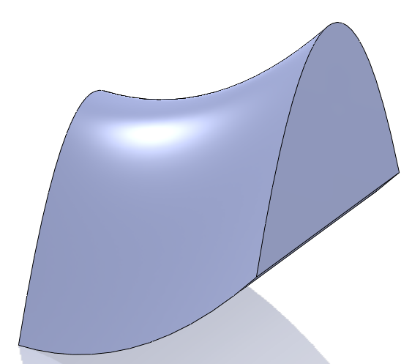

Click OK button to create the feature.

Create horizontal As it is a horizontal cut the top plane
base can be used as the cut surface.
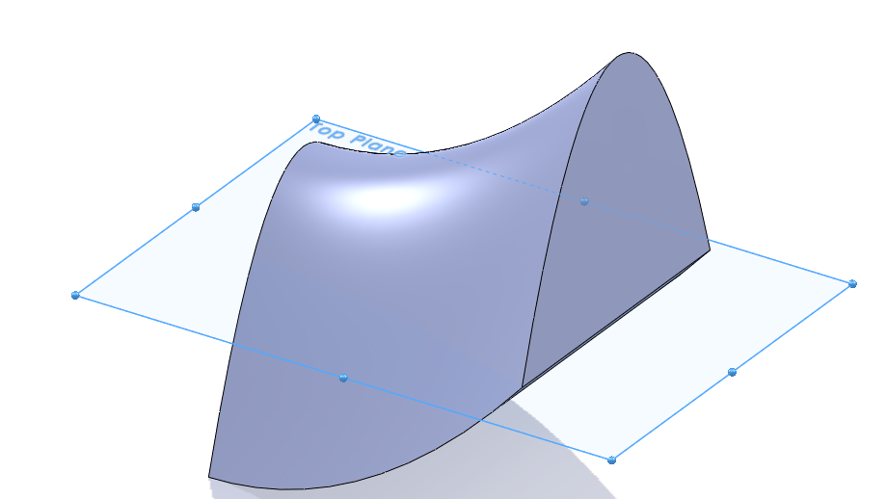
Select the Top plane in the
FeatureManager.

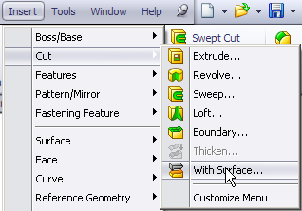
Cut with surface

From the top toolbar, select insert,
cut, with surface.

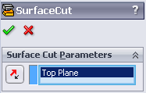
SurfaceCut The featureManager will appear with
the top plane selected as the surface cut
as shown.

The direction of the cut can be selected
using the flip cut option.

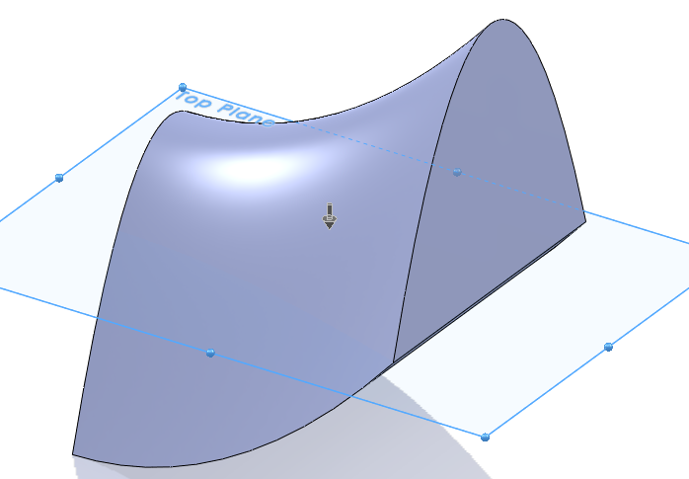

The arrow in the middle of the part indicates
which side of the part is going to be removed
when cut.
Arrow

Click OK button to create the surface cut.
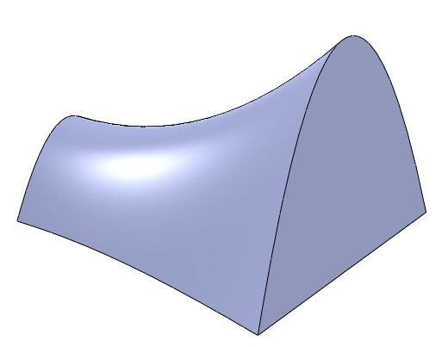

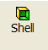
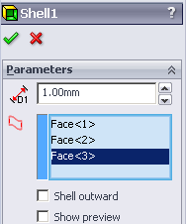
Shell out the part Select shell on the features toolbar.

Select the front surface, bottom surface and
the back surface of the part to shell.

Enter thickness of 1mm.

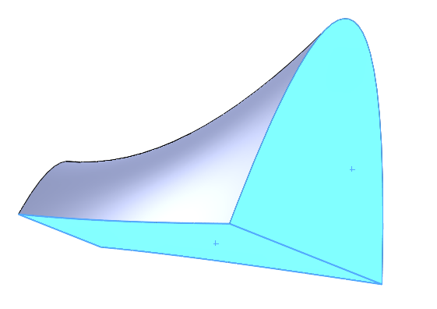
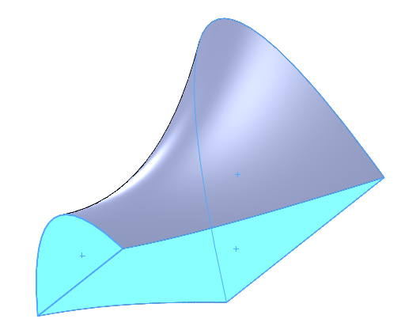

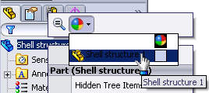
Change appearance Right click on the part name,
select the beach ball and then the Shell
structure.

Add appropriate colour from the palette.
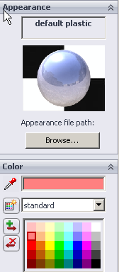

Lesson Complete!

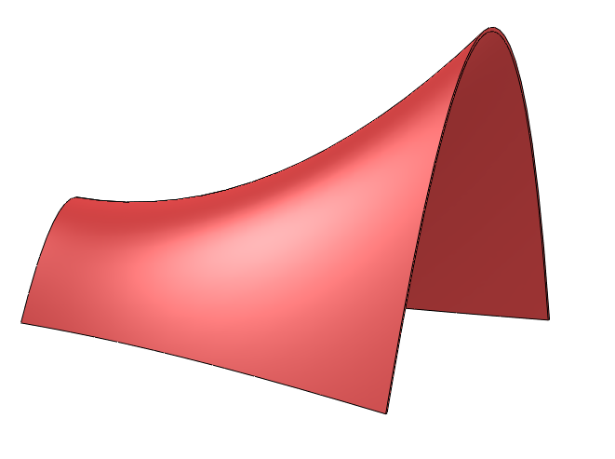

Other Possible Sweep Options

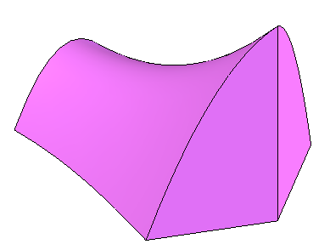
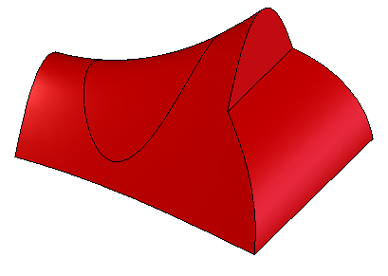

2007 Higher Level 2003 Higher Level

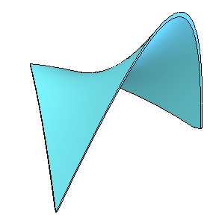
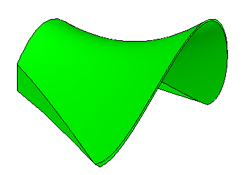

2001 Higher Level 1999 Higher Level



