Introduction to Revolved Cut - A Table Lamp

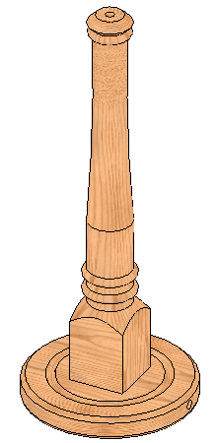

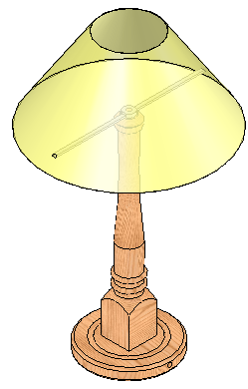

Prerequisite Knowledge Previous knowledge of the following commands are required to complete this lesson, sketching (line construction, arc construction, dimensioning), Fillet, Extruded Boss/Base, Extruded Cut, Revolved Boss/Bass, Textures.

Focus of the Lesson Revolved cut involves removing material by revolving one or more profiles around a centerline.

On completion of this lesson you will have the used the following:
- Selected the correct planes of reference in modelling the part.
- Revolved a sketch contour about an axis to create a revolved cut.
- Revolved a sketch contour about an axis to create a revolve boss/base.
- Revolved a sketch contour about an axis to create a thin revolve.
- Applied textures to the part modeled.

Commands Used This lesson includes Sketching (Centerline, line, Centerpoint Arc, 3 Point Arc, Smart Dimension), Extrude Boss/Bass, Revolved Cut, Revolved Boss/Base, Fillet, Extruded Cut, Revolved Thin feature and Textures.

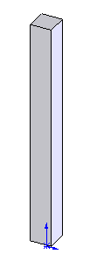
Where to start?
Note: This table lamp would normally be modeled as

an assembly. But has been modeled in this exercise as
a part to demonstrate the following applications:
- Revolved Cut - Lamp Stem
- Thin Revolve - Lamp Shade

We will start with a square section of material for the stem just as if the lamp was being manufactured using a wood lathe.

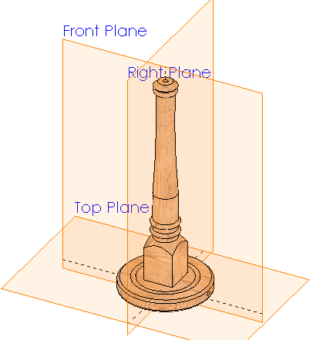

Selecting a Plane The base of the lamp will sit on the Top
Plane with its centre on the Origin. The Front Plane and Right Plane will therefore pass through the axis of the stem.

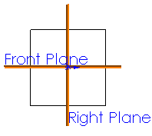

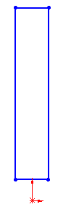
Getting Started In order for this to happen the sketch for the stem will be created on the Front Plane. It can then be extruded using Mid-plane as the end condition.

Open new Part file and save as ‘Table Lamp’.

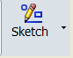
Select Sketch on the Features Command Manager.

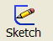
Select Sketch from the toolbar and select the Front Plane.
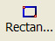
Sketch a rectangle as shown.

Note: The bottom of the rectangle is drawn above the
origin (approx 20mm).

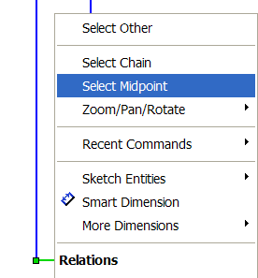
Adding Relations To ensure that the rectangle is centered over the origin a relation must be first created between the two.

Right click on the bottom line of the rectangle
and choose Select Midpoint. Hold down the Control
Key (Ctrl) select the origin.

The Add Relation Property Manager opens.
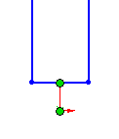
Select Vertical in this property manager
and confirm.

The midpoint of the horizontal side of the rectangle is now located vertically over the Origin.
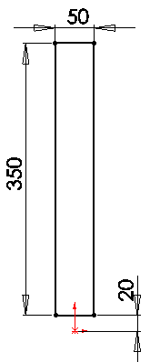

Dimension the sketch Dimension the sketch as shown

Note: The sketch is now fully defined.

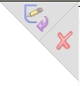
Confirm the sketch.

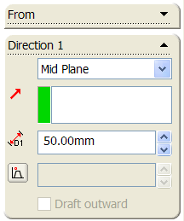
Creating the feature Select Extruded Boss/Bass from the Features toolbar.
Choose the Mid Plane as the end condition and
enter a Depth of 50mm.
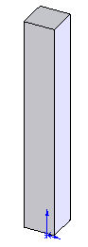


Choose to confirm feature.

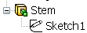
Rename Feature Rename this feature as ‘Stem’

Sketch for Profile Having the block of wood, you now want to cut (revolve) the profile around
the stem.
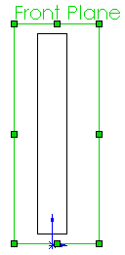
The sketch will be created on the Front Plane in this case.
(It could also be created on the Right Plane because the axis is located on both planes)

Select the Front Plane and choose Sketch from the toolbar.

Select Normal To from the View Toolbar to get
a perpendicular view.

Note: Having a perpendicular view makes it easier
to create a accurate sketch.
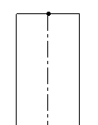

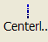
Centrelines Select centerline and create a central axis
from the mid-points of the rectangle as shown.

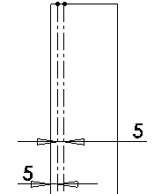

Create two centerlines vertically on
the rectangle as shown.
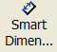
Smart dimension the centerlines as shown.

Note: When defining a sketch, it is best practice to sketch, add relations, and finally add dimensions. However, because of the complexity of this sketch the dimensions are indicated as the sketch develops to aid clarity.

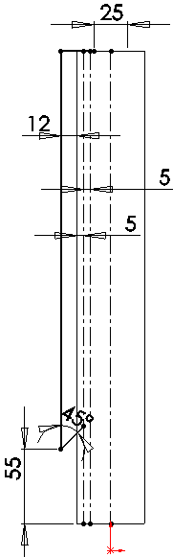

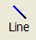
Create profile Select Line and create the sketch as
shown.

Note: The 45⁰ line is drawn to the first centerline
as shown.
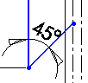

Create circular Zoom into the bottom area of the sketch.
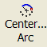
beads

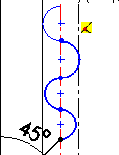
Select Centerpoint Arc and construct four semi circles along the centerline as shown.

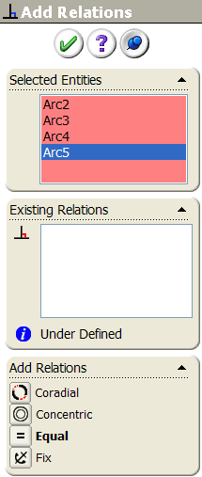

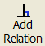

Add Relations Select Add Relations and select the 4
semi-circles.

Choose Equal from the Add Relations
dialog box.

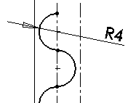
Dimensions Dimension the semi circles, radius 4mm.

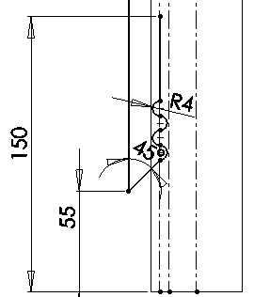

Construct line Construct a vertical Line along the
centerline as shown.

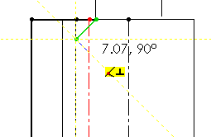

Create top of lamp Zoom into the top area of the lamp.

Create the sketch using Line command
up to the centerlines as shown.

Note: The perpendicular relation between
the two lines is created automatically using
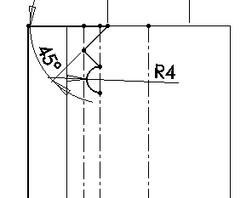
the inference line as shown.

Dimension Sketch Using the Centerpoint Arc command create
the semi-circle. Smart Dimension the
sketch as shown.

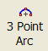
Complete Sketch Select 3 Point Arc from the sketch toolbar.
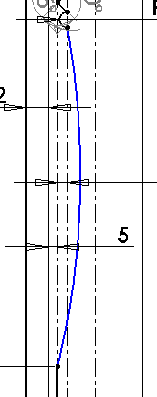
End Point

Construct a 3 Point Arc by choosing the end
points of the 2 beads and select any mid point
for the arc as shown over.

Smart Dimension the Arc radius 1000mm.

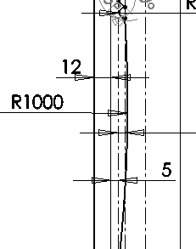

End Point

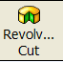

Creating the feature Choose Revolved Cut from the features toolbar.

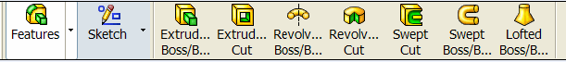

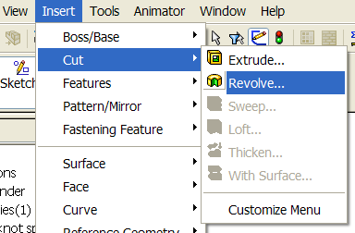
OR

From the top toolbar select Insert, Cut
and choose Revolved Cut.

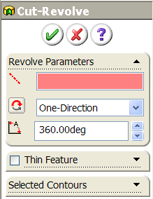
Revolved Cut Feature The PropertyManager appears
Settings with these default conditions.

Analyzing the
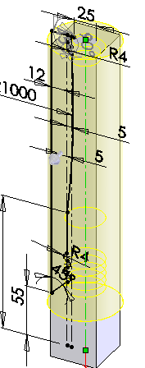
PropertyManager
Axis of Revolution = Axis of Revolution

In this case SolidWorks cannot recognized
which of the centerlines created in the sketch
is the Axis of Revolution. Therefore the axis
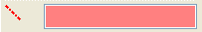
is currently empty
Axis of Revolution

Select the correct centerline in the sketch. The
model will now give you a preview of the revolve
cut as shown. Notice the axis of revolution window
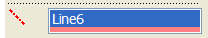
now appears like this

Note: Change the model view to isometric or trimetric
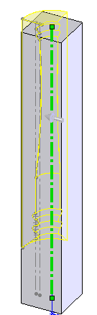
to get a better image of the feature.

Revolve Angle Enter Angle = 90⁰

The revolved cut preview will alter as shown.
Where the sketch profile will cut rotate through
90⁰.

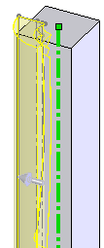

Revolve Direction Select Reverse Direction. The Revolved Cut
will now revolve in the opposite direction as
shown.

Revolve Type Select Mid-Plane in Revolve Type window as shown.
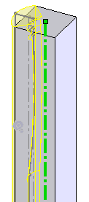
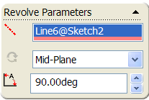

The sketch profile will now revolve
cut through 90⁰ Mid-Plane within the
block of wood.

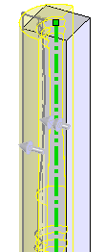

Select Two-Direction in the Revolve Type window.

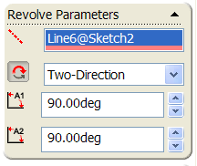

Now you are given the option to enter two angles

The Revolve Cut will now cut in two direction at any
chosen angle as shown.

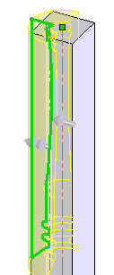
Selected Contours Allows you the select a single or number of
individual sketch profiles which are to be
revolved about the axis of revolution.
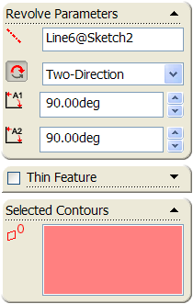

Sketch (contour)

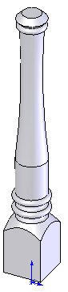

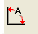
Enter Required Enter Angle = 360⁰.
Parameters

Select One-Direction in
Revolve Type window

Click OK button to create the feature.

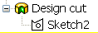
Rename Feature

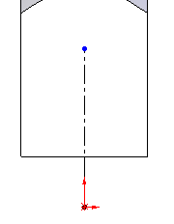
Creating the base Create a sketch on the Front Plane for the base.

Select centerline and construct an Axis of Revolution
from the origin as shown.

Complete Sketch Select the line command and complete the sketch using the dimensions
shown for the base.
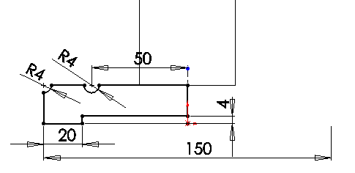

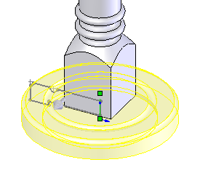
Revolve Boss/Base Revolve the sketch using the centerline as
axis of revolution and sketch as contour
profiles. Revolve angle of 360⁰.

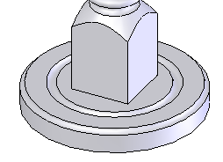

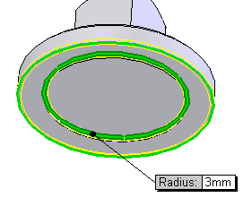

Add fillets Add 3mm fillets to the bottom edges shown.

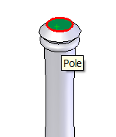
Create hole for flex Create a sketch on the top surface of the stem.

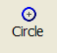
Select circle and construct a circle using the
Origin as centre

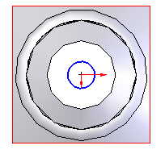
Note: Select Normal To for a
perpendicular view of top surface.

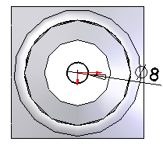

Dimension circle Dimension the circle – diameter 8mm.

Extruded Cut Extrude cut the sketch using the Offset from
Surface end condition.
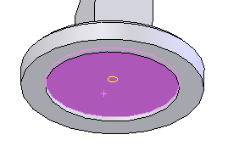
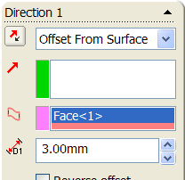

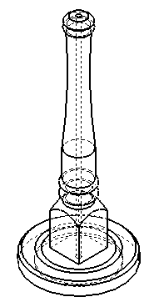
Select the bottom surface of the base as the Face to offset
from as shown and Depth from surface of 3mm.

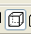
Display Style Select Hidden Line Visible from the view toolbar.
The view of the lamp will now change as shown.

Note: The position of the hole can be now seen.

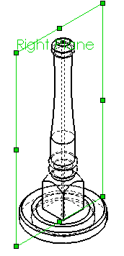
Create the hole We need to create a hole in the base for the flex.
through the base The vertical face of the base is circular. We cannot create a sketch on this surface.

The lamp has been created with the planes
of reference through the axis of the stem. Therefore the Right Plane or the Front Plane can be selected
to create the circular cut through the base.

The sketch will be created on the Right Plane.

Construct Circle Create a sketch, on the Right Plane using the dimensions shown.
A centerline is first constructed from Origin for the centre of the circle.

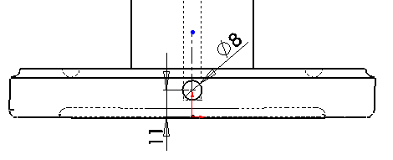

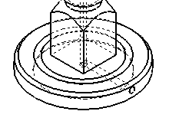
Extruded Cut Extrude Cut the sketch using the
Through All end condition to
Create the hole.

Lamp is now complete

Lets look at how to model the lamp Shade

The Lamp Shade
Note: This exercise could also be modeled as an assembly.

How to create the The lamp shade is a thin surface or feature which is
Lamp Shade revolved about an axis of revolution. Using the
Revolved Boss/Base this can be easily created.

What plane will the sketch be created on?

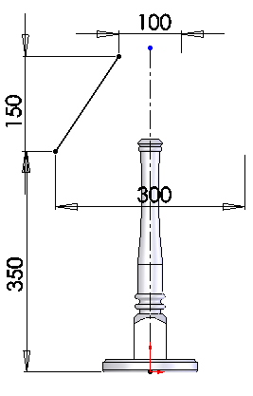
Sketch Lamp Create a sketch on the front plane
Shade using the dimension shown.

Note: The sketch for the lamp shade
is just a line.

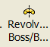
Thin Revolve Select Revolve Boss/Bass.
The following message will pop up.
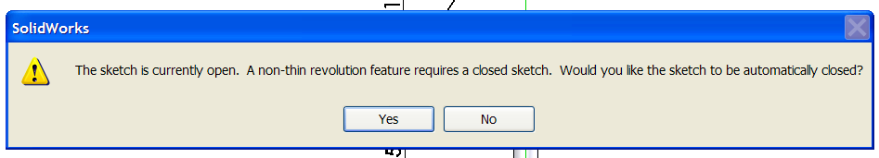

The programme gives you the opportunity to close the sketch. If you select ‘Yes’ (to close the sketch) a fustrum of a cone (solid feature) will be created.
In this case you want the sketch left as a line so that a thin feature is created.

Select NO in the dialogue box.
Note: When using Revolve Boss/Base to model a part the sketch profile
must be closed (complete).

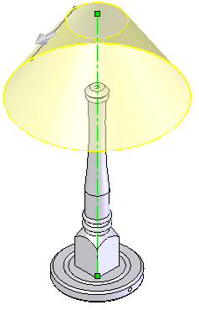
Enter Parameters Thin Feature will now be automatically
be ticked. Enter thickness of 1mm.

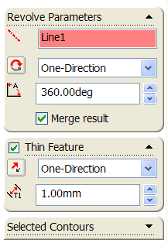

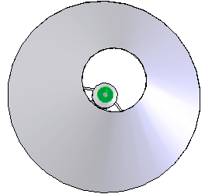
Shade Supports Select top surface of the lamp
pole as shown.

Note: Select the Normal To view.

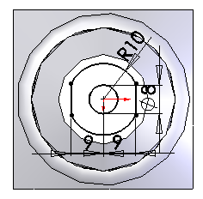
Sketch supports Create the sketch shown, using circle
and line commands.

Dimension the sketch as shown

Note: Use power trim to remove unwanted
lines in sketch.

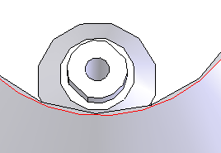
Extrude Boss/Base Extrude the sketch using the
Blind end condition and a
Depth of 6mm.

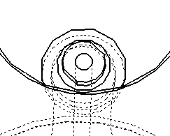
Display Style Change the display style to
Hidden Line Visible

Note: This allows you to see through
the lamp shade to the support already
created.

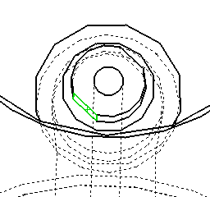
Sketch Radial Support Select the face surface as shown

Create rectangular sketch about the
the centerline as shown.

Smart Dimension as shown.
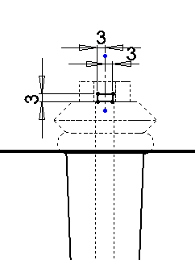

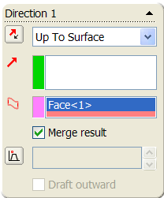
Extruded Boss/Base Extrude the sketch using the Up
To Surface end condition.

Select the inner surface of the shade and
click correct direction in the
FeatureManager window

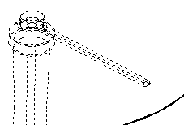

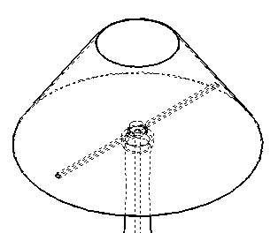

Repeat Extrude Repeat the procedure on other side of
centre piece for other arm.

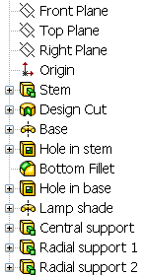

Rename Features Each of the features in the FeatureManager
should be renamed as shown. This allows each
feature / sketch to easily identified later if necessary.

Add Texture Right hand click on the feature Stem,
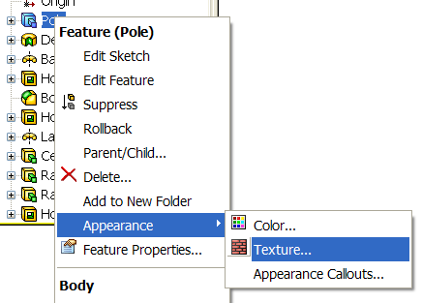
select Textures.

Scroll down through the SolidWorks
Textures to Wood.

Select Pine inside the wood menu as
shown
Select OK

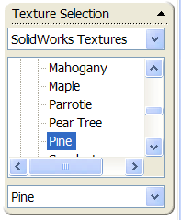

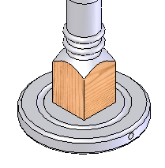

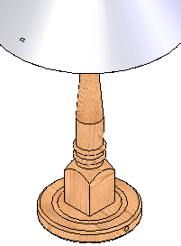
Add textures to Repeat the above procedure for each of these
other features features
- Design Cut
- Base
- Bottom Fillets
- Hole in Stem
- Hole in Base
Note: As the lamp has been created as a part, and not
as an assembly, each individual feature will have to be
textured separately.

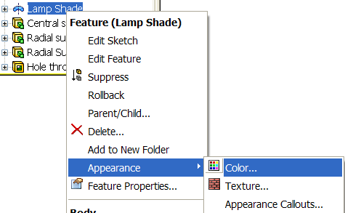
Add appearance Right hand click on the feature Lamp
to lamp shade Shade, select Appearance and Color.

Choose an appropriate colour from
the colour swatch.
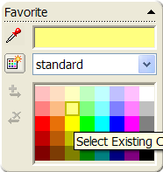

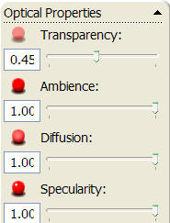
Make lamp shade Scroll down the Property Manager to Optical
Transparent Properties.

Adjust the Transparency setting to 0.45
as shown. Select OK

Add Texture to Add an appropriate Texture to
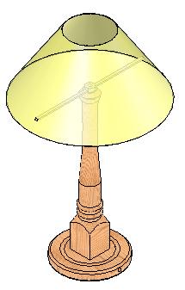
Radial Support the radial support.

Lesson Complete!

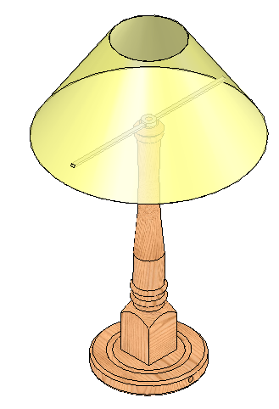

Other Possible Revolved Cuts Options
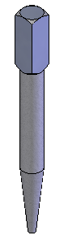

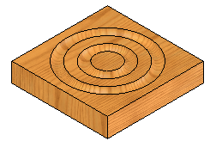
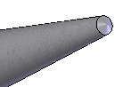
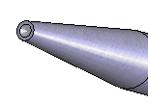

Center Punch Nail Punch Architrave Block
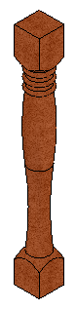

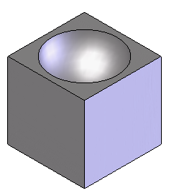
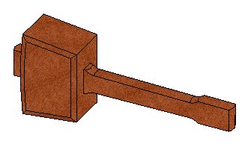

Table Leg Block Mallet

Where is the Revolved Cut feature used in the mallet?

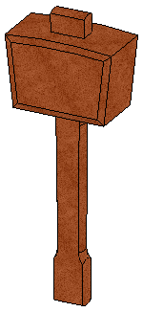

The shaping on the handle is created using the revolved
cut feature as shown.

Sketch Profile


