Introduction to Loft - Hyperboloid of Revolution Part (B)

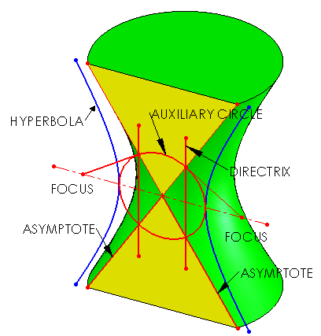

Prerequisite Knowledge Previous knowledge of the following commands is required to complete this lesson, sketching (line construction, circle, add relations, dimensioning, convert entities), Inserting Planes, Loft Boss/Base, Cut with surface.

Focus of the Lesson Loft creates a solid feature by making transitions between profiles.

On completion of this lesson you will have the used the following aspects:
- Inserted reference planes to create the model.
- Created a Hyperboloid of Revolution (double ruled surface) using the Lofted feature.
- Surface cut to locate the Asymptotes of the Hyperboloid of Revolution.
- Covert entities to locate the Directrix and locate the Focus of the Hyperbola.

Commands Used This lesson includes Sketching (line, circle, Smart Dimension, covert entities), Inserting Planes, Loft Boss / Base, Cut with surface and Appearance.

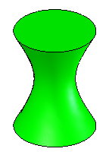
Where to start? How is a Hyperboloid of Revolution created?

There are numerous ways in which a Hyperboloid of Revolution can be
modelled in SolidWorks. Here are a few of the methods which can be used:

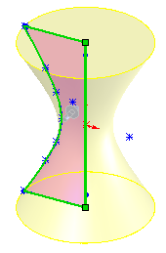

- Revolve a Hyperbola about an axis.

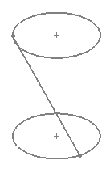

- Loft a circle along one of the straight line
elements.


Note: The straight line element could also be revolved
about a central axis. But SolidWorks will not allow
an open sketch to be revolved.

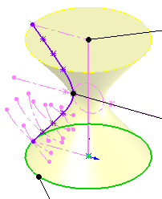

3. Sweep a circle along a Hyperbola guide curve.

Note: For the purpose of this exercise the focus will be the lofted method.

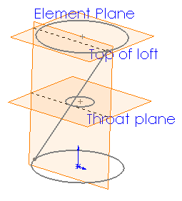
Getting started What sketches are required to
create a lofted Hyperboloid of Revolution?
The following sketches are required:

- Base Circle
- Top Circle
- Straight Line Element

Note: A sketch plane is required for each of
these sketches.

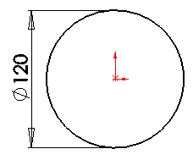
Sketch the base Create a sketch of the base circle on
the Top Plane as shown.

Note: The circle is constructed with it
center on the origin.
Origin

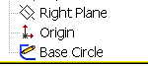
Exit sketch and On completion of the sketch, Exit the sketch
Rename
Rename the sketch a “Base Circle”

Save part Save part as Hyperboloid of revolution.

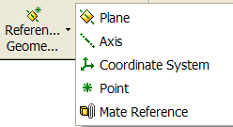
Insert sketch planes Select Reference Geometry and Plane on the
features toolbar.

OR
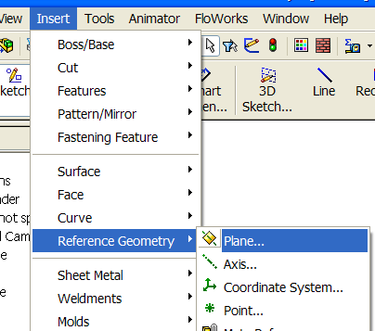

Select Insert, Reference Geometry and
Plane.

Plane parameters Choose the top plane as the reference entity and
set the distance as 80mm.

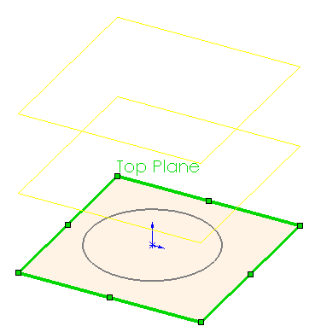
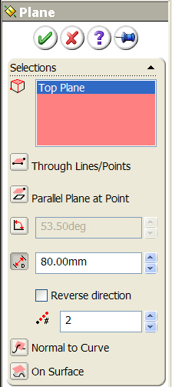
Preview of Planes

Number of planes to create

Set the number of planes to create to 2 planes.

Note: Only one of these planes is required to model the Hyperboloid
of Revolution. The middle plane is being setup to locate the throat circle
later in the exercise.


Click OK button to create the plane

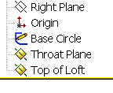
Rename Plane Rename the planes as shown.

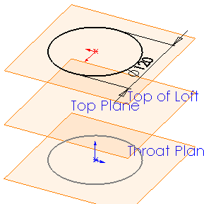
Sketch the top Create a sketch of the Top circle on
the Top of loft Plane as shown

Note: The center of the circle is
collinear with the origin.

Insert plane for Select Reference Geometry and Plane .
straight line element Choose the front plane as the reference entity and
set the distance as 30mm.

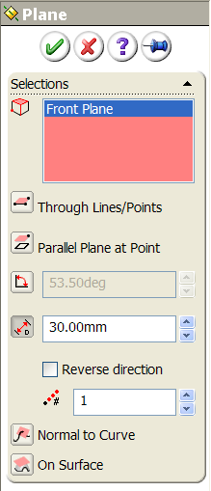
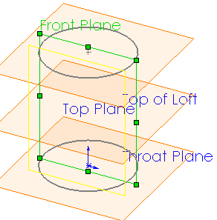

Click OK button to create the plane.

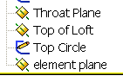

Rename plane Rename the plane “element plane”

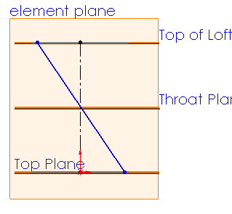
Sketch straight line Create a sketch on element plane.
element
Construct a centerline and one
straight line element between the
base and top circles as shown.

Note: The straight line element must now
be constrained to the circles to construct
the surface.

Constrain the element The straight line element must be fixed centrally between the circles.
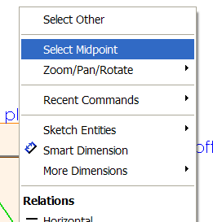

Right click on the straight line element and choose
Select Midpoint. Holding down the control key
choose the centerline.

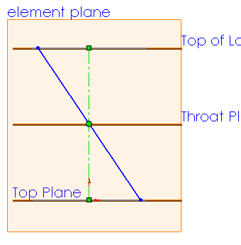

On the left hand side choose Coincident
from the Add Relations properties.

Midpoint of the element is fixed onto the centerline.

Note: As there are so many sketch planes currently active. Hide some of
the sketch planes to get a clear view of model.

Add Relations between Add relation to endpoint of the element and
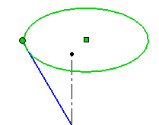
sketches the top circle.
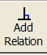
Select Add relations from sketch toolbar.

Select the endpoint and top circle. Choose Pierce
from the add relations window.

Note: The two sketches are now intersecting each other.

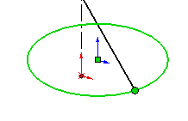
Add Pierce relation to the endpoint of the element
and the base circle as shown.

Pierce the element through the base circle

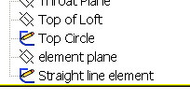
Exit sketch and On completion of the sketch, Exit the sketch
Rename
Rename the sketch a “Straight line element”

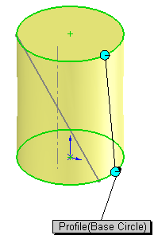
Lofted Boss/Base Select the base circle and top circle as the
profiles.


Guide Curves Selection Select Single Contour Select to select the guide curves.
Select the Guide Curves window and choose straight line element as shown.

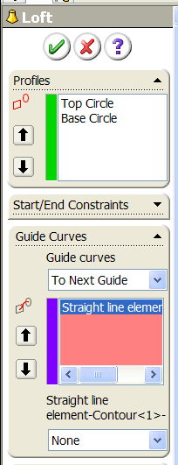
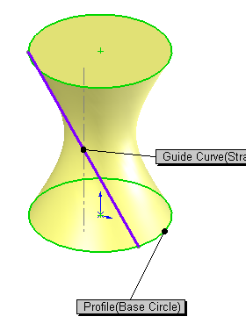

Click OK button to create the Hyperboloid of Revolution.

Locate Asymptotes Create a vertical cut through the Hyperboloid of Revolution to find the
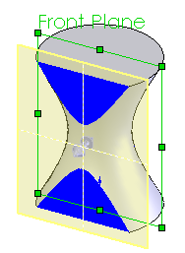
Asymptotes of the Hyperbola.

Where can this vertical section taken?

Vertical Section Plane

A vertical section can be taken in any position
about the Hyperboloid of Revolution once it is taken tangential to
the throat circle as shown to locate the Asymptotes.
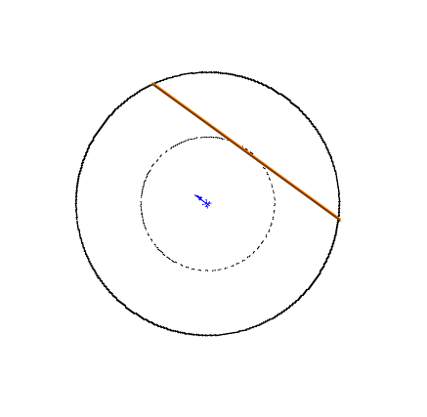
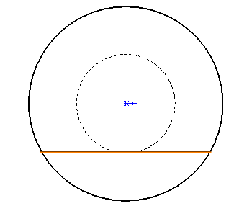
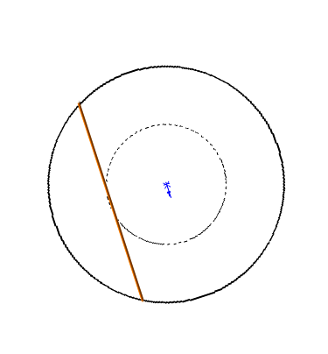

Throat Circle
Vertical Section

Note: In this case a vertical section plane parallel to the front plane will
yield the best view. Therefore having already setup a plane in this position
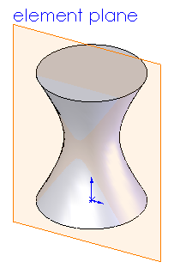
element plane, this can be used.

Create vertical Select the Element plane in the
section plane FeatureManager.

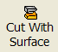
Cut with surface Choose Cut with Surface, from the features toolbar.

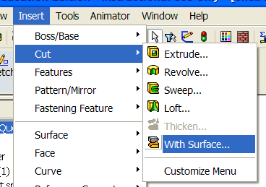
OR

From the top toolbar, select insert,
cut, with surface.

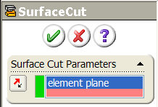
SurfaceCut The featureManager will appear with
the element plane selected as the surface cut
as shown.

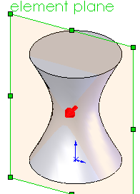
The direction of the cut can be selected
using the flip cut option.

The arrow in the middle of the part indicates
which side of the part is going to be removed
when cut.

Cut in this direction

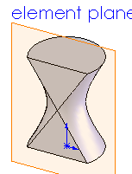

Click OK button to create the surface cut.

Note: The two straight line elements located are used to created the double
ruled surface (Asymptotes).

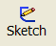

Locate the Hyperbola’s Select front plane in the featuremanager and sketch

Rotate the Hyperboloid of Revolution
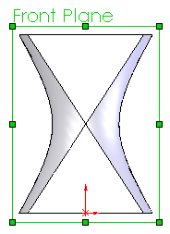
into a perpendicular view
as shown.

Note: The Double Hyperbola can now be seen
along the edge of the Hyperboloid of
Revolution.

Hyperbola’s

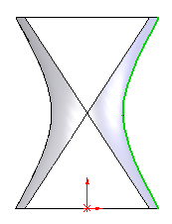
Locate Hyperbola Select one of the Hyperbola’s as shown.


Select Convert Entities from the
sketch toolbar.

OR
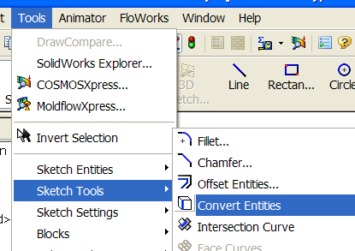

Select Tools, Sketch Tools and Convert
Entities.

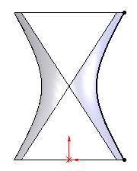

This has now created a sketch of the Hyperbola
on the front plane as shown.

Fully defined sketch of Hyperbola

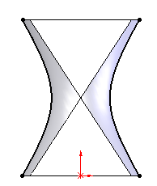
Repeat the procedure for the Hyperbola on the
opposite side.

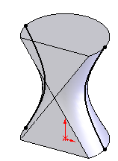

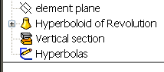
Exit sketch and On completion of the sketch, Exit the sketch
Rename
Rename the sketch a “Hyperbolas”

Locate throat circle The throat circle is located tangential to the vertical section and passes
through the vertices of the Hyperbola’s. Having a plane already setup
in this position the Throat Plane, the circle can be created on this plane.
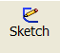
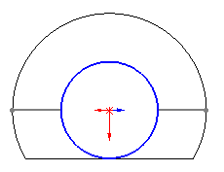
Select the Throat plane and sketch

Create the circle as shown tangential to the
vertical section.

Note: Select normal to to see the
plane as an edge view.
Vertical Section

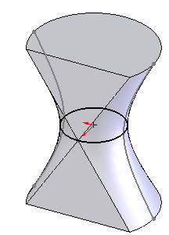
Add Relation Add a tangent relation between
the circle and vertical section fix circle to
correct position.

Analyse the geometry On which plane would the geometry of the Hyperboloid of Revolution be
constructed to get the best results/view. In this case the front plane or element
plane (vertical section) would be the most suitable. As each have some of the
necessary geometry (Asymptotes and Hyperbola curves). In this case the
element plane will be the most suitable, as the details can be clearly seen.

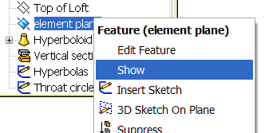
Show plane Show the element plane.

Select the plane in Featuremanager and
right click. Select Show to display the plane
in the graphics window at all times.

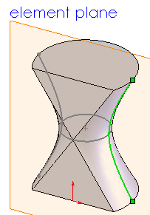
Locate Hyperbola’s Create a sketch on the element plane for
the Hyperbola’s.

Note: The double Hyperbola’s have been
located already on the front plane son they can
converted to the element plane.

Select one of the Hyperbola’s on the front plane
as shown.

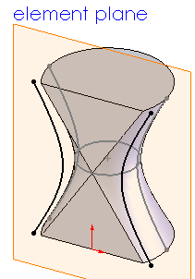

Select Convert Entities from the sketch
toolbar.

The Hyperbola has now be converted onto the
element plane as shown. Repeat procedure for other
hyperbola.

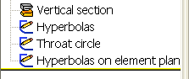
Exit sketch and On completion of the sketch, Exit the sketch
Rename
Rename the sketch a “Hyperbolas on element plane”

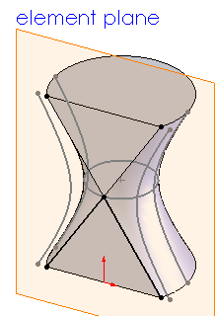
Locate Hyperbola Create a sketch on the element plane again
asymptotes for the Hyperbola’s properties.

Use convert entities to locate Asymptotes
lines as shown.

Asymptotes

Note: We have now created two sketches on
the element plane therefore these sketches can
be coloured separately


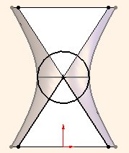
Locate Auxiliary Circle Construct a circle using intersection
of asymptotes as center and drawn up to
hyperbola.
Add tangent relation
between circle and hyperbola.

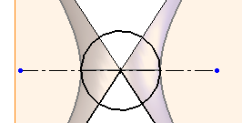
Draw axis Construct axis using centerline as shown.

Locate directrix Construct directrix using line command.

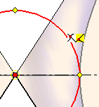
Point of intersection
The directrix is located through the
intersection of the auxiliary circle and
asymptotes vertically.

Moving the mouse over the point of
intersection until the intersection symbol
appears. Select and draw directrix.

Note: The directrix line could be drawn vertically and relations added.
But SolidWorks does not allow the selection of the intersection point within the
add relation command.

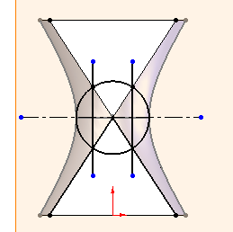

Draw directrix Draw directrix lines as shown.

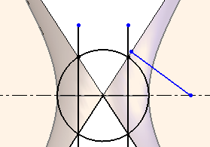

Locate focus points Construct a line perpendicular from the
asymptote to the axis as shown to find
the focus.

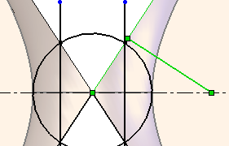
Add relations Add a perpendicular
relation between the asymptote and line.

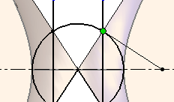
Add a merge relation
between endpoint of line and
intersection of asymptote and directrix
as shown. To find focus on axis.

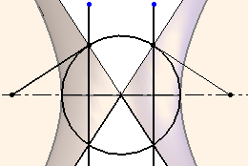
Focus

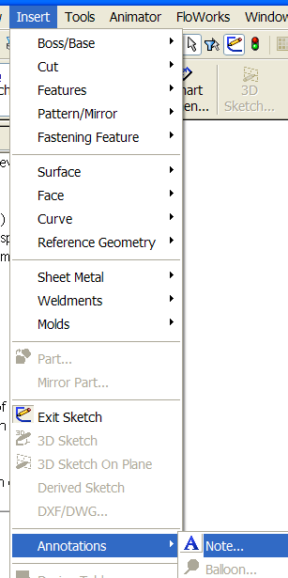
Label details Select Insert, Annotations and Note.

Label the details of the Hyperbola
construct as shown.

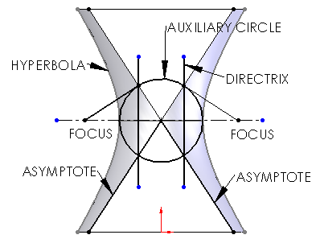

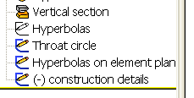
Exit sketch and On completion of the sketch, Exit the sketch
Rename
Rename the sketch a “construction details”

Add appearance to Right hand click on the feature Hyperboloid of Revolution select
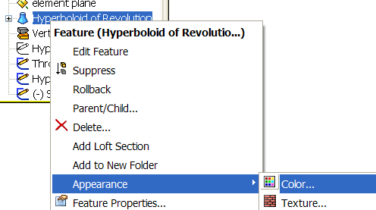
Hyperboloid of Appearance and Color
Revolution

Choose an appropriate colour from
the colour swatch.

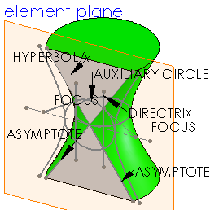

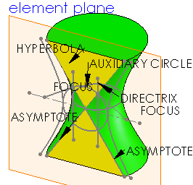
Add appearance to Add appropriate colour to vertical section
vertical section as shown.

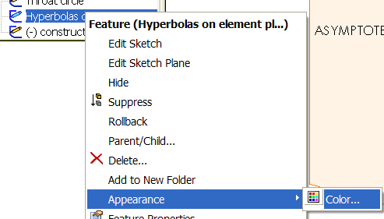
Add appearance to Right hand click on the sketch
sketches Hyperboloids on element plane select
Appearance and Color

Choose appropriate colour.

Repeat the procedure for the construction detail sketch.

Lesson Complete!

Other Possible Loft Options

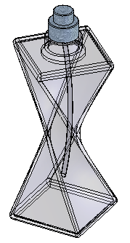

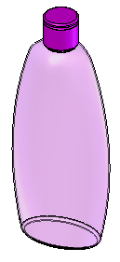

Johnson’s Baby Shampoo Aftershave Bottle

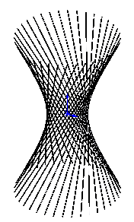
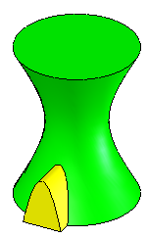

Hyperboloid of Revolution with door Hyperboloid of Revolution – circular array
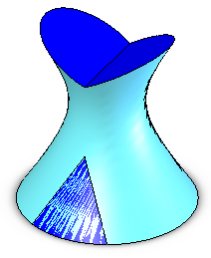

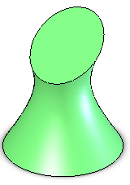

Hyperboloid of Revolution 1998 Hyperboloid of Revolution 2004



