Creating Layer of the same body shape

Start off by drawing something simply like a cylinder

Highlight the face you want to copy.

Once this face is highlighted choose KNIT on the surfaces tab…
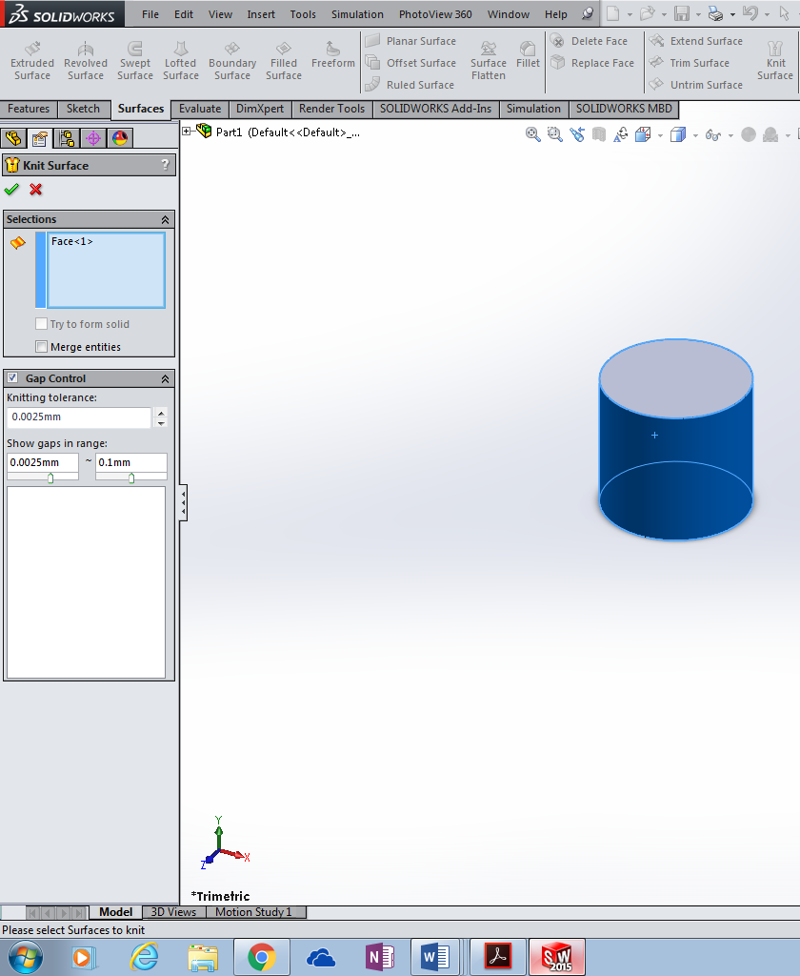
Make sure you untick the merge box here…….
Highlight the outside surface again….. this time select Thicken on the surfaces tab….

You can decide if you want the layer to be on the inside of the cylinder or outside by playing around with left middle or right line boxes… plus you can give a size you want to thicken it….

Again it is vital you untick the merge box…

Now the cylinder looks to have been increased however if you look through your work bar on the left hand side of your screen you can make the inner cylinder disappear…. By doing the following…

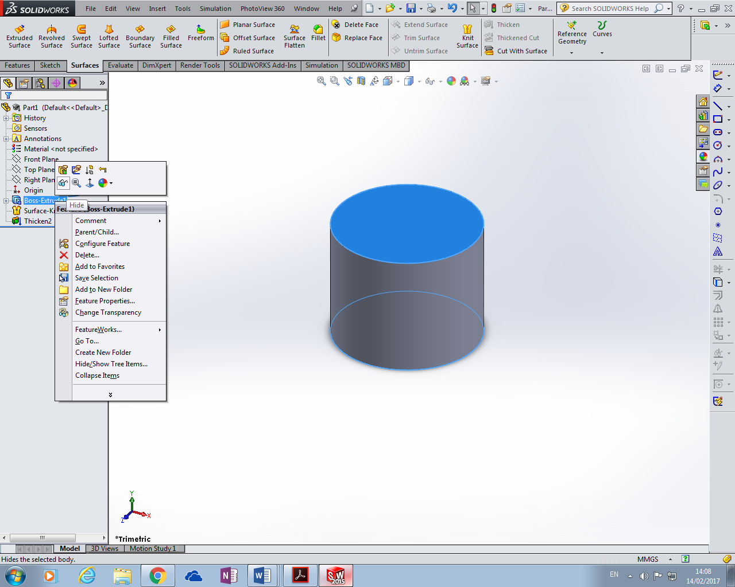

Choose hide here….

You can subtract one from the other if you wish using thickened cut or just delete face then ensure you save…..

