Chocolate Bar Exercise

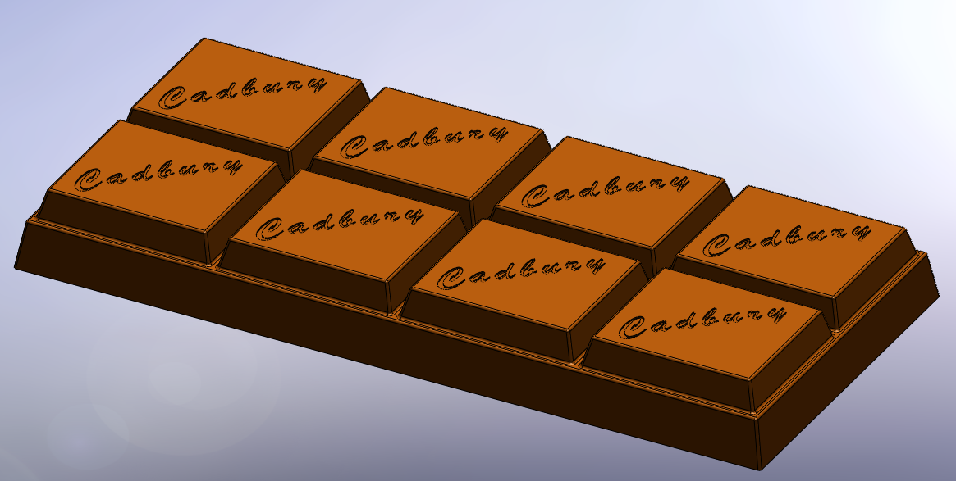

Commands Used This lesson includes Sketching, Extruded Boss/Base(with draft),
Extruded Cut, Fillet and Linear Pattern.

Getting Started Create a sketch, on the top plane using the dimensions shown. Position the sketch such that the origin is in the lower left hand corner.

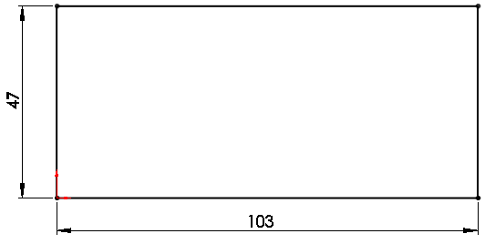

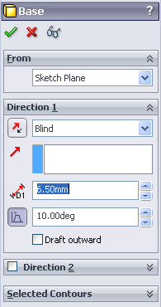

Creating the feature Select Extruded Boss/Base
Choose the Blind option from the list and
enter a Depth of 6.5mm.

Adding draft Draft will slope the edges of an extruded boss.

Where to find it Select Draft On/Off, enter a value of 10º.
Choose OK

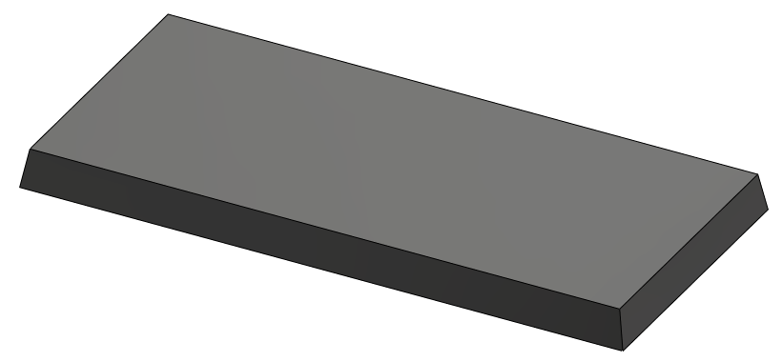

Adding the top blocks
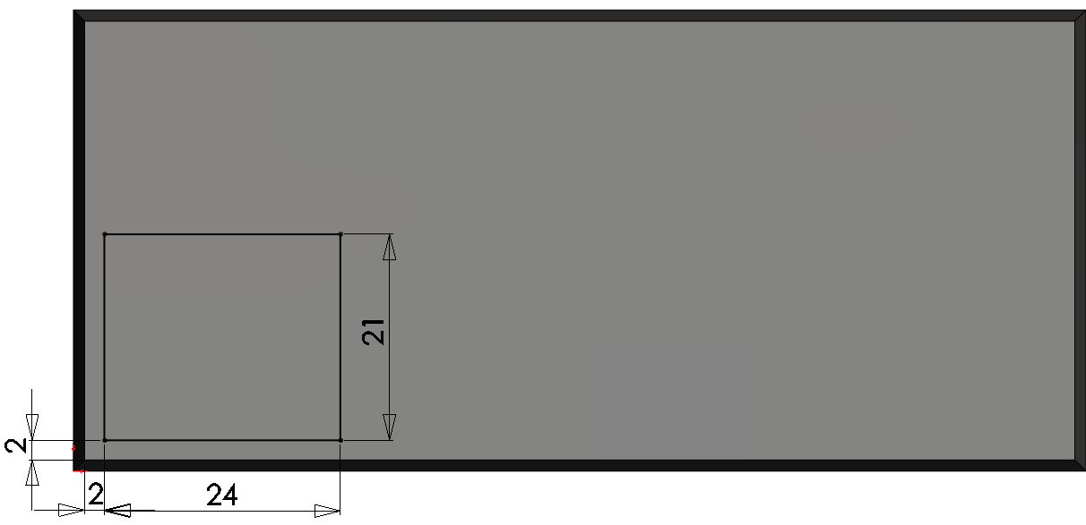
Creating the sketch Create the rectangular sketch
on the top face and dimension
as shown.


A sketch may be defined using
edges and features which are
not on the active sketch plane.

Extrude Boss/Base Extrude Feature Settings

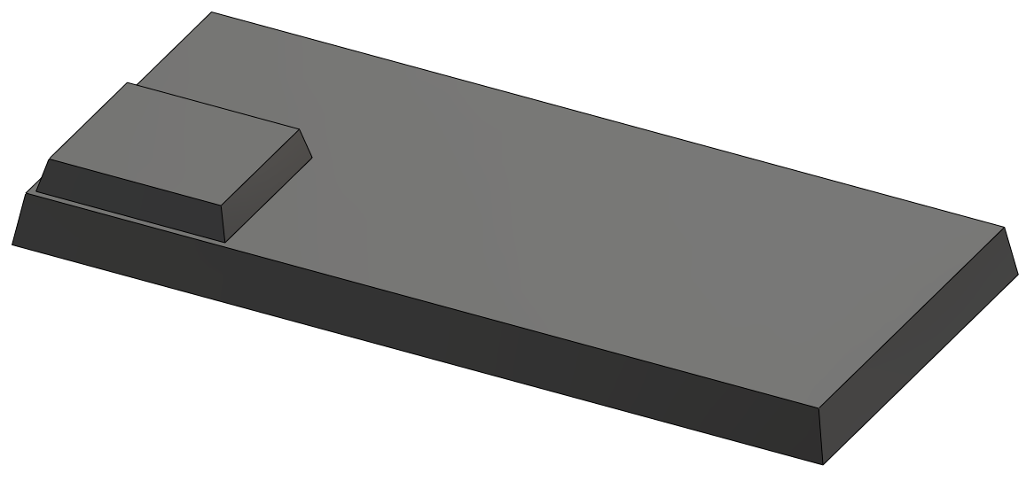
End Condition = Blind
Depth = 4mm

Draft Angle = 15º

Choose OK

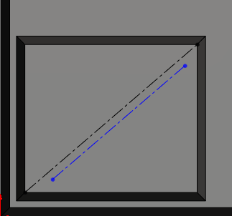
Text
Generating the text Create a sketch on the top surface of
the chocolate block.
Add a diagonal line as a Centerline.
Draw another line on the surface and
add a Paralell Relation.

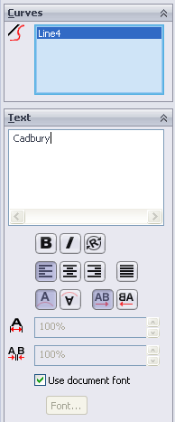
Adding Text Select Tools/Sketch Entities/Text
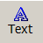
or select text from the sketch
toolbar.

Select the parallel centerline as the text guide

Type Cadbury into the text window

Use Document Font will be selected by
default. Deselect by clicking on the tick
next to it. Font is no longer greyed out.

Font Details Choose Font and make the selections as shown. Select OK

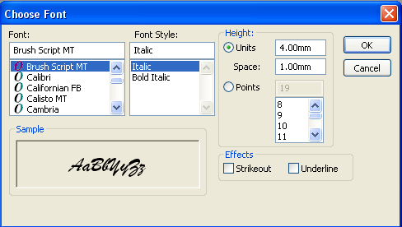

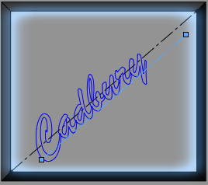
Text Spacing SolidWorks will not extrude a sketch with
overlapping lines or regions. Script
text utilises such overlapping regions, as
shown opposite. To eliminate these, the
spacing between the letters must be increased.
Increasing spacing Increase the spacing to 120% to
eliminate the overlapping regions, as shown
below.

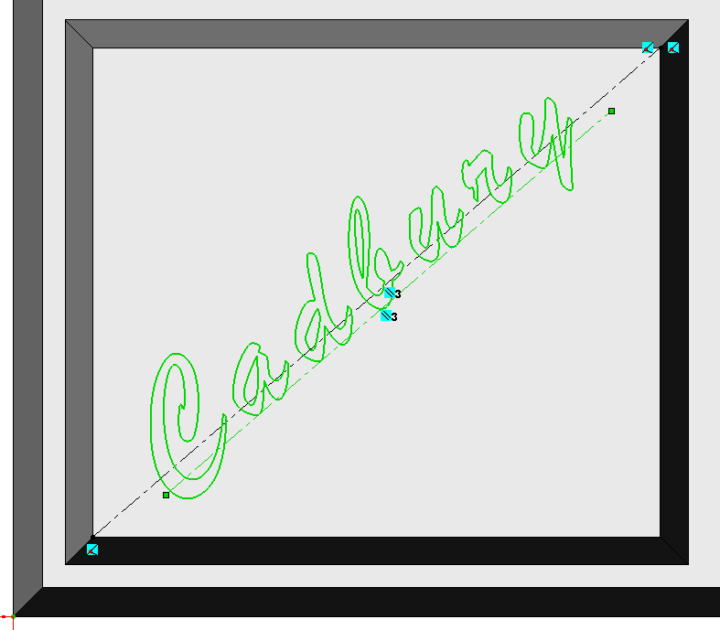
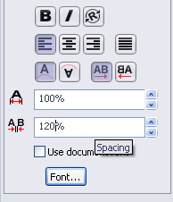

Choose OK
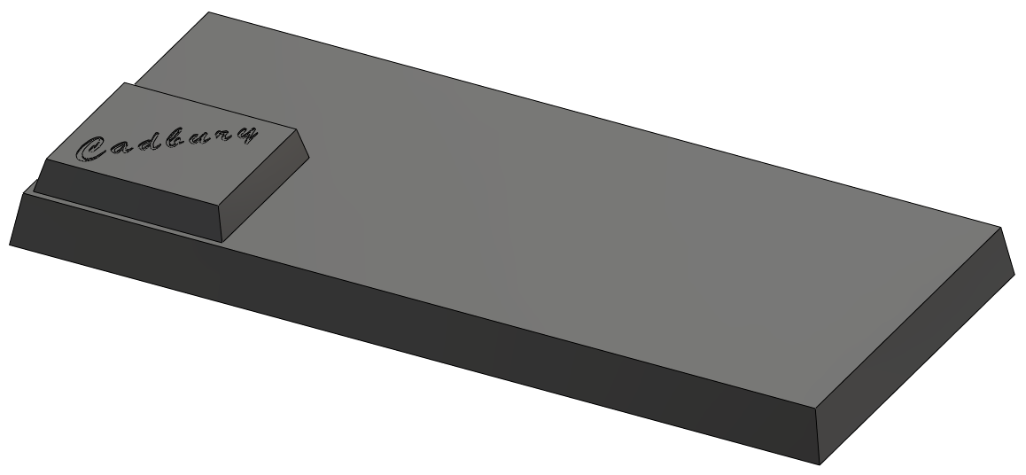
Creating the feature Extrude Cut the
text to a depth
of 0.2mm

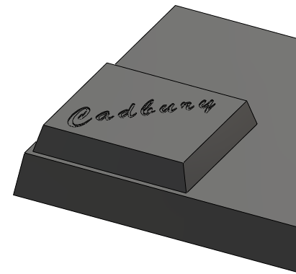
Fillet Create a fillet of 0.35mm radius on all
of the edges of the top block.
Create a second fillet of 0.35mm on
the edges of the lower block, excluding
the base edges.
Note These fillets were created individually
because, the edges of fillet1 must be copied to form the
remaining top blocks whereas the edges of fillet2 are not.
If they were formed in one feature it would prove more difficult to
select them.
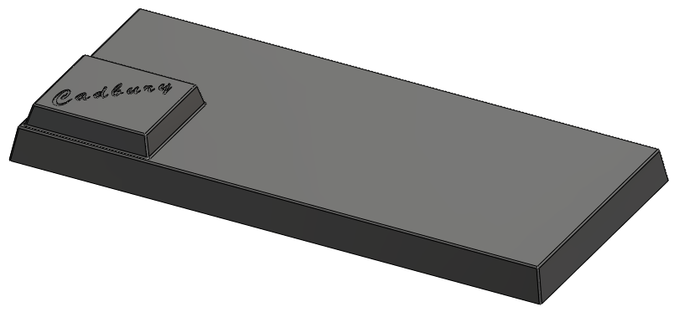

Patterns Patterns are used when creating multiple instances of one or more features.

Linear Array This can be a one or two directional array.

Where to find it On the features toolbar click the Linear Pattern tool 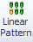
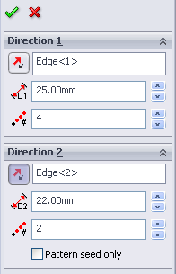
Select the linear edge of the base
in front as Direction 1, with a
Spacing of 25mm and
Number of Instances = 4
Select the linear edge on the side
as Direction 2, with a Spacing of 22mm
and Number of Instances = 2
To select Features to Pattern click in the
Features to Pattern Window, it turns pink.

Flyout Feature Expand the Feature Manager Design Tree by
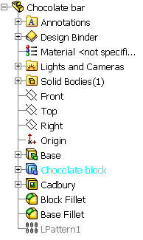
Manager Design clicking on the plus ‘+’ sign next to the file name
Tree on the top left hand side of the Drawing Area.

It expands as shown on the right.

Choose the Chocolate block, extruded text and
the fillet1 features as features to pattern

A preview is displayed in the drawing area.
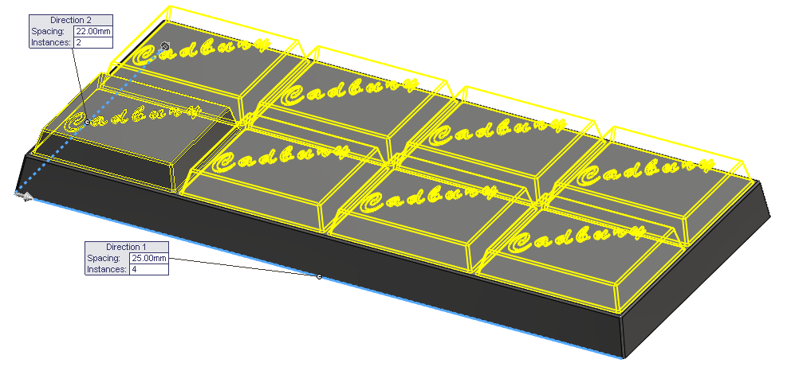

Reverse Direction If necessary, select Reverse Direction next to each Pattern Direction, to set the direction shown.
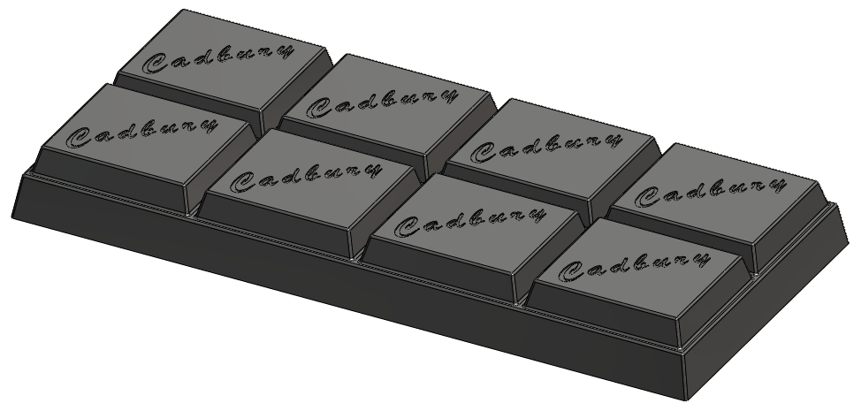
Choose OK

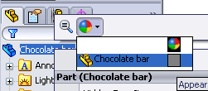
Edit Colour With the cursor positioned over the file
name at the top of the Feature Manager
Design Tree, right click Select Appearance

Choose an appropriate colour from the colour swatch. Select OK

Lesson Complete!



