Digital Camera Exercise

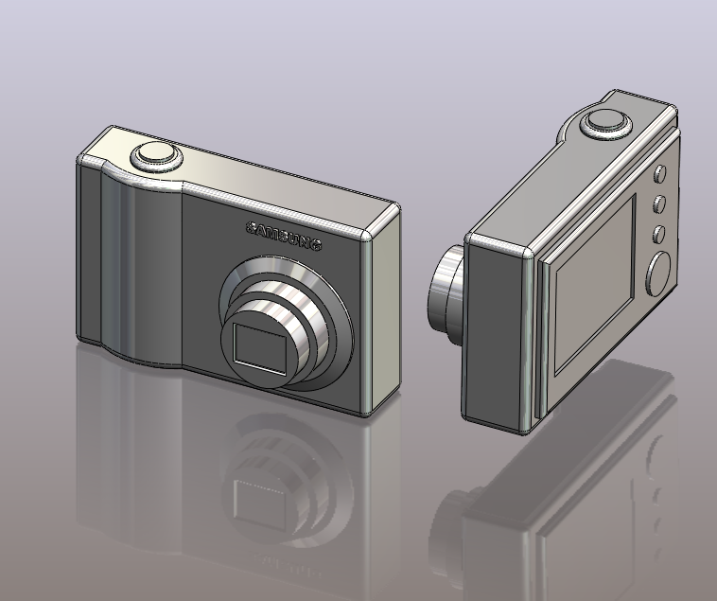

Commands Used This lesson includes Sketching, Extruded Boss/Base, Extruded Cut, Fillet, Chamfer and Text.

New Part Click File, New on the standard toolbar. Select Part from the New SolidWorks Document dialog box. Select OK.

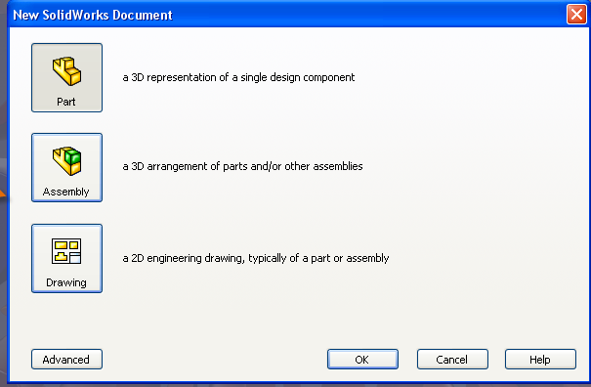

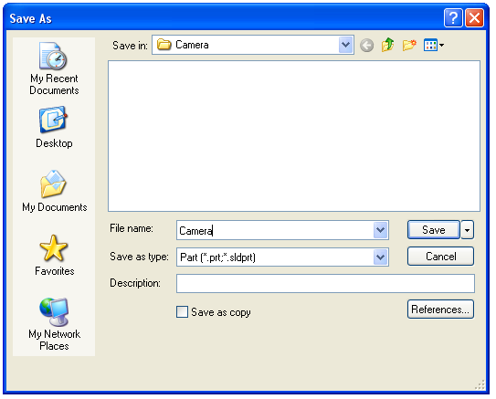
Saving the Part Select File, Save as on the standard toolbar. Save the part in your chosen location as camera. A part is identified by its extension *.sldprt . It is recognised as good practice that a new folder would be used for each project created. Continue to save periodically throughout the exercise

Where to start? The first feature of the part to be created is the body of the camera. This will be an extruded feature based on a sketch.

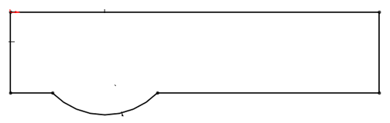
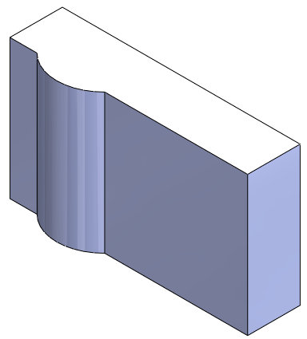

Sketch to generate the feature

Extruded Feature
Getting started
Select the top plane from the feature manager the sketch command will appear. The selected plane will rotate to a normal to view and the origin will be displayed.

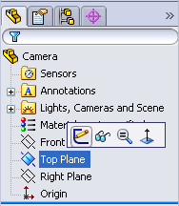

Creating a sketch Using the Rectangle command, create a sketch, from the origin as shown, approximately 100mm x 25mm. Ensure that all lines are either horizontal or vertical indicated by the relations.
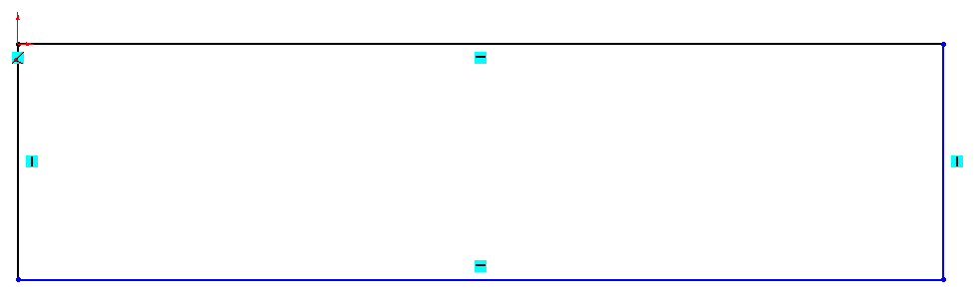

Select the Circle command from the sketch toolbar. Choose a point coincident with the back line as the centre and drag as shown below, click to form the circle.

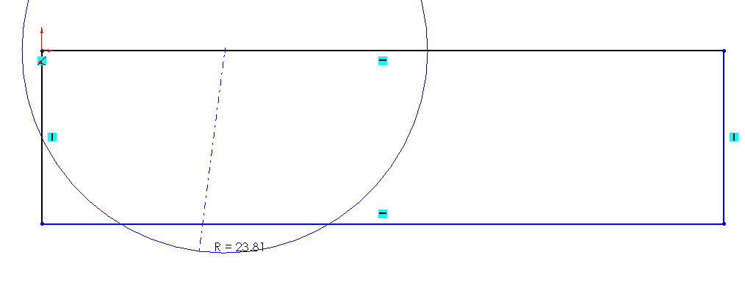

Using the Trim Entities 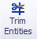 command, select the areas of the circle and the front edge to be removed.
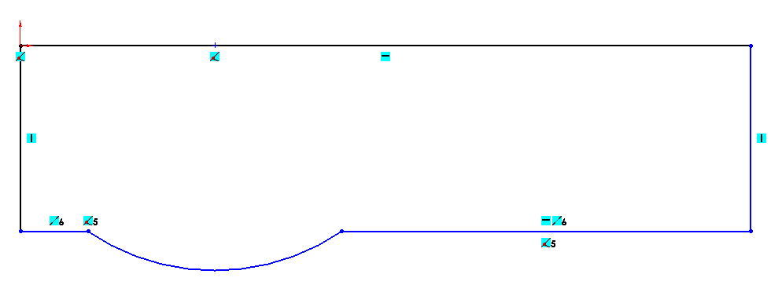

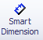

Dimensioning the Select Smart Dimension from the sketch toolbar and dimension
sketch sketch as shown below.
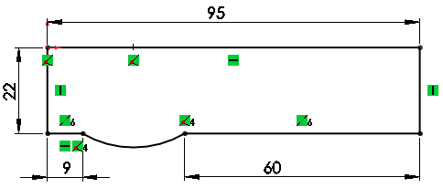

Note – The sketch changes from blue to black when it is fully defined.
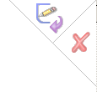
To exit the sketch, select the sketch tool on the confirmation corner, sketch will be saved. Selecting
X will discard changes made.

Creating the feature Select Features from the Command Manager. The Features toolbar has now replaced the Sketch toolbar along the top of the screen

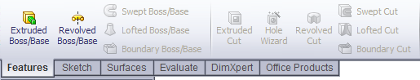

Choose Extruded Boss/Base, the sketch rotates to a trimetric view with a preview of the proposed extrude.

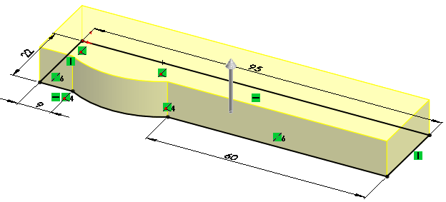
Extrude Feature Settings

End Condition = Blind

Depth = 62mm

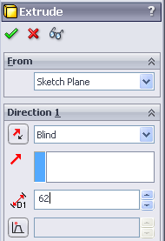
Click OK button to create the feature.

Alternatively select the from the
confirmation corner

Completed feature This is the first completed feature of the
part. The sketch has been absorbed into
the EXTRUDE 1 feature in the Feature
Manager.
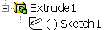


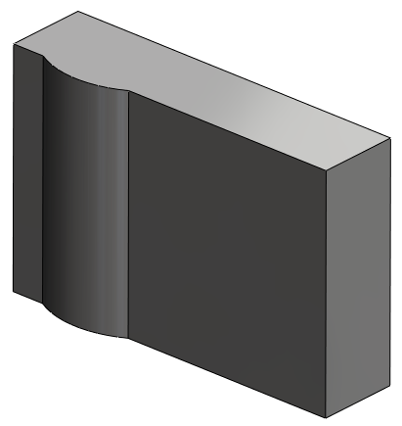
Renaming a feature Select the feature in the Feature Manager
Tree. Press F2.

The feature name will be
highlighted with a flashing cursor on
the right hand side. Type the new name to
replace it. (Camera Body)

Adding the camera lens

Sketching on a face Select Sketch on the Command Manager. Sketch toolbar replaces the feature toolbar at the top of the screen.

Select the front face of the camera and select sketch.
Select Normal to from the Heads Up Toolbar

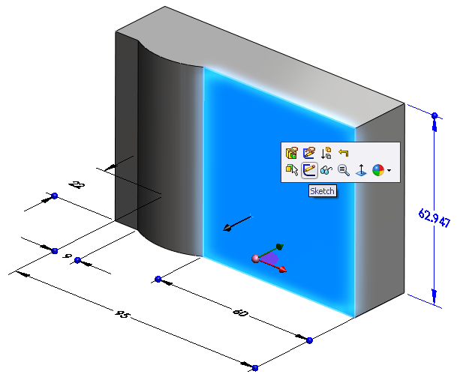
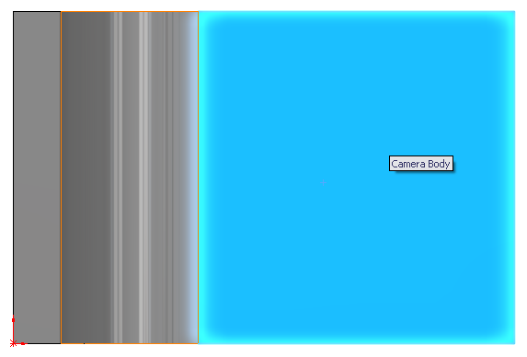

Creating the sketch Sketch a circle on the face and dimension as shown.

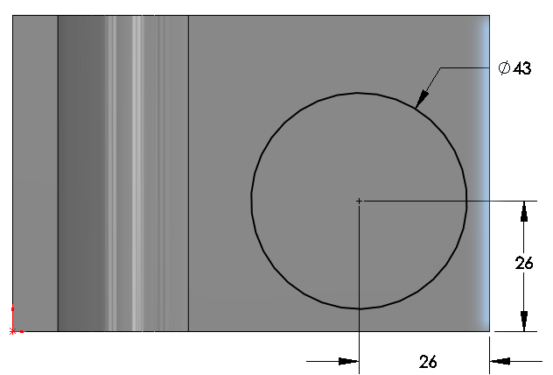

Creating the Select Features, Extruded Boss/Base. Choose Isometric View cylindrical feature from the Head Up Toolbar
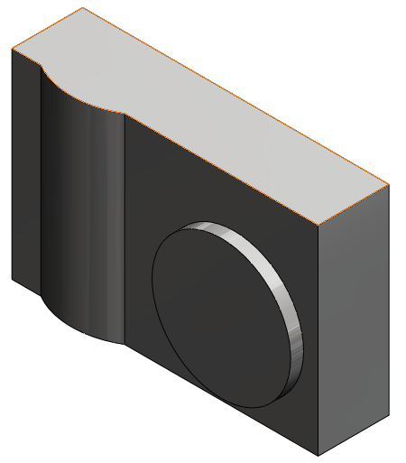
Extrude Feature Settings

End Condition = Blind

Depth = 4mm

Creating concentric Use the same procedure to create two further concentric cylindrical features
features as shown below.

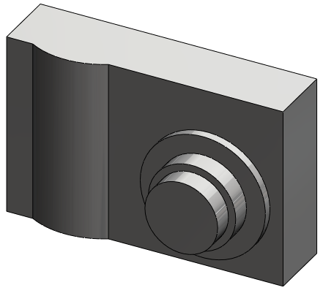

Ø30mm x 7mm

Ø25mm x 10mm

To ensure When sketching the circle on the face of the existing cylinder move the cursor concentricity of the over the edge as shown in fig. 1, without clicking, to display the centre of the three cylinders face. Move the cursor back to the centre, select the centre point and drag the radius, as in fig. 2.

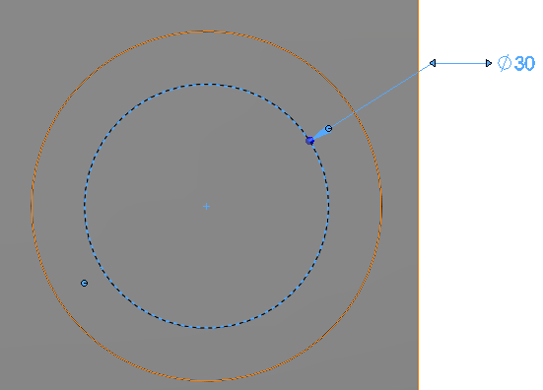
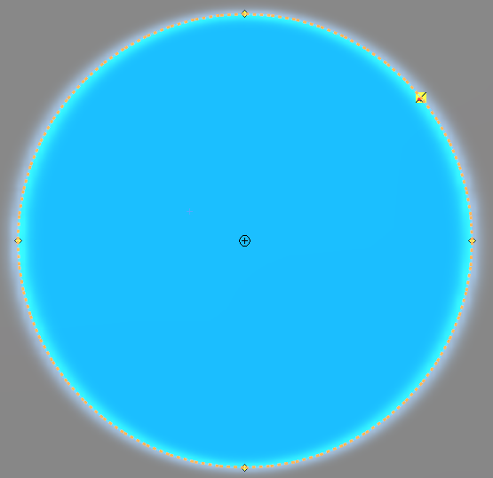

Fig.2 – Move the cursor to the centre, select and drag the radius
Fig.1 – Using the cursor to determine the face centre

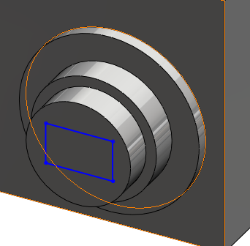
Using Extruded Cut To remove the shutter from the front of
the lens, a sketch is generated on the
face having the desired profile. This is
then cut from the solid to the required
depth using Extruded Cut.

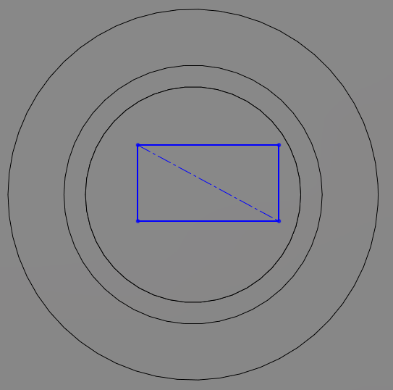
Creating the shutter Create a sketch on the front face
sketch. of the lens and choose Normal To view
from the view toolbar. Sketch a rectangle
as shown and add in a diagonal
centre line.

Adding a concentric To ensure that the shutter remains in the centre, a relation must be created
relation between it and the circle.
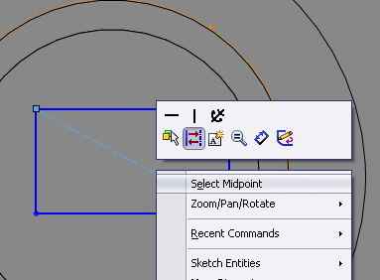
Right click on the centreline and choose Select
Midpoint. Holding down the control key choose
the circumference of the circle.
On the left hand side choose Concentric
from the Add Relations dialog box shown below.
Select to close the dialog box. The rectangle
will move to the centre of the circular face.
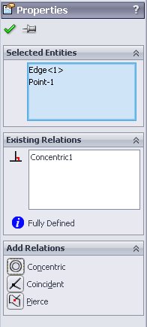
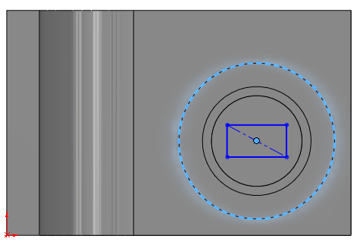

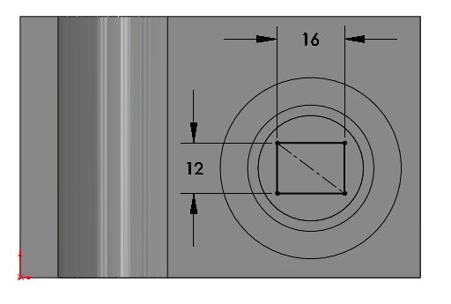
Adding dimensions Because the sketch is blue it is not
to fully define a yet full defined. Using
sketch. Smart Dimension define the
sketch as shown opposite.

The sketch now turns black and
is fully defined.

Exit the sketch using the
Confirmation Corner.

Select a 3-dimensional
view from the Heads Up Toolbar

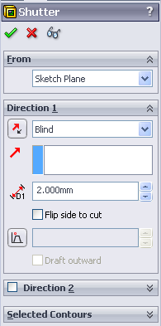
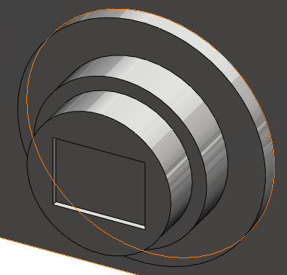
Creating the From the features toolbar choose
Extruded Cut Extruded Cut. When prompted
feature. select the rectangle as the sketch
for extrusion.

The Cut Extrude dialog box appears
on the left with a preview of the
extrusion.

Cut Extrude Feature Settings

End Condition = Blind
Depth = 2mm
Click OK button to create the feature.
Adding the raised To create the raised profile on the back of the camera, a rectangular sketch profile on the back is required, positioned on the back face.
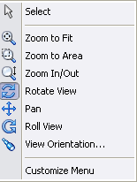
Rotate View It is necessary to rotate the model to choose the back
face as the surface on which to create the sketch.
Within the graphics area click the Right hand mouse
button and select the rotate command. Rotate the model
until the back surface is exposed.

Sketching
Create a sketch and choose the back surface as the plane on which to build the sketch. Sketch a rectangle on the back face and dimension as shown.
Exit the sketch

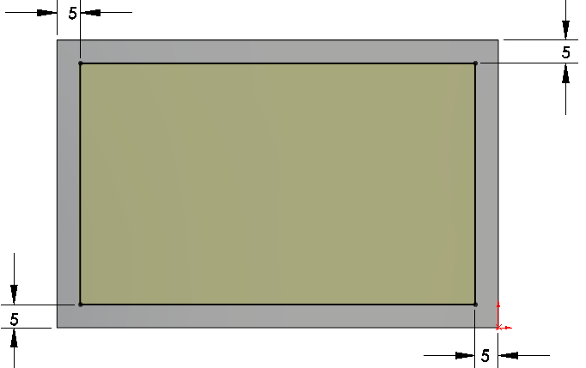

Dimensioning Should the overall size of the camera change the raised panel will remain offset 5mm from the altered dimension.

Creating the extruded Choose Extruded Boss/Base from the features toolbar
panel feature. Select the rectangle as the sketch to create the feature

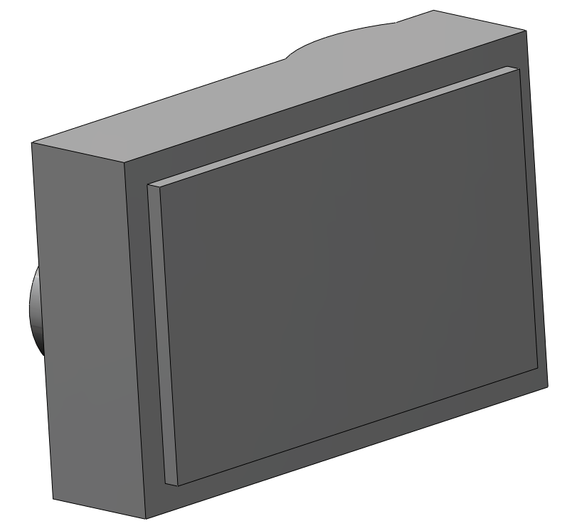
Extrude Feature Settings

End Condition = Blind

Depth = 3mm

Rotate to a 3 dimensional
view to ensure the extrude
direction is correct
Click OK button to
create the feature

Removing the screen Similar to the shutter, the screen is produced using an Extruded Cut.
The face of the extruded rear panel is used as the sketch plane. Sketch dimensions are shown below along with feature settings
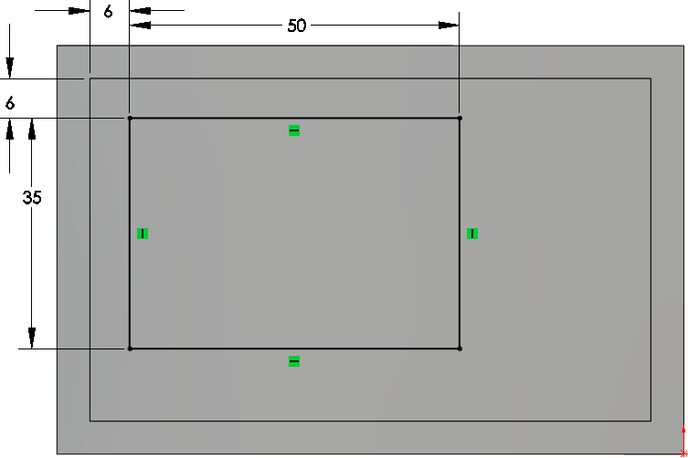
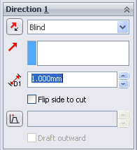

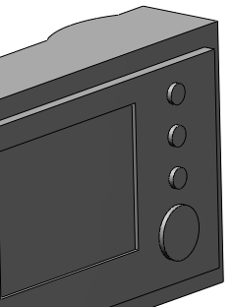
Inserting the back The function buttons will be added as an
function buttons. Extruded Boss/Base feature
Create a new sketch and choose the face of the
extruded panel as the sketch plane. Select a
Normal To view from the View toolbar.

To ensure that all of the buttons remain vertically aligned, a vertical centre line will be added and the centres of the circles will be made coincident with it.
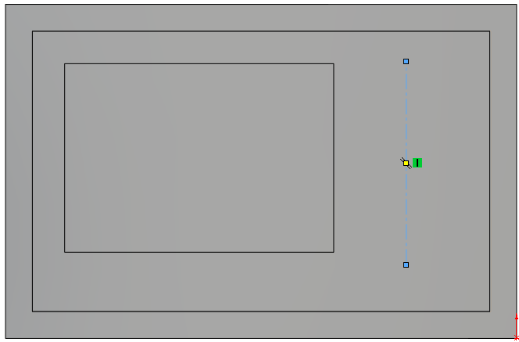
Choose Centerline from the sketch
toolbar and add in a centerline as
shown.

The vertical relation symbol
indicates that the line is vertical.


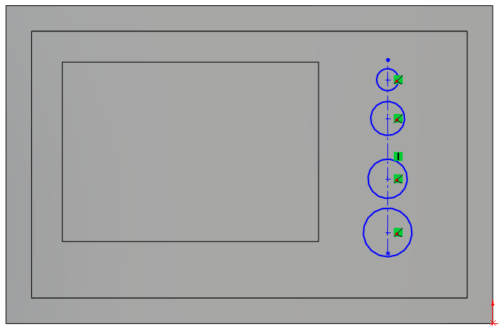
Adding the sketch Sketch the four circles as
shown ensuring that each
centre is coincident
with the vertical centreline.

Diameter sizes are irrevelent
at this stage.

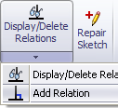
Adding an equals In order to make the three smaller
relation circles equal radii it is necessary
to add an Equal Relation.
Select Add Relation command and
select the top three circles

In the Add Relations dialog box
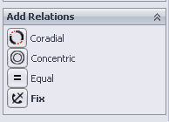
select Equal

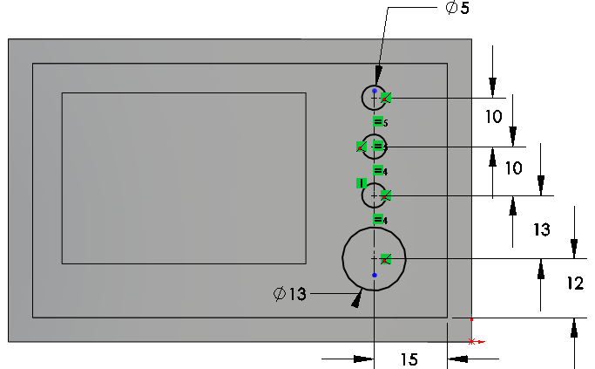
Adding dimensions Dimension the sketch
using Smart Dimension.

When the sketch entities
turn black, the sketch is
fully defined.

Exit the sketch

Creating the feature Extrude the feature using the feature settings below.

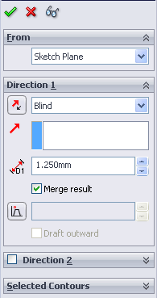
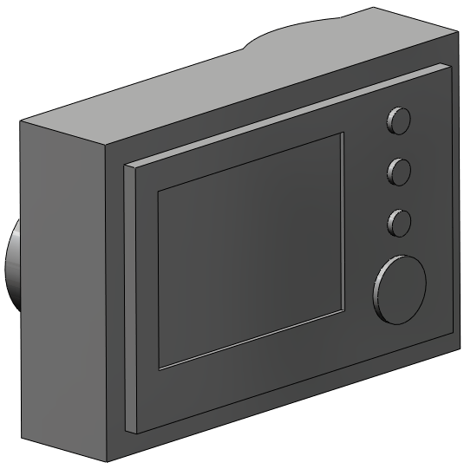

Creating the Capture This button will be created with two concentric extrusions similar to the
Button. construction of the front lens.

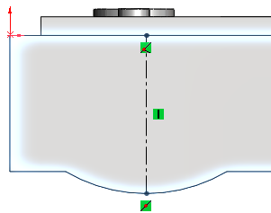
Sketching Create a sketch using the top surface. Select Normal To view from the Heads Up toolbar.

Sketch a centre line with the Sketch
Relations shown.

Sketch a circle with its centre coincident
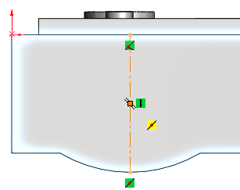
with the midpoint of the centerline
and Smart Dimension as shown

Fully Defined The sketch has turned black!
Why is the sketch Fully Defined with
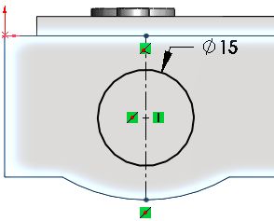
the addition of just one dimension?

Because of the inclusion of the Sketch
Relations

Change Orientation Choose Trimetric View from the view toolbar

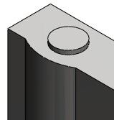
Extrude Boss/Base Extrude the sketch to a depth of 2mm

Capture Button To complete the capture button
a further sketch and extrusion will
be required.

Create a sketch on the top face of the
existing cylinder. Sketch a circle of
Ø10mm.

Ensure that the circle is concentric to
the face by selecting the face centre
as before.

Extrude Boss/Base Extrude the sketch to a
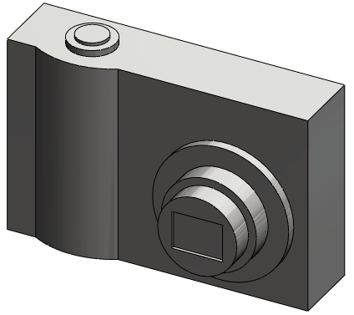
depth of 1mm.

Introducing Text The Text tool allows you to insert text into a sketch and extrude as a boss/base or cut feature.
Construction lines must be added to guide the text
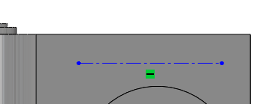

Text Sketch Create a sketch on the front
face and add the centreline
as shown

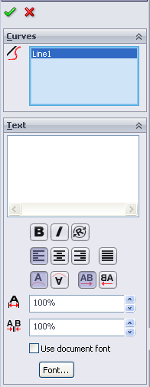

Adding text Select text from the sketch
toolbar.
Select the centerline as the text guide

Type SAMSUNG into the text window

Use Document Font will be selected by
default. Deselect by clicking on the tick
next to it. Font is no longer greyed out.

Select Font.
Choose Arial Black, Regular, Size 2.5mm
Select OK

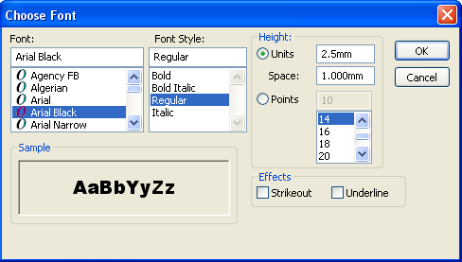

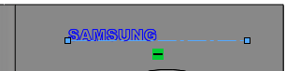

Select to exit the command.

Changing text The length and position of the line,
position and hence the position of the text, may be varied
by holding down the left mouse button on the
endpoint of the line and dragging the line.

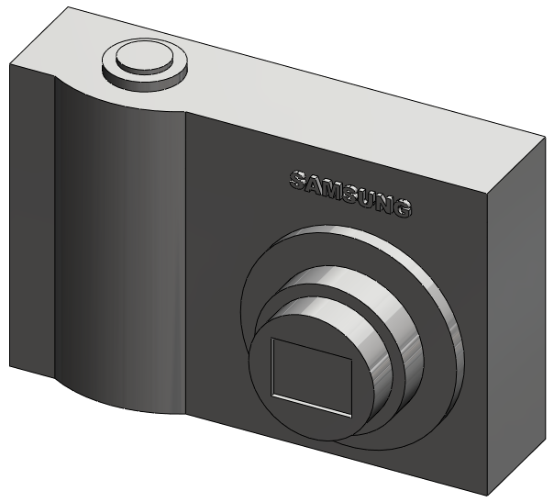
Creating the text Extrude a boss with a
feature Depth of 1mm.

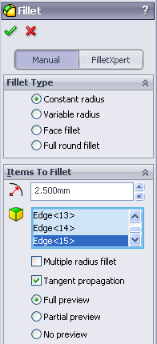
Introducing Fillet Fillets are generally added to the solid rather than the sketch and are hence referred to as applied features .

Where to find it Select the Fillet tool 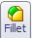 from the features toolbar

Insert Fillet Select the Fillet option. The fillet options
appear in the property manager.

Set the Radius value to 2.5mm

Select Full Preview

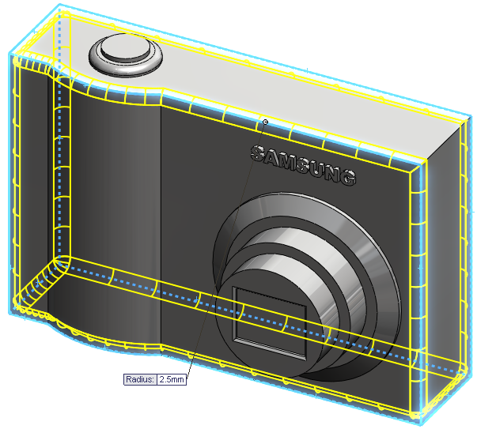
Edge Selection The edges will highlight red as the
cursor moves over them and appear
green as they are being selected.

Select the edges shown and click OK

It may be necessary to rotate the solid
to select all edges.

Removing edges Should an incorrect edge be chosen,
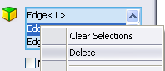
from selection right click on the selection name in
the fillet dialog box and choose Delete.
That edge will be removed from the list.
Clear Selections will delete all.

Further fillet Create a further 1.5mm fillet to the
edge of the rear panel and the rim of the
capture button as shown.
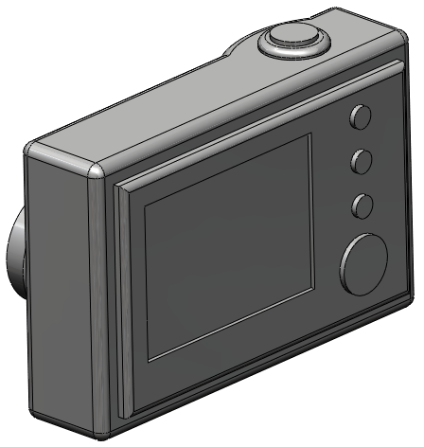

Introducing Chamfer Similar to Fillet, Chamfer is an Applied Feature. Chamfer creates a bevel on one or more edges. A chamfer may be defined by two distances or a distance and an angle.

Where to find it Select the Chamfer tool 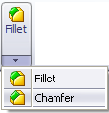 from the features toolbar

Insert Chamfer Select the Chamfer option. The chamfer options
appear in the Chamfer Property Manager.

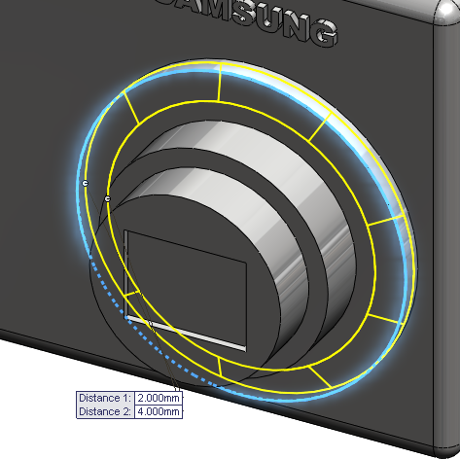
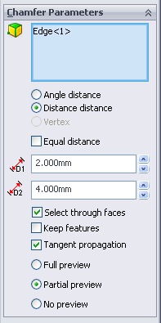
Add a Chamfer
using the edge of
the lens as shown.
Set the distances
using the values
shown on the
right

Select OK.

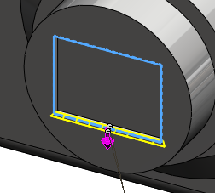
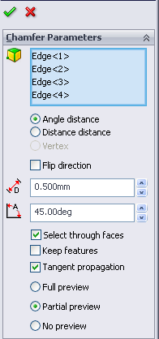
Chamfer distance/angle Select Chamfer.

Add a Chamfer
using the edge of
the shutter as shown.
Set the options as
shown opposite

Select OK.

Exercise Complete!

