Calculator Exercise

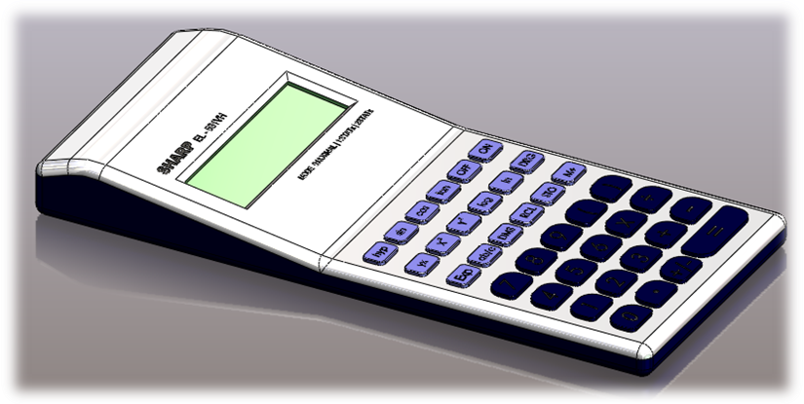

Commands Used This lesson includes Sketching (including Text), Extruded Boss/Base, Extruded Cut, Fillet, Chamfer and Linear Pattern.

Getting Started Create a sketch, on the front plane using the dimensions shown. Position the sketch such that the origin is in the lower right hand corner.

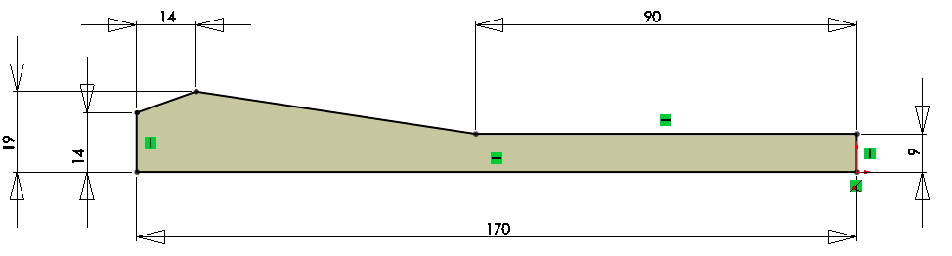

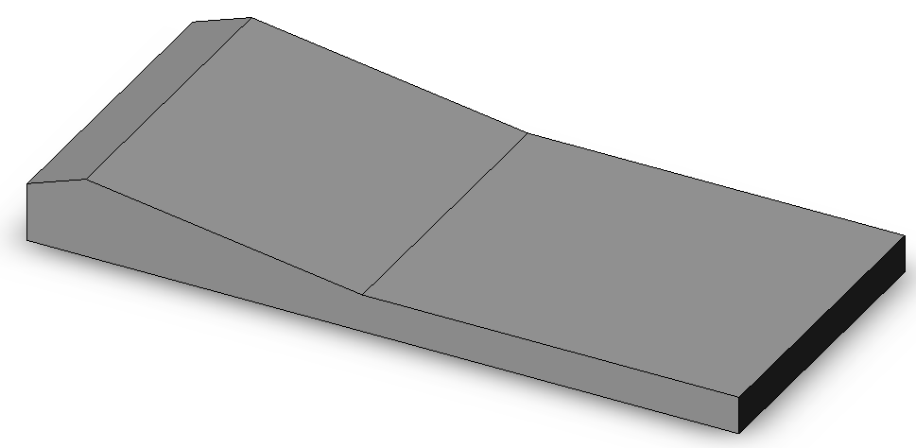
Extruded Boss/Base Extrude the sketch using the
Blind End Condition and a
Depth of 75mm

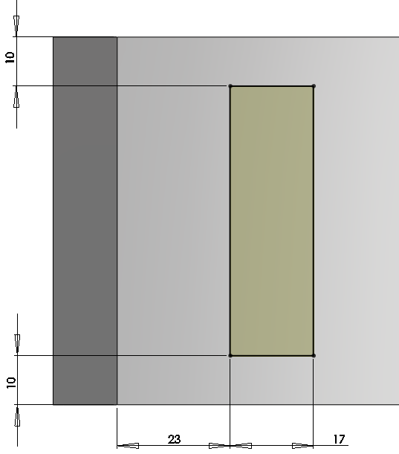
Extruded Cut Sketch the rectangle on the sloping
surface and Smart Dimension
as shown.

Extrude Cut the sketched rectangle
to a depth of 2.5mm.

Adding the buttons Create a rectangular sketch
on the top face.

Smart Dimension
as shown.
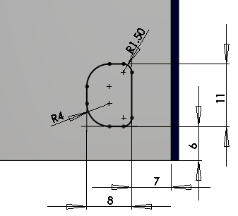
Create a Sketch Fillet
on the corners of R4mm
and R1.5mm.

Extrude the sketch to a
Depth of 1mm.

Create a Fillet of 0.15mm
on the top edge of the button.

Linear Patterning Create a Linear Pattern using the settings shown.


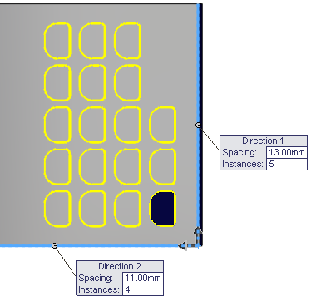
The fillet must be selected
independently of the button
feature, in features to
pattern, to create the linear
pattern

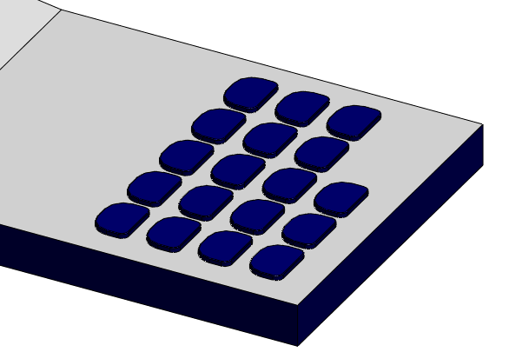

Function Buttons Create the sketch of the function buttons using the sketch dimensions below.
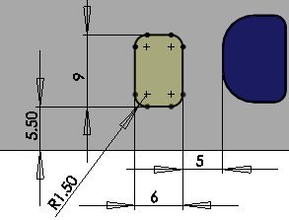
Extrude Boss/Base Extrude the sketch to a
Depth of 1mm

Fillet Add a Fillet of 0.2mm
to the top face of the
feature

Linear Patterning Create a Linear Pattern using the settings shown.

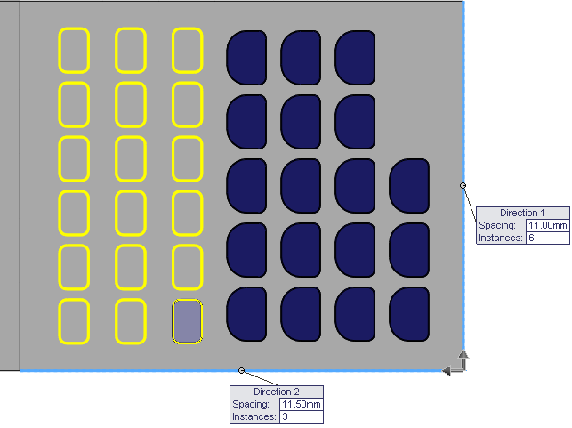

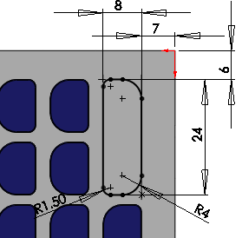
Creating the ‘=’ Create the sketch as shown.
Button
Add a Collinear Relation
between the lines and the existing
features to fully define
the sketch.

Extrude the sketch to a Depth of
1mm .

Add a Fillet of 0.2mm as before.

Main Body Fillet Add a 3mm fillet to the edges shown below. Note the omitted edges.

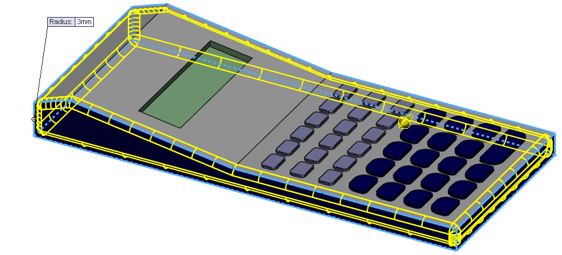

Add a 20mm fillet to the remaining two edges at the intersection of the
top faces.

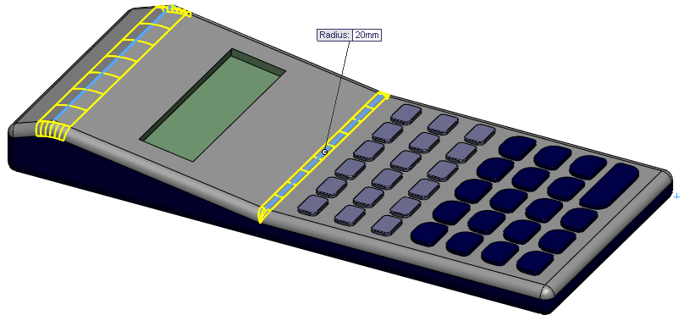

Screen Chamfer Create a 1.5mm x 45º Chamfer
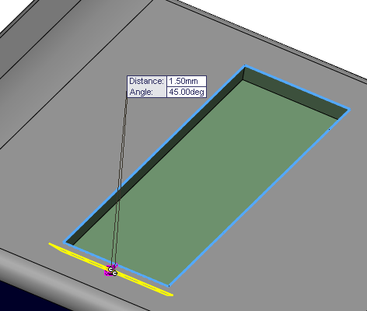
to the screen edge as shown.

Text Add Text to the lower
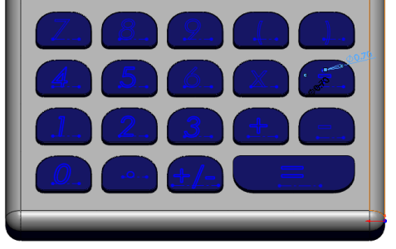
buttons as shown.

Cut Extrude the sketch
to a depth of 0.2mm

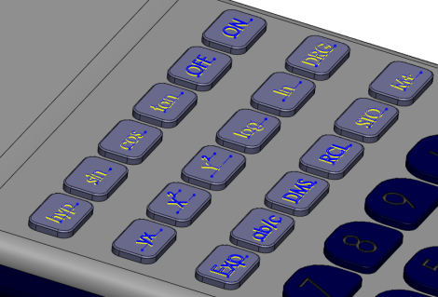
Add the Text to the upper
buttons as before.

Cut Extrude the sketch
to a depth of 0.2mm

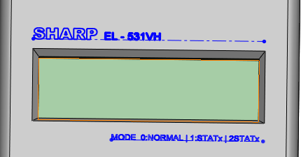
Create a sketch on the sloping
face and add the text shown.

Extrude Cut the text to a depth
of 0.1mm

Completed Model

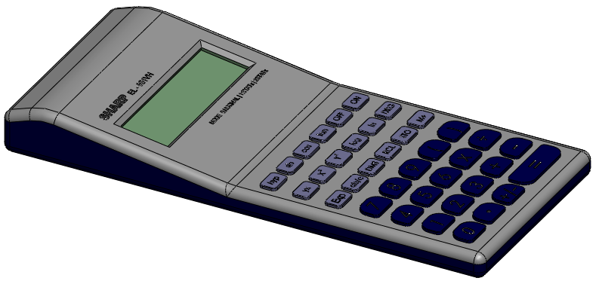

Edit Colours and Edit the colour and texture settings to make the model look more
Textures realistic, as shown on the front page of the document.

Lesson Complete!



