Bodies encased within bodies

Draw outer shell first depending on shape…..
Save it as say outer body

Then shell this outer body to required thickness

In order to form a body that will fit inside this part you will need to click on the inside of the body you just shelled.

In the surfaces toolbar you will see the tab ‘offset surface’ this will detect the inside of the highlighted surface…. Ensure the thickness is 0mm

Now you will have created skin within the surface of the original body…. Now it just need a wall thickness… to do this in the surfaces toolbar click on ‘thickness’ but more importantly ensure the merge box is unticked otherwise you will not be able to subtract one part from the other….. now just choose a thickness suitable for the part see e.g. of 3mm here.

This should be the following result

At this point you have to be smart and save this part twice as you have to save one as an outer part and the other as inner part.
In the feature toolbar click on the ‘Combine’ tab…. You should now get the option of subtracting one part from the other… depending on which part you’re in say outer then you will subtract the inner and visca versa… until you are left with two parts which should fit into one another seamlessly in an assembly….

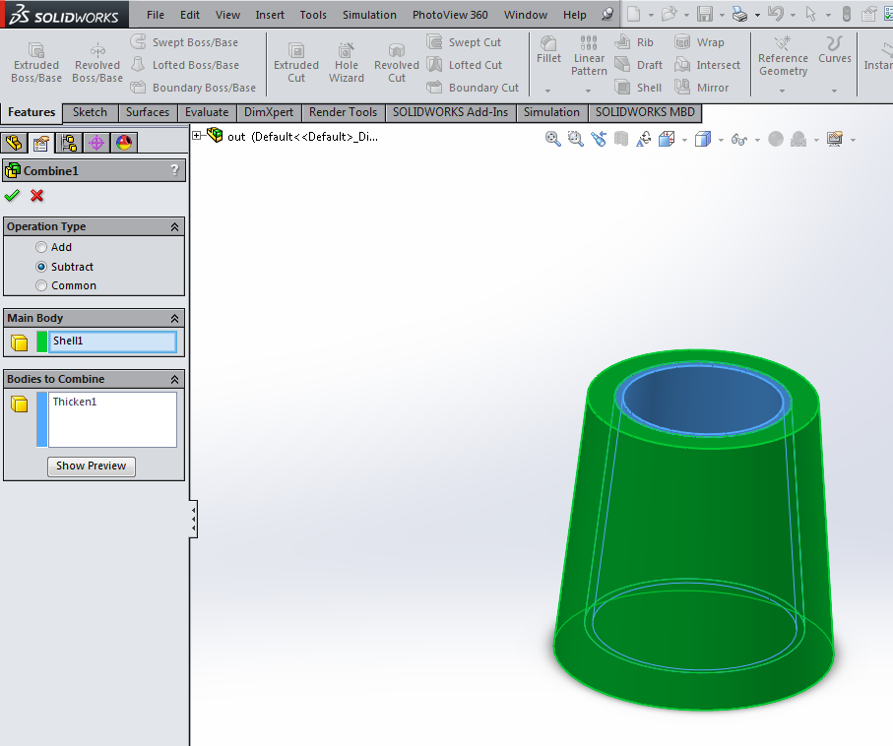

Then you can play around with each part and place into an assembly until desired effect is achieved

